|

9/18/2013 @ 3:44PM |6,854 views

Mexico's Ambassador Blasts Hollywood For Promoting Racist Stereotypes
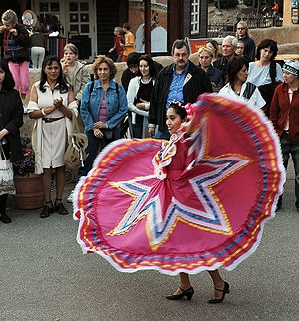
Mexico, A 'Beautiful Country' With A 'Poor' Reputation Dolia Estevez Contributor
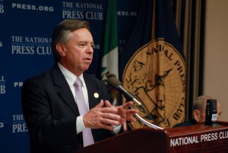
Mexico's Ambassador to the U.S. Eduardo Medina Mora: Not a fan of Hollywood (photo credit: Embassy of Mexico)
In blunt remarks for a diplomat, Mexico’s Ambassador to the United States, Eduardo Medina Mora, accused Hollywood’s film industry of promoting “racist” stereotypes of Mexicans. “Mexicans on the silver screen are usually portrayed as poor and uneducated at best, corrupt and violent at worst”, he complained.
In a spirited news conference on Friday at Washington’s National Press Club, Medina Mora said that “contemporary American cinema’s depiction of Mexicans as inherently bad people, drug dealers and corrupt policemen is not only racist, it is totally wrong.”
Mexico’s top diplomat said that the movies a nation produces can provide insight into the attitudes of that country and that he has concluded that in the films produced in Hollywood’s studios, “Mexican characters are frequently drug dealers and gardeners.” While there is nothing wrong with being a gardener, he said “it implies that they are not capable of doing anything else” and ignores the contribution Mexicans have made to the United States.
Typecasting of Mexicans limits the range of roles which even the most talented Mexican actors can play. “Even our best actors, like Demián Bichir, cannot escape the gardeners and drug dealers trap for Mexicans in Hollywood”. Bichir was nominated for an Oscar for his role as a gardener in the 2011 drama A better Life; in the 2012 crime thriller Savages, he is given the role of a drug dealer. “I am still eagerly waiting for the movie where Salma Hayek plays a Nobel Prize winning chemist that teaches young Americans to create new forms of alternative energy…”
As for the role of drug dealers “so often played by Mexicans in American cinema”, Medina Mora did not deny that Mexico has a significant drug problem, but rejected as “racist” the “stereotypes” of Mexicans as only that. He asked to frame the debate on what to do about drugs in a larger discussion about social context and institutional strength and capabilities.
Medina Mora, a former Attorney General involved in the previous Mexican administration’s highly controversial war on drugs, warned that the problem with the stereotypes of Mexicans fueled by films such as Savages and From Dusk till Dawn, is that “the American public, which consumes those types of movies, will inevitably be influenced by them.”
In an attempt to change Americans’ distorted image of Mexicans, Medina Mora told the press that the demographic on the rise in Mexico is not drug dealers or gardeners, but a sophisticated middle class which grew by more than 11% between 2000 and 2010.
While there is not one apparent event that prompted Medina Mora’s blast of Hollywood, it is not the first time he has taken on a country’s entertainment industry to confront what he sees as misconceptions of Mexico. In 2011, when he served as Ambassador to the UK, he got into a public dispute with the BBC’s TV show Top Gear, after Richard Hammond branded Mexicans “lazy, feckless, and flatulent” before he and fellow presenter James May insulted Mexico’s food. Medina Mora called their remarks “offensive, xenophobic and humiliating” and asked the BBC for an apology.
Follow me on Twitter: @DoliaEstevez

This article is available online at:
http://www.forbes.com/sites/doliaestevez/2013/09/18/mexicos-ambassador-blasts-hollywood-for-promoting-racist-stereotypes/

