FICTION
FEBRUARY 23, 2009 ISSUE https://www.newyorker.com/magazine/2009/02/23/the-daughters-of-the-moon

THE DAUGHTERS OF THE MOON
By Italo Calvino
February 16, 2009
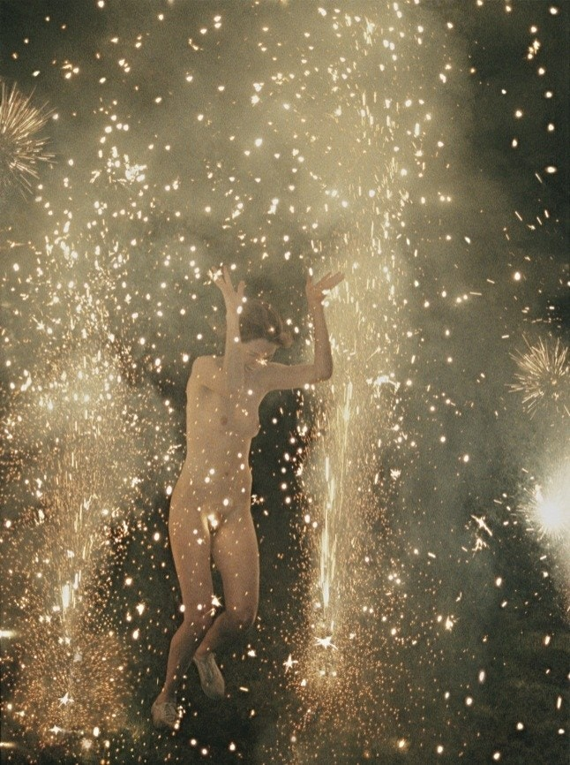
Photograph by Ryan Mcginley; “Fireworks Hysteric” (2007-08) / Courtesy Team Gallery, NY

Deprived, as it was, of a covering of air to act as a protective shield, the moon found itself exposed right from the start to a continual bombardment of meteorites and to the corrosive action of the sun’s rays. According to Thomas Gold, of Cornell University, the rocks on the moon’s surface were reduced to powder through constant attrition from meteorite particles. According to Gerard Kuiper, of the University of Chicago, the escape of gases from the moon’s magma may have given the satellite a light, porous consistency, like that of a pumice stone.
The moon is old, Qfwfq agreed, pitted with holes, worn out. Rolling naked through the skies, it erodes and loses its flesh like a bone that’s been gnawed. This is not the first time that such a thing has happened. I remember moons that were even older and more battered than this one; I’ve seen loads of these moons, seen them being born and running across the sky and dying out, one punctured by hail from shooting stars, another exploding from all its craters, and yet another oozing drops of topaz-colored sweat that evaporated immediately, then being covered by greenish clouds and reduced to a dried-up, spongy shell.
What happens on the earth when a moon dies is not easy to describe; I’ll try to do it by referring to the last instance I can remember. Following a lengthy period of evolution, the earth had more or less reached the point where we are now; in other words, it had entered the phase when cars wear out more quickly than the soles of shoes. Beings that were barely human manufactured and bought and sold things, and cities covered the continents with luminous color. These cities grew in approximately the same places as our cities do now, however different the shape of the continents was. There was even a New York that in some way resembled the New York familiar to all of you, but was much newer, or, rather, more awash with new products, new toothbrushes, a New York with its own Manhattan that stretched out dense with skyscrapers gleaming like the nylon bristles of a brand-new toothbrush.
In this world where every object was thrown away at the slightest sign of breakage or aging, at the first dent or stain, and replaced with a new and perfect substitute, there was just one false note, one shadow: the moon. It wandered through the sky naked, corroded, and gray, more and more alien to the world down here, a hangover from a way of being that was now outdated.
Ancient expressions like “full moon,” “half-moon,” “last-quarter-moon” continued to be used but were really only figures of speech: how could we call “full” a shape that was all cracks and holes and that always seemed on the point of crashing down on our heads in a shower of rubble? Not to mention when it was a waning moon! It was reduced to a kind of nibbled cheese rind, and it always disappeared before we expected it to. At each new moon, we wondered whether it would ever appear again (were we hoping that it would simply disappear?), and when it did reappear, looking more and more like a comb that had lost its teeth, we averted our eyes with a shudder.
It was a depressing sight. We went out in the crowds, our arms laden with parcels, coming and going from the big department stores that were open day and night, and while we were scanning the neon signs that climbed higher and higher up the skyscrapers and notified us constantly of new products that had been launched, we’d suddenly see it advancing, pale amid those dazzling lights, slow and sick, and we could not get it out of our heads that every new thing, each product that we had just bought, could similarly wear out, deteriorate, fade away, and we would lose our enthusiasm for running around buying things and working like crazy—a loss that was not without consequences for industry and commerce.
That was how we began to consider the problem of what to do with it, this counterproductive satellite. It did not serve any purpose; it was a useless wreck. As it lost weight, it started to incline its orbit toward the earth: it was dangerous, above and beyond anything else. And the nearer it got the more it slowed its course; we could no longer calculate its phases. Even the calendar, the rhythm of the months, had become a mere convention; the moon went forward in fits and starts, as though it were about to collapse.
On these nights of low moon, people of a more unstable temperament began to do weird things. There was always a sleepwalker edging along the parapet of a skyscraper with his arms reaching toward the moon, or a werewolf starting to howl in the middle of Times Square, or a pyromaniac setting fire to the dock warehouses. By now these were common occurrences that no longer attracted the usual crowd of rubberneckers. But when I saw a girl sitting, completely naked, on a bench in Central Park I had to stop.
Even before I saw her I’d had the feeling that something mysterious was about to happen. As I drove through Central Park at the wheel of my convertible, I felt myself bathed in a flickering light, like that of a fluorescent bulb emitting a series of livid, blinking flashes before it turns on fully. The view all around me was like that of a garden that had sunk into a lunar crater. The naked girl sat beside a pond reflecting a slice of moon. I braked. For a second I thought I recognized her. I ran out of the car toward her, but then I froze. I did not know who she was; I just felt that I urgently had to do something for her.
Everything was scattered on the grass around the bench: her clothes, a stocking and shoe here and the others there, her earrings, necklace, and bracelets, purse and shopping bag with the contents spilled out in a wide arc, and countless packages and goods, almost as if the creature had felt herself called on her way back from a lavish shopping spree and had dropped everything, realizing that she had to free herself of all objects and signs that bound her to the earth, and she was now waiting to be assumed into the lunar sphere.
“What’s happening?” I stammered. “Can I help you?”
“Help?” she asked, with her eyes staring upward. “Nobody can help. Nobody can do anything.” And it was clear that she was talking not about herself but about the moon.
The moon was above us, a convex shape almost crushing us, a ruined roof, studded with holes like a cheese grater. Just at that moment, the animals in the zoo began to growl.
“Is this the end?” I asked mechanically, and I myself didn’t even know what I meant.
She replied, “It’s the beginning,” or something like that. (She spoke almost without opening her lips.)
“What do you mean? It’s the beginning of the end, or something else is beginning?”
ADVERTISEMENT
She got up, walked across the grass. She had long copper-colored hair that came down over her shoulders. She was so vulnerable that I felt the need to protect her in some way, to shield her, and I moved my hands toward her as though to be ready to catch her if she fell or to ward off anything that might harm her. But my hands did not dare even graze her, and always stayed a few centimetres from her skin. And as I followed her, in this way, past the flower gardens, I realized that her movements were similar to mine, that she, too, was trying to protect something fragile, something that might fall and shatter into pieces, and that needed thus to be led toward a place where it could settle gently, something that she could not touch but could only guide with her gestures: the moon.
The moon seemed lost. Having abandoned the course of its orbit, it no longer knew where to go; it let itself be transported like a dry leaf. Sometimes it appeared to be plummeting toward the earth, at others corkscrewing in a spiral movement, and at still others it looked to be just drifting. It was losing height, that was certain: for a second it seemed as if it would crash into the Plaza Hotel, but instead it slid into the corridor between two skyscrapers and disappeared from view in the direction of the Hudson. It reappeared shortly afterward, on the opposite side of the city, popping out from behind a cloud, bathing Harlem and the East River in a chalky light, and, as though caught by a gust of wind, it rolled toward the Bronx.
“There it is!” I shouted. “There—it stopped!”
“It can’t stop!” the girl exclaimed, and she ran naked and barefoot over the grass.
“Where are you going? You can’t wander around like that! Stop! Hey, I’m talking to you! What’s your name?”
She shouted out a name like Diana or Deanna, something that could also have been an invocation. And she disappeared. In order to follow her, I jumped back into my car and began to search the drives of Central Park.
The beams of my headlights lit up hedges, hills, obelisks, but the girl, Diana, was nowhere to be seen. By now I had gone too far: I must have passed her; I turned around to go back the way I’d come. A voice behind me said, “No, it’s there, keep going!”
Sitting behind me on the trunk of my car was the naked girl, pointing toward the moon.
I wanted to tell her to get down, to explain that I could not travel across the city with her so prominently on view in that condition, but I did not dare to distract her, intent as she was on not losing sight of the luminous glow that was disappearing and reappearing at the end of the drive. And in any case—and this was even stranger—no passerby seemed to notice this female apparition sitting up on the trunk of my car.
We crossed one of the bridges that link Manhattan to the mainland. Now we were going along a multilane highway, with other cars alongside us, and I kept my eyes staring straight ahead, fearing the laughter and crude comments that the sight of the two of us was no doubt prompting in the cars around us. But when a sedan overtook us I nearly went off the road in surprise: crouched on its roof was a naked girl with her hair blowing in the wind. For a second, I thought that my passenger was leaping from one speeding car to another, but all I had to do was turn my head ever so slightly to see that Diana’s knees were still there, level with my nose. And her body was not the only one glowing before my eyes: now I saw girls everywhere, stretched out in the strangest poses, clinging to the radiators, doors, and fenders of the speeding cars, their golden or dark strands of hair contrasting with the pink or dark gleam of their naked skin. There was one of these mysterious female passengers on every car, all leaning forward, urging their drivers to follow the moon.
They had been summoned by the endangered moon: I was certain of that. How many of them were there? More cars carrying lunar girls gathered at every crossroads and junction, converging from all quarters of the city to the place above which the moon seemed to have stopped. At the edge of the city, we found ourselves in front of an automobile scrap yard.
The road petered out in an area with little valleys, ridges, hills, and peaks, but it was not the contours of the land that created the uneven surface but, rather, the layers of things that had been thrown away: everything that the consumerist city had used up and expelled so that it could immediately enjoy the pleasure of handling new things had ended up in this unprepossessing neighborhood.

