FLASH FICTION

COURAGE
By Daniel Smith
August 22, 2019
https://www.newyorker.com/books/flash-fiction/courage
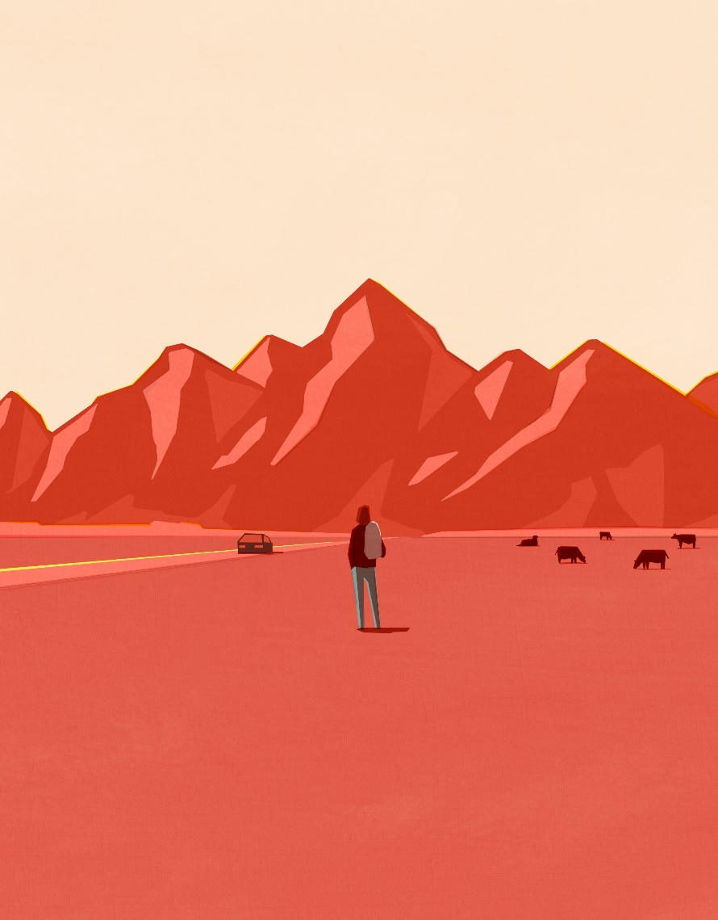
Illustration by Taku Bannai

This is the eighth story in this summer’s online Flash Fiction series. You can read the entire series, and our Flash Fiction stories from 2017 and 2018, here.
People were braver than he was. He was sure of it. He was kind and smart in his way, but he was not brave, and he never had been.
He and his wife had lunch with her sister and her new husband. The husband’s daughter came to lunch, too. She was the youngest of his three children, and she had recently walked the Appalachian Trail, all of it, from Maine to Georgia. Now she was moving to Wyoming to work on a cattle ranch. Her father didn’t mind this, but her mother, her grandparents, and even some of her friends objected strongly. The girl didn’t seem to care. She said that at first she had cared but then she saw that they were only jealous of her willingness to do what she wanted, free of expectations, and then she didn’t care anymore. She was twenty-one.
He thought of himself at twenty-one. Where had he been? He had been in college. Then he had graduated and begun to work, at a drug clinic. In the summer between college and working he went to study Italian at an immersion program in Vermont, but he was lonely and intimidated, and he left after three days. He thought of his wife’s sister’s husband’s daughter’s decision not to care what people thought of her. She had described it as a sort of switch: first she had cared, then she had not cared. The switch was her will. He could not remember ever applying his will to such drastic effect, particularly about other people and their feelings about him. This, he decided, was the essence of her courage and of his cowardice.
That night, while undressing, he tried to explain all this to his wife. She understood him immediately, but she raised a number of objections and mitigating forces.
1.) The girl was overstating or misrepresenting her experience. She very likely did care what other people thought of her—especially her mother—and was portraying her transformation as stark only because it was a) more dramatic to speak that way, b) more self-aggrandizing to speak that way, and c) a means of convincing herself of her own
2.) The girl was not known, given the stories her sister told about her, to be especially generous or compassionate, whereas by all reports he always had been, and these qualities—generosity and compassion—entailed their own form of courage: the courage to serve others. (At this he winced.)
3.) At the time he had grown anxious and homesick and left the language school, his mother had been deathly ill, a detail that ought to soften his judgment of himself. It was important to consider context.
He thanked her, this woman who loved him and who didn’t judge him for those parts of himself that most troubled and shamed him, but he offered counterarguments to which he believed she would have no effective response.
1.) Even if the girl was misrepresenting herself in order to bolster her spirits, this was, as he saw it, further evidence of her courage—courage consisting, as everyone knew, not of action in the absence of objections but action in the face of them.
2.) Selfishness was its own form of courage, and in fact was, within reason, exactly the kind of courage that he had in mind.
3.) Many people had mothers who were dying and then died. A dying mother does not preclude the study of Italian. There are always excuses.
They lay in bed. They could hear two men on the sidewalk talking and laughing. They kissed for a while. It seemed that they were going to make love but they didn’t, and as his wife slept he thought about the girl. What would she do on the ranch in Wyoming? Would she drive steer? Would she cook and clean? He had meant to ask her but then the conversation had turned. Was she frightened at all? Did she have reservations? What resources of mind or spirit did she think she possessed to move to a place two thousand miles from her family, a place in which she knew nobody and the terrain and climate were utterly different from those which she had always known? If she grew lonely, what comforts would she seek out? And did she love herself? Under the great sweeping Western sky, among the cattle and the mountains bathed in red light, was it really herself whom she loved most of all?

