Stepin Fetchit
Stepin Fetchit remains one of the most controversial movie actors in American history. While he was undoubtedly one of the most talented physical comedians ever to do his shtick on the Big Screen, achieving the rare status of being a character actor/supporting player who actually achieved superstar status in the 1930s (becoming a millionaire to boot), his characterization as a lazy, slow-witted, jive-talkin' "coon" offended African-Americans at the time he was a major attraction in motion pictures (primarily the 1930s) and still offends African-Americans in the 21st century, more than 50 years after he had faded from the screen. Yet some African-Americans claim him as the first black superstar, and thus a trailblazer for others of his "race." The controversy over Stepin Fetchit remains alive to this day, with two biographies published about him in 2005.
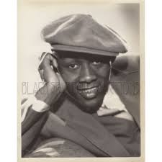 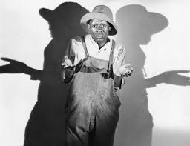 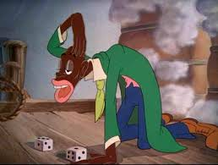
Stepin Fetchit was the stage name of Lincoln Theodore Monroe Andrew Perry, who claimed a birth date of May 30, 1902, but he may have been born as early as 1892. Perry was born in Key West, Florida, to West Indian immigrant parents. Sometime in his teens Perry became a comic performer. A literate and very intelligent man who wrote for the premier African-American newspaper, "The Chicago Defender," Perry evolved a character called "The Laziest Man In the World" as part of a two-man vaudeville act that broke through to play the white circuits. Eventually, he went solo ("Stepin Fetchit" likely was the original name of the act covering both performers, as "Step 'n Fetchit." As a solo, he kept the name).
While some believe that his stage name is a contraction of "step and fetch it", implying a servile persona (the so-called "Tom") that is synonymous with degrading racial stereotypes in popular entertainment in the 19th century and the first half of the 20th century, Perry claimed he got the name from a race horse. However, it's important to make the distinction that African-American cultural historians do (while at no time condoning Perry's career) - rather than a servile Tom (named after Harriet Beecher Stowe's "Uncle Tom"), Stepin Fetchit was an evolution of a later construction, the "coon" who undermined his white oppressors by denying his labor and cooperation through an act of defiance that included the appearance of being lazy and stupid. Essential to the "coon" persona was talking in what to white ears is gibberish (which Perry excelled at), but which to black folk can be understood and contains barbed insults to "The Man." What rankles so badly (since the Coon remains a stereotype that resonates in African-American culture) is that white audiences swallowed Perry's Stepin Fetchit act whole, as a true representation of a "Negro."
The "Coon" persona mitigated the low status accorded African-Americans by whites by feigning near-idiocy in order to frustrate whites by ironically fulfilling their low expectations (the "Tom," by contrast, is praised by whites for his good work and loyalty. A parallel racial caricaturization of black men by whites, the "buck," is the repository of their racial and sexual fears, and still can be seen in blaxploitation movies of the 1970s and, more recently, in the "gangsta" rapper). Perry used this mitigation stratagem when dealing with whites in real life, allegedly maintaining a coon persona while auditioning for a role in _In Old Kentucky (1938)_, where he stayed in the Stepin Fetchit character before and after the audition. Often, while making movies in which he found the lines offensive, Perry would skip or mumble lines he did not like, pretending to be too stupid to comprehend the script.
The "Coon" stereotype existed long before Perry decided to adopt it (its prevalence as a defiance stratagem intensified after the gains that African-Americans had made in the post-Civil War Reconstruction Era were rolled back by segregationist Jim Crow laws, when an "uppity" African-American could well wind up hanging from a tree at the end of a rope). However, he was such a hit with white audiences that his Stepin Fetchit persona popularized the "Coon" image to an unprecedented degree in the medium of film, and many stereotypical black movie characters, including the child Stymie in the "Our Gang" comedy series, were based upon Stepin Fetchit to cash in on his popularity.
Perry reached the apex of his career co-starring with Will Rogers in several films, including John Fords Steamboat Round the Bend (1935). When viewed objectively today (without revulsion), Perry's Stepin Fetchit character can be seen as more than holding his own with the great Rogers, achieving some kind of inverse parity with his white "massa" through the sheer forcefulness of his personality. Rogers clearly is fond of Perry (if not Stepin Fetchit), although he is liable to denigrate the Stepin Fetchit character unmercifully. In a way, it provides a window on race relations in that Southern and other white Americans could experience fondness for black folk, but would "put them in their place" at any time, for any reason.
Stepin Fetchit became the first African-American actor to become a millionaire, but he mishandled his fortune through lavish overspending and was bankrupt by 1947. In the 1940s his career in mainstream "white" cinema was essentially over, and he crossed over into "race" films, movies made specifically for (and sometimes by) African-Americans, where he essentially played the same shtick. By 1960 he was a charity case in Chicago.
Perry had been denounced by the same civil rights leaders that eventually forced CBS to mothball the popular TV series The Amos 'n Andy Show (1951), as they didn't want any stereotypes pandering to the inherent racism of whites while they were trying to obtain equality. Cast out and an exile in the 1960s, Perry was rehabilitated by heavyweight champion Cassius Clay--the symbol of African-American racial pride who had become Muhammad Ali--making him one of his entourage after Perry allegedly showed him a punch that Ali successfully used during a fight. Following Ali's example, Perry converted to the 'Honorable Elijiah Muhammad''s Lost-Found Nation of Islam (the so-called "Black Muslims"). He was saved. (http://www.imdb.com/name/nm0275297/bio)

Uncle Tom
Definition: A black man who will do anything to stay in good standing with "the white man" including betray his own people (Urban Dictionary)

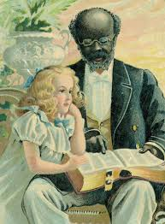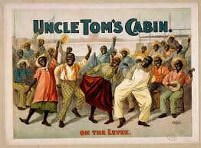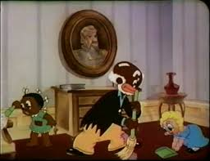

The Tom caricature portrays black men as faithful, happily submissive servants. The Tom caricature, like the Mammy caricature, was born in ante-bellum America in the defense of slavery. How could slavery be wrong, argued its proponents, if black servants, males (Toms) and females (Mammies), were contented and loyal? The Tom is presented as a smiling, wide-eyed, dark skinned server: fieldworker, cook, butler, porter, or waiter. Unlike the Coon, the Tom is portrayed as a dependable worker, eager to serve. Unlike the Brute, the Tom is docile and non-threatening to whites. The Tom is often old, physically weak, psychologically dependent on whites for approval. In his book, Toms, Coons, Mulattoes, Mammies, & Bucks, Donald Bogle (1994) summarizes the depiction of Toms in movies: Always as toms are chased, harassed, hounded, flogged, enslaved, and insulted, they keep the faith, n'er turn against their white massas, and remain hearty, submissive, stoic, generous, selfless, and oh-so-very kind. Thus they endear themselves to white audiences and emerge as heroes of sorts. (pp. 5-6)
Bogle's description is similar to the portrayal of the main black character in Harriet Beecher Stowe's antislavery novel Uncle Tom's Cabin. Stowe's Tom is a gentle, humble, Christian slave. His faith is simple, natural, and complete. Stowe uses Tom's character to show the perfect gentleness and forgiving nature which she believed lay dormant in all blacks. These qualities reveal themselves under favorable conditions. Mr. Shelby, Tom's first Master is kind; therefore, Tom's innate spirituality flourishes. Mr. Shelby is not a good businessman; his financial troubles necessitate that he sell Tom. Tom does not run away despite a warning that he is to be sold. Mr. St. Clare, his second master, befriends Tom and promises to free him. Unfortunately for Tom, Mr. St. Clare is killed before signing manumission papers. Tom's fortunes take a decidedly sad turn. Tom is sold to Simon Legree, a brutal and sadistic deep South plantation owner. Legree is also a drunkard who hates religion and religious people.
Legree intends to make Tom an overseer. Tom is ordered by Legree to flog a woman slave. Tom refuses. Legree strikes him repeatedly with a cowhide lash. Again, he tells Tom to beat the woman. Tom, with a soft voice, says, "the poor crittur's sick and feeble; 'twould be downright cruel, and it's what I never would do, nor begin to. Mas'r, if you mean to kill me, kill me; but, as to my raising my hand agin anyone here, I never shall, -- I'll die first" (Stowe, p. 439).
Stowe wanted to show how slavery was incongruent with Christianity. How could Christians, she wondered, buy, sell, and trade slaves? How could they offer even tacit approval of slavery? How could white Christians allow their enslaved brethren to be sold to the likes of Legree? Her book is an unabashed attack on slavery, and Tom is one of her two perfect Christian characters; Mr. St. Clare's daughter, Eva, the other. Both die, Tom as a martyr. (http://www.ferris.edu/jimcrow/tom/)

Aunt Jemima
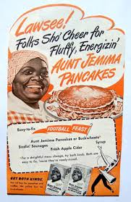Hattie McDaniels 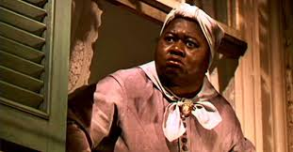 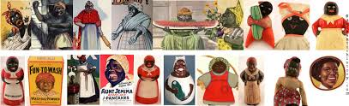
Mammy is the most well known and enduring racial caricature of African American women. The Jim Crow Museum at Ferris State University has more than 100 items with the mammy image, including ashtrays, souvenirs, postcards, fishing lures, detergent, artistic prints, toys, candles, and kitchenware. This article examines real mammies, fictional mammies, and commercial mammies.
From slavery through the Jim Crow era, the mammy image served the political, social, and economic interests of mainstream white America. During slavery, the mammy caricature was posited as proof that blacks -- in this case, black women -- were contented, even happy, as slaves. Her wide grin, hearty laugher, and loyal servitude were offered as evidence of the supposed humanity of the institution of slavery.
This was the mammy caricature, and, like all caricatures, it contained a little truth surrounded by a larger lie. The caricature portrayed an obese, coarse, maternal figure. She had great love for her white "family," but often treated her own family with disdain. Although she had children, sometimes many, she was completely desexualized. She "belonged" to the white family, though it was rarely stated. Unlike Sambo, she was a faithful worker. She had no black friends; the white family was her entire world. Obviously, the mammy caricature was more myth than accurate portrayal….
Abolitionists claimed that one of the many brutal aspects of slavery was that slave owners sexually exploited their female slaves, especially light-skinned ones who approximated the mainstream definition of female sexual attractiveness. The mammy caricature was deliberately constructed to suggest ugliness. Mammy was portrayed as dark-skinned, often pitch black, in a society that regarded black skin as ugly, tainted. She was obese, sometimes morbidly overweight. Moreover, she was often portrayed as old, or at least middle-aged. The attempt was to desexualize mammy. The implicit assumption was this: No reasonable white man would choose a fat, elderly black woman instead of the idealized white woman. The black mammy was portrayed as lacking all sexual and sensual qualities. The de-eroticism of mammy meant that the white wife -- and by extension, the white family, was safe.
The sexual exploitation of black women by white men was unfortunately common during the antebellum period, and this was true irrespective of the economic relationship involved; in other words, black women were sexually exploited by rich whites, middle class whites, and poor whites. Sexual relations between blacks and whites -- whether consensual or rapes -- were taboo; yet they occurred often. All black women and girls, regardless of their physical appearances, were vulnerable to being sexually assaulted by white men. The mammy caricature tells many lies; in this case, the lie is that white men did not find black women sexually desirable.
The mammy caricature implied that black women were only fit to be domestic workers; thus, the stereotype became a rationalization for economic discrimination. During the Jim Crow period, approximately 1877 to 1966, America's race-based, race-segregated job economy limited most blacks to menial, low paying, low status jobs. Black women found themselves forced into one job category, house servant. (http://www.ferris.edu/jimcrow/mammies/)

Buckwheat
*BuckWheat Thomas was born on this date in 1931. He was an African American child actor best remembered for portraying the character of Buckwheat in the Our Gang (Little Rascals) short films.
William "Billie" Thomas, Jr. was a native of Los Angeles, California. In 1934 his mother brought him to audition at the Hal Roach Studios, he worked in the series until the series' end in 1944. Billie Thomas first appeared in the 1934 Our Gang shorts For Pete's Sake!, The First Round-Up, and Washee Ironee as a background player. The "Buckwheat" character was a female at this time, portrayed by Our Gang kid Matthew "Stymie" Beard's younger sister Carlena in For Pete's Sake!, and by Willie Mae Taylor in three other episodes. Thomas began appearing as "Buckwheat" with 1935's Mama's Little Pirate.
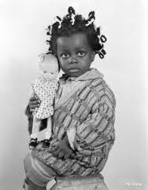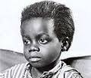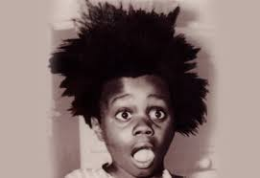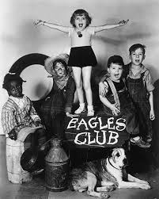
Despite Thomas being a male, the Buckwheat character remained a female dressed as a Topsy-esque image of the African American "pickaninny" stereotype with bowed pigtails, a large hand-me-down sweater and oversized boots. After Stymie's departure from the series later in 1935, the Buckwheat character slowly morphed into a boy, first referred to definitively as a "he" in 1936's The Pinch Singer. This is similar to the initial handling of another African American Our Gang member, Allen "Farina" Hoskins, who worked in the series during the silent and early sound eras.
Thomas always defended the stereotype critique of his work in the series, pointing out that Buckwheat and the rest of the black Our Gang kids were treated as equals to the white kids in the series. Despite the change in the Buckwheat character's gender, Billie Thomas's genderless costuming was not changed until his appearance as a runaway slave in the 1936 Our Gang feature film General Spanky. This new costuming overalls, striped shirt, oversized shoes, and a large unkempt Afro—was retained for the series proper from late 1936's Pay as You Exit on. Thomas remained in Our Gang for ten years, appearing in all but one of the episodes made from Washee Ironee in 1934 through the series' end in 1944. During the first half of his Our Gang tenure, Thomas' Buckwheat character was often paired with Eugene "Porky" Lee as a tag-along team of "little kids" rallying against (and often outsmarting) the "big kids," George "Spanky" McFarland and Carl "Alfalfa" Switzer. Thomas had a speech impediment as a young child, as did Lee, who became Thomas' friend both on the set and off. The "Buckwheat" and "Porky" characters both became known for their collective garbled dialogue, in particular their catchphrase, "O-tay!" originally uttered by Porky, but soon shared by both characters
(http://www.aaregistry.org/historic_events/view/william-buckwheat-thomas-born)
Uncle Ben
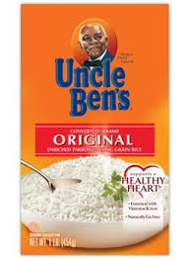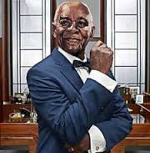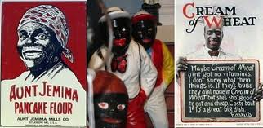
A racially charged advertising character, who for decades has been relegated to a minor role in the marketing of the products that still carry his name, is taking center stage in a campaign that gives him a makeover — Madison Avenue style — by promoting him to chairman of the company.

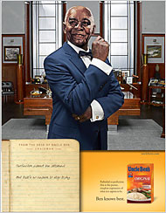
Newspaper ad and image of Uncle Ben in his office, Masterfoods USA
A Web site for Uncle Ben’s, unclebens.com, offers a look at his executive office.
Enlarge This Image
The character is Uncle Ben, the symbol for more than 60 years of the Uncle Ben’s line of rices and side dishes now sold by the food giant Mars. The challenges confronting Mars in reviving a character as racially fraught as Uncle Ben were evidenced in the reactions of experts to a redesigned Web site (unclebens.com), which went live this week.
“This is an interesting idea, but for me it still has a very high cringe factor,” said Luke Visconti, partner at Diversity Inc. Media in Newark, which publishes a magazine and Web site devoted to diversity in the workplace.
“There’s a lot of baggage associated with the image,” Mr. Visconti said, which the makeover “is glossing over.”
Uncle Ben, who first appeared in ads in 1946, is being reborn as Ben, an accomplished businessman with an opulent office, a busy schedule, an extensive travel itinerary and a penchant for sharing what the company calls his “grains of wisdom” about rice and life. A crucial aspect of his biography remains the same, though: He has no last name. (Elliot, Stuart http://www.nytimes.com/2007/03/30/business/media/30adco.html?ex=1176782400&en=fac51117ccc2daa5&ei=5070&_r=0)

