ENGL 326: Native Writing and Rhetorics Dr. Joyce Rain Anderson
FALL 2017 Tillinghast Hall 320
MW 12:20-1:35 in KELLY 121 508.531.2508
Office hours: M 11:00-12:00 joycerain.anderson@bridgew.edu
T 11:00-12:00 in CMA
W 9:00-10:00 and by appointment

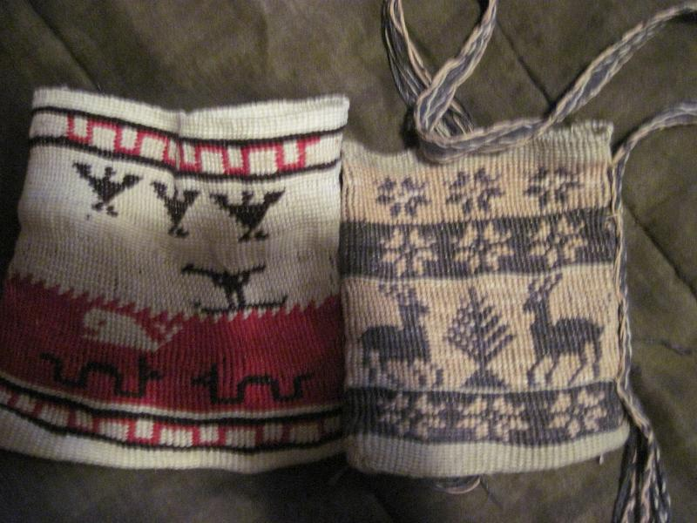
Kunepeum (welcome) to Native Writing and Rhetorics. In this course we will be reading a variety of writings which move across traditional boundaries (such as poetry, fiction, theory, activist and so on) and doing projects to experience a broader scope of Indigenous rhetorics. Many of you will enter this course with preconceived notions of Native peoples primarily because of the many misrepresentations that have shaped our perceptions. We will begin with some of these ideas to explore how and why you have come to internalize them, and we will work to a fuller and richer understanding of Native peoples and cultures. We will read broadly and deeply and still will not be able to read everything. Yet, we will read a substantial amount for each class. You will also explore
something on your own to share with the class, and you will each find an area which warrants more attention for the final projects. We will sometimes have guests from local native communities or see presentations from Native peoples who will provide their own perspectives on Native peoples of southeastern Massachusetts. We will also talk and read and listen and make and write. We will see how Native peoples engage in meaning-making and learn new stories about Native writing and rhetorics.

A few questions to consider:

- What do we mean by Indigenous rhetorics?

- How do we define things like writing, texts, digital, visuals, performance, and materials?

- How do our cultural biases influence our interpretations?

- How do Native peoples present their worldviews?

- How do “marginalized” groups deal with colonization and dominance?

- How do we become more aware of inscribed images and stereotypes?

- How do we re-inscribe a variety of images or materials to better represent Native perspectives?

Some objectives include, but are not limited to, the following:
- Identifying and exploring your own understanding of Native peoples and places, particularly in southeastern MA.
- Broad general knowledge of the field Indigenous rhetorics.
- Experience of negotiating and thinking through questions of the field.
- Develop an understanding of Native men’s and women’s roles within a variety of communities.
- Develop an understanding of writings by Native peoples and what constitutes writing.
- Bring a variety of theories into conversations with each other.
- Situate your own scholarly projects.
- Gain professional training in conference presentations.

Required Texts and Materials:
A set of readings will be posted to my website www.joycerain.com . You are responsible for bringing these readings to class.
A way of taking notes (notebook or digital)
A pen or pencil
Materials for map and final project.

Class Assignments and Projects:

Readings: For each class you will be asked to read one or more pieces which will enrich our understanding. Each of you will be assigned a day where you will begin our class discussion around these readings. You are also expected to write a critical response to the set of readings (see next).

Critical responses: For each set of readings, you are expected to write a single-spaced one-page critical response. These one-pagers are assigned to express your active engagement with the readings: what you glean from the readings, how you make connections to your own experiences, other readings, your writing, work of the class and so on. You may consider how the readings contribute to your understanding of Indigenous rhetorics and the writings by Native peoples, what relationships they might have to your learning, identity, and other aspects of your experiences, and/or connections among the class readings and your own readings. You might also create a list of questions that these readings raise which can be brought to our class discussions. These responses must be completed before each class, and you must bring a hard copy to each class for peer response. You will also keep these to comment on in the reflective paper.

Inkshedding: Inkshedding is a social form of freewriting that encourages deeper engagement with concepts through written dialogue. In this class, we will use inkshedding with our one-pagers at the beginning of class. Procedure: Pass your one-pager to the right. Read your neighbor’s writing all the way through and then underline a sentence or two that stands out as interesting or intriguing. Then, flip the page over, and write a response. This response should not be evaluative (i.e. “good job!”), but written to continue the conversation on paper – to continue the writer’s thinking, pose questions raised by the writer’s thoughts, reflect on what the writer said. When you’re done, look for another person who has finished writing and swap one-pagers. The goal is for each one-pager to receive at least two responses. Once each piece has two sets of responses, we will return the one-pagers to the writers. We will then use these written conversations to start the class discussion, and I will collect the one-pagers at the end of class (assignment and description written by Dr. Michelle Cox). Due: As homework for each class

Stereotypes and Realities Presentation: For this assignment, ala Dunbar-Ortiz’s and Gilio Whitaker’s “All the Real Indians Died Off” and 20 Other Myths about Native Americans, you will be given a list of commonly-held beliefs about Native peoples and cultures. You will draw one of these topics from a hat, and you will read that particular chapter as well as do some research on your own. You will prepare a ten-minute presentation for the class on how you expand your understanding of Native Writing and Rhetorics through this particular piece. Each day one-two of you will present. Your may pair up with someone for this presentation (15 minutes). You will also need to write a one-page summary of your presentation and hand it in. Due: as assigned

You Must Make Your Own Map: We are mostly taught how to analyze discourses and rhetorical situations without understanding our own. This project allows you to think critically about your own practices and the spaces from which they emerge. It’s about learning to understand spaces and places you occupy as power systems. It requires you create a map of your homeland or a physical space that holds meaning for you. Once you have done so, you will begin to overlay Indigenous spaces onto your map to see how the land and power structures shifted. It will also require you to create a cultural and spiritual “map” as you examine the ways in which these influence your physical space. While you may use a variety of ways to produce your map, a handout will be provided to offer more details and suggestions. Due: October 2

Mid-term A take-home mid-term will be handed out during week four with several short essay questions.
Due: October 30

Final Project: There will be handouts available to explain writing a proposal, abstract, annotated bibliography, and literature review. I will provide some examples for you to review before you decide on your own topic. You have a choice from these options, but you must meet with me to get approval of your project:
- A fifteen-minute conference presentation that explores some aspect of Native Writing and Rhetorics as you have come to understand these and as drawn upon through scholarly research. Because you are preparing conference presentation, this option requires that you include the following:
  - A 200-250 word conference proposal (ideally for a future conference such as the BSU symposium)
  - A 150-200 word abstract to be included with your paper
  - A literature/materials review or annotated bibliography using primary and secondary sources (3-5 pages)
  - A written conference paper (10-12 pages) which will be read/orated along with visuals or tactiles (see next)
  - Visuals: PPT , overheads, handouts, digital, visual or material rhetorics which will be presented with your paper
- Create a teaching unit on Native Rhetorics. Include the following:
- A 200-250 word proposal
- A cover letter which offers a description of the teaching unit. Include the institutional and curricular contexts and a review of the components (literature review, material review, etc). (3-5 pages)
  - Weekly schedule with descriptions of the focus and approaches used
  - Assignments and activities as written for the students
  - List of materials needed/provided
  - Assessment tool
- Create a multi-genre case study using primary and secondary sources on Native rhetorics which takes into account the following:
- A 200-250 word proposal describing the purpose of the project
- A project which includes multi-forms (this may take shape as a performance or video. If you choose this form, let’s talk)
- A literature/scholarship review (3-5 pages)
- Demonstration/presentation of your project
- The completed multi-genre project (equivalent to 10 pages of writing)
- A 2-3 page reflection on the research and process of the project.
DUE: December 18 by noon in my office

Reflection on the Course: At the end of the course and included with your final project, you must write a reflection on the course. This can be in the form of a letter or essay or any other creative way you would like to present it. In it, you should discuss your understanding of Native peoples and cultures before and after the course. You should also specifically mention which articles, films, events, discussions (etc.) helped to shape your thinking around the issues. Also discuss which were not as useful and what you think might be valuable as the course is taught again. As well, discuss your participation and contributions along with the work you did.
DUE: December 18 by noon in my office

Evaluating Your Work

20% Class Participation: At the upper-levels of college, you should be actively engaged in the class. This means reading all the materials, responding in a critical manner, taking part in discussions and workshops and being prepared. I value your insights regarding class materials and the nature of our discussions. This kind of participation allows us as scholars to engage in thoughtful discussions and, ultimately, new levels of learning. This also means up to a twenty-point difference in your final grade.

15% Homework: Homework is a priority and includes anything you are asked to do before the next class meeting. Unless you have a strong reason, no late homework will be accepted. Not coming to workshops with a draft of your project steps will result in a zero. One pagers not posted will receive the same. If the responses are less than a page or do not show evidence of thoughtful response, they will receive half or zero credit.
15% Map Project
20% Midterm
30% Final Project and Course Reflection Project: Your final project and presentations as well as your course reflection will constitute this grade.

Note: I have marked several places on the tentative schedule as extra credit opportunities. To obtain extra credit for these, you must attend the event (for full time if a film/speaker; for at least two hours of powwow) and then write a one-page, single-spaced response to be handed in. The response must include what you observed and how it informed you. Let me know beforehand if you are taking advantage of this opportunity.
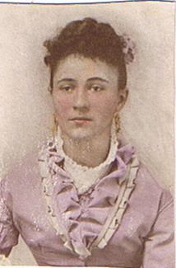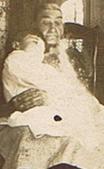
Your ancestors sit on your shoulders to keep your feet on the ground.

Attendance, Plagiarism and Other Suggestions
1. In Native communities, we talk about the four Rs: Reverence, Reciprocity, Respect, and Responsibility. I make every attempt to conduct my personal and professional life under these four Rs. I hold great admiration for each of you and for the work we will do together. We are in a space of sharing gifts of learning with one another. As with any endeavor, there are responsibilities that we take on and expectations that need to be fulfilled. It goes without saying that respectful behavior is expected from all of us. Respecting one another includes coming to class on time and prepared as well as being present and engaging in deep listening as well as contributing. While we may disagree, and I hope we will, there are ways to challenge and ask difficult questions in ways that do not devalue anyone in the room.
2. You must come to class on time. While things happen such as illness, car troubles, unplanned events, try to make every class. After four missed classes (equally two weeks), your grade will be affected; miss six classes and do not expect to pass the course. If you are habitually late or you are not taking the class seriously, your grade will be affected. Likewise, please do not make appointments for advising during our class time
3. Plagiarism—we all know that this is intellectual theft. Bottom line, don’t do it. It’s a serious offense that could not only jeopardize your grade, but has other serious consequences. This is a link to BSU’s Academic Integrity Policy: http://catalog.bridgew.edu/content.php?catoid=10&navoid=970
4. Electronic devices are a huge distraction, but sometimes necessary to the classroom. Unless your laptop or tablet is open to the reading we are discussing or being used in sharing writing for this class, you must keep it closed or put away. Too often, I’ve had to ask students to close their laptops because they are not present in this class, and I do not like to embarrass you. Likewise, your cellphones should also be used for purposes of our class. While I know people expect you to be on call 24/7, most things can wait. If there is a pressing reason why you must have access to your phone, let me know.
5. Please let me know if you have a preferred name or preferred pronouns. I will expect the class to respect your preferences.
6. Feel challenged—one of the great things about this work is that we are still breaking some new ground. While the reading load is very heavy, there is still so much more. If you find something that looks interesting, bring it in or discuss it in your responses. Enjoy the learning, work hard at it, and open yourself to thinking in challenging ways.
7. Talk to me—I make myself available in multiple ways. Let me know if there are any issues before they grow.
8. Have a sense of humor.
9. Take risks

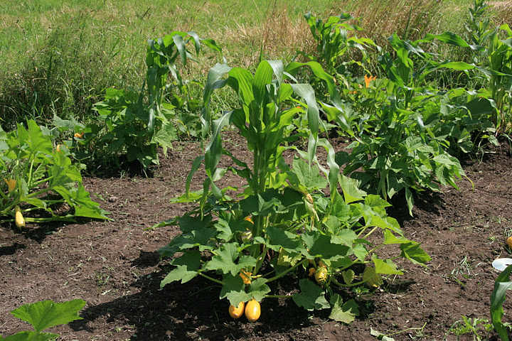
Three Sisters Garden

<->Tentative Schedule<->
(This schedule is subject to change with sufficient notice to participants.)

 | WEEK 1 Introduction to the course
September 6 | Smudging…“The Thanksgiving Address”; Prior knowledge activity –what do we know?  Introductions  Brief Overview; go over syllabus.  Homework for next class: Read—(1) Berkofer, (2) LePore, How to Read a Document, and (4) the Introduction to “All the Real Indians Died Off.” Watch--We Shall Remain: After the Mayflower. Post a one-page response; bring a copy to class.
 | WEEK 2
 | Last Day for Add/Drop 9-14
September 11 | Reintroduce ourselves  Inkshedding and discussion.  Sign up for S&R Presentation  Writing Groups to discuss Project 1: You Must Make Your Own Map  Homework for next class: Read—Kimmerer “The Three Sisters”” excerpt from Awiakta, and excerpt from The Land Has Memory Post a one-page response; bring a copy to class
September 13 | Inkshedding and discussion.  Visit to the Three Sisters Garden (weather permitting) and creative endeavor  Project I discussion  Homework for next class: Read excerpts from Powell “Rhetorical Powwows” and excerpts from Braiding Sweet Grass (Kimmerer) Post a one-page; bring a copy to class. Work on Project 1 and bring ideas to class
 | WEEK 3
September 18 | S&R Presentation by _____________________________  Inkshedding and discussion.  Making Project  Writing Groups to discuss Project 1  Homework for next class: Read Gould, Harjo, “Map to the Next World,” and “ Land as Pedagogy (Simpson). Write a one-page response; bring a copy to class.
September 20 | S&R Presentation by _____________________________  Inkshedding and discussion.  Writing Groups to discuss Project 1  Homework for next class: Read Lyons “Rhetorical Sovereignty,” excerpts from Firsting and Lasting (O’Brien), and Powell “River” Write a one-page response; bring a copy to class
 | WEEK 4
September 25 | S&R Presentation by _____________________________  Inkshedding and discussion.  Homework for next class: Read excerpts from A Common Pot (Brooks). Write a one-page response and bring a copy to class. Prepare Project I for Peer Review.
September 27 | S&R Presentation by _____________________________  Inkshedding and discussion.  Peer Review Project I  Homework for next class: Read King, The Truth about Stories; Deloria; and articles on the Bering Strait. Write a one-page response and bring a copy to class. Prepare Project I for handing in.
 | WEEK 5
October 2  *Map Project Due | S&R Presentation by _____________________________  Inkshedding and discussion.  Discuss Midterm  Homework for next class: Read Standing Bear; Zitkala Sa; and Erdrich, “Indian Boarding School” . Read and Explore The Carlisle Indian School website: http://carlisleindian.dickinson.edu/ and Background on “Indian Boarding School..” http://www.english.illinois.edu/maps/poets/a_f/erdrich/boarding/index.htm Write a one-page response on W; bring a copy to class.
October 4 | S&R Presentation by _____________________________  Inkshedding and Discussion  Excerpt from film In the Whiteman’s Image  Homework for next class: Read excerpts from Rethinking Columbus  Write a one-page response; bring a copy to class.
 | WEEK 6
October 9 | Indigenous Peoples Day—Holiday
October 11 | Two Spirit Talk in RCC 201  MAPS due  Midterm Handout  Homework for next class: “Shaking Our Shells,” Driskill Poems and “Two-Spirit People, Body Sovereignty And Gender Self-Determination” Write a response to the event and readings. Share with a classmate to inkshed
 | WEEK 7
October 16 | I will be away giving a talk at the University of Tennessee Knoxville. In lieu of class, please do readings, find someone to share and comment, and work on your midterm.  Readings for class: “Why Educators Can’t Ignore Mascots” “Native Images in Schools and the Racially Hostile Environment,” and watch some of the Smithsonian conference (https://www.youtube.com/watch?v=NWpy7ozOwTU ). Write a one-page response; Share with a classmate to inkshed
October 18 | I will be in Pine Ridge the end of this week. . In lieu of class, please do readings, find someone to share and comment, and work on your midterm.  Homework for next class: Read excerpts from Playing Indian and Lisa King “Revisiting Winnetou”. Read and Explore: Native Appropriations: http://nativeappropriations.com/ Write a one-page response; bring a copy to class.
 | WEEK 8
October 23 | S&R Presentation by _____________________________  Inkshedding and discussion.  Homework for next class: Read excerpts from All Our Relations and articles of NO DAPL. Write a one-page response; bring a copy to class
October 25 | S&R Presentation by _____________________________  Inkshedding and discussion.  Homework for next class: Read “First Fruits” Introduction to and “The Joys of Reading and Writing: Superman and Me” Visit Debbie Reese’s page American Indians in Children’s Literature https://americanindiansinchildrensliterature.blogspot.com/ Write a one-page response; bring a copy to class  Work on midterm due next Monday
 | WEEK 9
October 30  *Midterm Due* | S&R Presentation by _____________________________  Inkshedding and Discussion  Groups to Discuss Final Project  Homework for next class: “Coyote and the Pebbles,” “Moshup”(W) and Laura Weaver on Creation Stories. Write a one-page response; bring a copy to class.  Write proposal for Final Project (see handout)
November 2  EXTRA CREDIT | Robin Wall Kimmerer presents this on Thursday afternoon in DMF Auditorium (Science Building 120). If you attend and write a one-page critique, you can get extra credit.
November 1 | S&R Presentation by _____________________________  Inkshedding and Discussion  Short Film (A Seat at the Table or In Light of Reverence)  Groups to Discuss Final Project proposals.  Homework for next class: Read excerpts from Like a Hurricane and “The Rhetoric of Activism” and “Walking with Our Relatives” Watch Wounded Knee: https://www.youtube.com/watch?v=Opbxnuw0Dw0 Write a one-page response; bring a copy to class  Revise proposal and gather resources
 | WEEK 10
November 6 | S&R Presentation by _____________________________  Inkshedding and Discussion  Homework for next class: Read “The Politics of Pottery” and NAGPRA Write a one-page response; bring a copy to class.
November 8  FRIDAY SCHEUDLE—NO CLASS | Homework for next class: Read “The Politics of Pottery” and NAGPRA Write a one-page response; bring a copy to class.
 | WEEK 11
November 13 | S&R Presentation by _____________________________  Inkshedding and Discussion  Groups to discuss final project resources; annotated sources  Homework for next class: Read “Metacom(ic)Moments” “The Long Shadow of King Philip’s War” Write a one-page response; bring a copy to class: Work on Final Project
November 15 | S&R Presentation by _____________________________  Inkshedding and Discussion  Groups to discuss final project  Homework for next class: Read “Wampum as Hypertext” and “Visual Folk Art” and Moosehair Embroidery. Visit On the Wampum Trail https://wampumtrail.wordpress.com/ Write a one-page response; bring a copy to class. Prepare Final Project for Peer Review.
 | November 18th is the last day to withdraw from a class
November 19 | BSU/MCNAA National Native American Heritage Month Powwow 11:00-5:00 Kelly Gym. You need to attend, interview a dancer, vendor, or demonstrator and write a 1-2 page report.
 | WEEK 12
November 20 | S&R Presentation by _____________________________  Inkshedding and Discussion  Final Project Peer Review  Homework for next class: Paul Cuffee and Native Whalers. Write a one-page; bring a copy to class.
November 22 | S&R Presentation by _____________________________  Inkshedding and Discussion  November 23-24 Fall Feast Holiday Break. Enjoy connecting with relations  Homework for next class: Work on Final Projects
 | WEEK 13
November 27 | S&R Presentation by _____________________________  Catch-up Discussion  Updates on Final Projects  Homework for next class: Read “Culture Coming Out of the Ground” and Oren Lyons Interview. Write a one-page; bring a copy to class.
November 29 | S&R Presentation by _____________________________  Inkshedding and Discussion  Work in groups for Final Projects  Homework for 4/28: Read Carceri vs. Salazar and “Indian Gaming.” Write a one-page; bring a copy to class.
 | Student Research Symposium—Extra Credit for presenting
 | WEEK 14
December 4 | Inkshedding and Discussion  Updates on final projects  Homework for next class: Read “Seeds and Soil” and “Food sovereignty as decolonization” Read and Explore Food Sovereignty Guide: http://www.tribalcollegejournal.org/archives/2343 Write a one-page; bring a copy to class.
December 6 | Inkshedding and Discussion  Mini reports on final projects
December 11  Extra Credit | Student Research Symposium—Extra Credit for presenting
 | WEEK 15
December 11 | Final Reflections and Gathering
 | Classes end on December 12: Reading Day is December 13: Finals are December 18-21
December 20 | Final Projects and Reflection Due in my office (Tillinghast 320) by 2:00 pm

