ENGL 511: Native Writing and Rhetorics Dr. Joyce Rain Anderson
Fall 2016 Tillinghast Hall 320
TH 4:45-7:25 in LIB 214 508.531.2508
Office hours: M 3:30-4:30 joycerain.anderson@bridgew.edu TTH 8:15-9:15
TH 11:00-12:00 in CMA
and by appointment

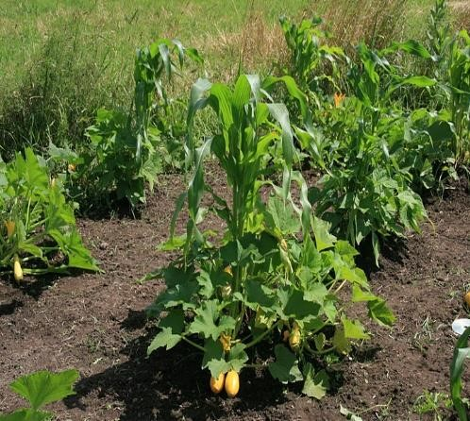
Kunepeum (welcome) to Native Writing and Rhetorics. In this course we will be reading a variety of writings which move across traditional boundaries (such as poetry, fiction, theory, activist and so on) and doing projects to experience a broader scope of Indigenous rhetorics. Many of you will enter this course with preconceived notions of Native peoples primarily because of the many misrepresentations that have shaped our perceptions. We will begin with some of these ideas to explore how and why you have come to internalize them, and we will work to a fuller and richer understanding of Native peoples and cultures. We will read broadly and deeply and still will not be able to read everything. Yet, we will read a substantial amount for each class. You will also explore
something on your own to share with the class, and you will each find an area which warrants more attention for the final projects. We will sometimes have guests from local native communities or see presentations from Native peoples who will provide their own perspectives on Native peoples of southeastern Massachusetts. We will also talk and read and listen and make and write. We will see how Native peoples engage in meaning-making and learn new stories about Native writing and rhetorics.

Some objectives include, but are not limited to, the following:
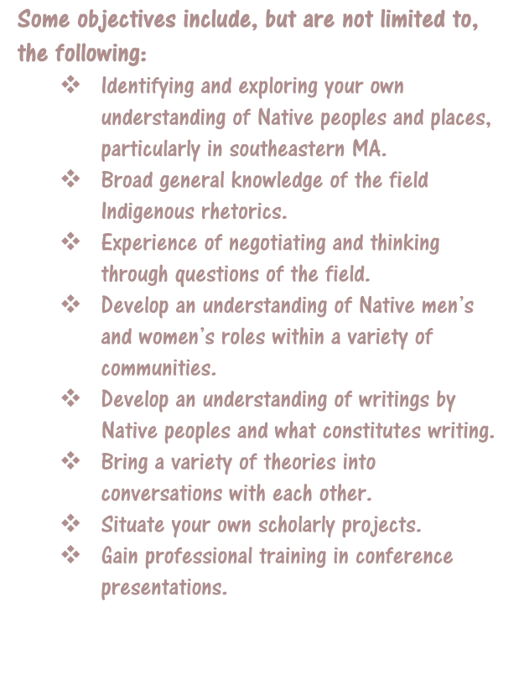
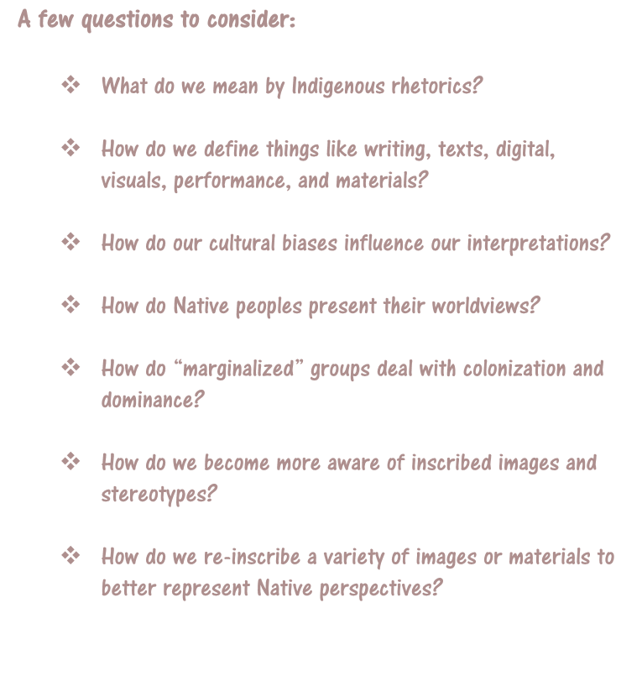
 Identifying and exploring your own understanding of Native peoples and places, particularly in southeastern MA.  Broad general knowledge of the field Indigenous rhetorics.  Experience of negotiating and thinking through questions of the field.  Develop an understanding of Native men’s and women’s roles within a variety of communities.
Develop an understanding of writings by
❖
Native peoples and what constitutes writing.  Bring a variety of theories into conversations with each other.  Situate your own scholarly projects.  Gain professional training in conference presentations.

A few questions to consider:

- What do we mean by Indigenous rhetorics?

- How do we define things like writing, texts, digital, visuals, performance, and materials?

- How do our cultural biases influence our interpretations?

- How do Native peoples present their worldviews?

- How do “marginalized” groups deal with colonization and dominance?

- How do we become more aware of inscribed images and stereotypes?

- How do we re-inscribe a variety of images or materials to better represent Native perspectives?

Class Assignments and Projects:

Readings: For each class you will be asked to read one or more pieces which will enrich our understanding. Each of you will be assigned a day where you will begin our class discussion around these readings. You are also expected to write a critical response to the set of readings (see next).

Critical responses: For each set of readings, you are expected to write a single-spaced one-page critical response. These one-pagers are assigned to express your active engagement with the readings: what you glean from the readings, how you make connections to your own experiences, other readings, your writing, work of the class and so on. You may consider how the readings contribute to your understanding of Indigenous rhetorics and the writings by Native peoples, what relationships they might have to your learning, identity, and other aspects of your experiences, and/or connections among the class readings and your own readings. You might also create a list of questions that these readings raise which can be brought to our class discussions. These responses must be posted to our Blackboard discussion forum before each class, and you must bring a hard copy to each class for peer response. You will also keep these to comment on in the reflective paper.

Inkshedding: Inkshedding is a social form of freewriting that encourages deeper engagement with concepts through written dialogue. In this class, we will use inkshedding with our one-pagers at the beginning of class. Procedure: Pass your one-pager to the right. Read your neighbor’s writing all the way through and then underline a sentence or two that stands out as interesting or intriguing. Then, flip the page over, and write a response. This response should not be evaluative (i.e. “good job!”), but written to continue the conversation on paper – to continue the writer’s thinking, pose questions raised by the writer’s thoughts, reflect on what the writer said. When you’re done, look for another person who has finished writing and swap one-pagers. The goal is for each one-pager to receive at least two responses. Once each piece has two sets of responses, we will return the one-pagers to the writers. We will then use these written conversations to start the class discussion, and I will collect the one-pagers at the end of class (assignment and description written by Dr. Michelle Cox). Due: As homework for each class

Stereotypes and Realities Presentation: For this assignment, ala Mihesuah’s American Indians; Stereotypes and Realities, you will be given a list of terms and or commonly-held beliefs about Native peoples and cultures to do some research on your own. You will prepare a ten-minute presentation for the class on how you expand your understanding of Native Writing and Rhetorics through this particular piece. Each day one-two of you will present. Your may pair up with someone for this presentation (15 minutes). You will also need to write a one-page summary of your presentation. Due: as assigned

You Must Make Your Own Map: We are mostly taught how to analyze discourses and rhetorical situations without understanding our own. This project allows you to think critically about your own practices and the spaces from which they emerge. It’s about learning to understand spaces and places you occupy as power systems. It requires you create a map of your homeland or a physical space that holds meaning for you. Once you have done so, you will begin to overlay Indigenous spaces onto your map to see how the land and power structures shifted. It will also require you to create a cultural and spiritual “map” as you examine the ways in which these influence your physical space. While you may use a variety of ways to produce your map, a handout will be provided to offer more details and suggestions. Due: October 3

5-8 Page Rhetorical Analysis of any contemporary film or book about Native peoples or about Native appropriations in the fashion industry*. Use at least four scholarly sources to support your claims. Due: October 31

Final Project: There will be handouts available to explain writing a proposal, abstract, annotated bibliography, and literature review. You have a choice from these options:
- A fifteen-minute conference presentation that explores some aspect of Native Writing and Rhetorics as you have come to understand these and as drawn upon through scholarly research. Because you are preparing conference presentation, this option requires that you include the following:
  - A 200-250 word conference proposal (ideally for a future conference such as the BSU symposium)
  - A 150-200 word abstract to be included with your paper
  - A literature/materials review or annotated bibliography using primary and secondary sources (3-5 pages)
  - A written conference paper (10-12 pages) which will be read/orated along with visuals or tactiles (see next)
  - Visuals: PPT , overheads, handouts, digital, visual or material rhetorics which will be presented with your paper
- Create a teaching unit on Native rhetorics. Include the following:
  - A 200-250 word proposal
  - A cover letter which offers a description of the teaching unit. Include the institutional and curricular contexts and a review of the components (literature review, material review, etc). (3-5 pages)
    - Weekly schedule with descriptions of the focus and approaches used
    - Assignments and activities as written for the students
    - List of materials needed/provided
    - Assessment tool
- Create a multi-genre case study using primary and secondary sources on Native rhetorics which takes into account the following:
  - A 200-250 word proposal describing the purpose of the project
  - A project which includes multi-forms (this may take shape as a performance or video. If you choose this form, let’s talk)
  - A literature/scholarship review (3-5 pages)
  - Demonstration/presentation of your project
  - The completed multi-genre project (equivalent to 10 pages of writing) o A 2-3 page reflection on the research and process of the project. DUE: December 20 in my office

Reflection on the Course: At the end of the course and included with your final project, you must write a reflection on the course. This can be in the form of a letter or essay or any other creative way you would like to present it. In it, you should discuss your understanding of Native peoples and cultures before and after the course. You should also specifically mention which articles, films, events, discussions (etc.) helped to shape your thinking around the issues. Also discuss which were not as useful and what you think might be valuable as the course is taught again. As well, discuss your participation and contributions along with the work you did.
DUE: December 20 in my office 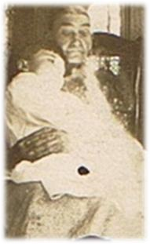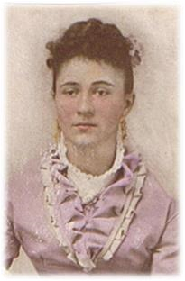

Your ancestors si
t on your shoulders to keep your feet on the ground.

Evaluating Your Work
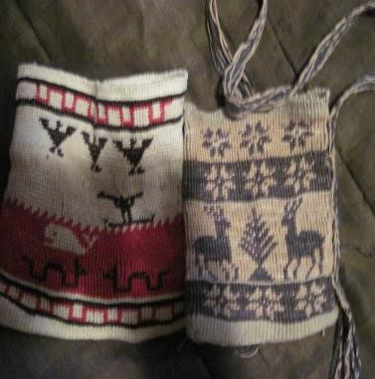
10% Class Participation: At the graduate level, you should be actively engaged in the class. This means reading all the materials, responding in a critical manner, taking part in discussions and workshops and being prepared. I value your insights regarding class materials and the nature of our discussions. This kind of participation allows us as scholars to engage in thoughtful discussions and, ultimately, new levels of learning.
15% Homework: Homework is a priority and includes anything you are asked to do before the next class meeting. Unless you have a strong reason, no late homework will be accepted. Not coming to workshops with a draft of your project steps will result in a zero. One pagers not posted will receive the same. If the responses are less than a page or do not show evidence of thoughtful response, they will receive half or zero credit.
15% Map Project
20% Rhetorical Analysis
40% Final Project and Course Reflection Project: Your final project and presentations as well as your course reflection will constitute this grade.

Attendance, Plagiarism and Other Suggestions
- In Native communities, we talk about the four Rs: Reverence, Reciprocity, Respect, and Responsibility. I make every attempt to conduct my personal and professional life under these four Rs. I hold great admiration for each of you and for the work we will do together. We are in a space of sharing gifts of learning with one another. As with any endeavor, there are responsibilities that we take on and expectations that need to be fulfilled. It goes without saying that respectful behavior is expected from all of us. Respecting one another includes coming to class on time and prepared as well as being present and engaging in deep listening as well as contributing. While we may disagree, and I hope we will, there are ways to challenge and ask difficult questions in ways that do not devalue anyone in the room.
- You must come to class on time. While things happen such as illness, car troubles, unplanned events, try to make every class. After four missed classes (equally two weeks), your grade will be affected; miss six classes and do not expect to pass the course. If you are habitually late or you are not taking the class seriously, your grade will be affected.
- Plagiarism—we all know that this is intellectual theft. Bottom line, don’t do it. It’s a serious offense that could not only jeopardize your grade, but has other serious consequences. This is a link to BSU’s Academic Integrity Policy: http://catalog.bridgew.edu/content.php?catoid=10&navoid=970
- Feel challenged—one of the great things about this work is that we are still breaking some new ground. While the reading load is very heavy, there is still so much more. If you find something that looks interesting, bring it in or discuss it in your responses. Enjoy the learning, work hard at it, and open yourself to thinking in challenging ways.
- Talk to me—I make myself available in multiple ways. Let me know if there are any issues before they grow.
- Have a sense of humor.
- Take risks

Tentative Schedule (This schedule is subject to change with sufficient notice to participants.)

 | WEEK 1 Introduction to the course
September 12 | Smudging and “Eagle Poem” Introductions; go over syllabus; discussion of stereotypes. Corn Mother and Makings  Homework: Read The Truth about Stories, Berkofer, and Firsting and Lasting . Skim the Introduction to American Indians: Stereotypes and Realities. Post a one-page response on W; bring a copy to class. From list choose 2-3 possibilities for your presentation.
 | WEEK 2
September 19 | Inkshedding and discussion.  Choosing presentation dates and topics. Writing groups for Project 1  We Shall Remain: After the Mayflower (film)  Homework: Powell-“Rhetorical Powwows” excerpts from The Land Has Memory, and A Common Pot check out http://archive.org/stream/indianplacenames00hude/indianplacenames00hude_djvu.txt Post a one-page response on W; bring hard copy to class
 | WEEK 3
September 26 | S&R Presentations  Inkshedding and discussion.  Homework: Read Intro to AIRS and “Rhetorical Sovereignty” “Down by the River” both on W. Check out this website “On the Wampum Trail”: https://wampumtrail.wordpress.com/ . Post a one-page response on W; bring hard copy to class. Work on Project 1
 | WEEK 4
October3 | S&R Presentations  Inkshedding and discussion.  American Indian Voting Rights  Groups to share Project 1  Homework: Deloria, the Bering Strait Articles, Re-Encounter and Rethinking Columbus (W) . Post a one-page response on W; bring hard copy to class. Work on Project 1 to hand in.
October 10 | WEEK 5—Holiday No Class
 | WEEK 6
October 17  Project 1 Due | S&R Presentations  Inkshedding and discussion.  American Indians in Children’s Literature Groups to share Project 2  Homework: Read Standing Bear; Zitkala Sa; and Erdrich, “Indian Boarding School” . Read and Explore The Carlisle Indian School website: http://carlisleindian.dickinson.edu/ and Background on “Indian Boarding School..” http://www.english.illinois.edu/maps/poets/a_f/erdrich/boarding/index.htm Post a one-page response on W; bring hard copy to class.
 | WEEK 7
October 24 | S&R Presentations  Inkshedding and discussion.  Groups to discuss Project 2  Film—In the White Man’s Image (excerpts)  Homework: Read excerpts from “Divorced from the Land,” “All Our Relations”, “Prisoners of History” and Native Women’s History” Work on Project 2 to hand in.
 | WEEK 7
October 31  Project 2 Due | S&R Presentations  Inkshedding and discussion. Making project
Groups to discuss Final Project. Proposal Discussion
Homework: Read excerpts from Playing Indian and Lisa King “Revisiting Winnetou”. Read and Explore: Native Appropriations: http://nativeappropriations.com/ Write final project proposal
 | WEEK 8
November 7 | S&R Presentations  Inkshedding and discussion.  Groups to discuss Final Projects  Homework: Read “Coyote and the Pebbles” and Moshup” “Seeds and Soil” and “Food sovereignty as decolonization” Read and Explore Food Sovereignty Guide: http://www.tribalcollegejournal.org/archives/2343  (W). Post a one-page response on W; bring hard copy to class. Find 4-5 resources for final project and annotate.
 | WEEK 9
November 7 | S&R Presentations  Inkshedding and discussion.  Homework: Read excerpts from Like a Hurricane , “The Rhetoric of Activism” and “Joining the Rounddance  Draft final project
 | WEEK 10
November 14 | S&R Presentations  Inkshedding and discussion: AIM and Idle No More.  Film—either Finding Dawn or Alcatraz is Not an Island  Homework: Read Metacom(ic) Moments,” “The Long Shadow of King Philip’s War. Post a one-page response on W; bring hard copy to class. Work on Final Project
 | WEEK 11
November 21 | S&R Presentations  Inkshedding and discussion.///  Film—We Still Live Here: Âs Nuyetân  Making project  Read: “Wampum as Hypertext” “Visual Folk Art” “The Politics of Pottery” Post a one-page response on W; bring hard copy to class.
 | WEEK 12
November 28 | S&R Presentations  Inkshedding and discussion.  Review of final projects—bring copies to class  Homework: Read “Why Educators Can’t Ignore Mascots” “Native Images in Schools and the Racially Hostile  Environment,” and watch some of the Smithsonian conference  (https://www.youtube.com/watch?v=NWpy7ozOwTU ). Work on Final Projects and presentations
 | WEEK 13
December 5 | Presentations
 | WEEK 14
December 12 | Presentations?
 | Final Projects and Reflections due in my office on December 19

