ENGL 493: Rhetorical Bodies Dr. Joyce Rain Anderson
Fall 2014 Tillinghast Hall 320
MW 12:20-1:35 in ROOM 508.531.2508
Office hours: MW 8:30-9:30 joycerain.anderson@bridgew.edu
T 12:30-1:30 in CMA
T 3:00-4:30 and by appointment

I think; therefore, I am. Rene Descartes | I am because I think and do. Malea Powell

ENGL 493: Seminar in Writing Studies: Rhetorical Bodies and Public Perceptions

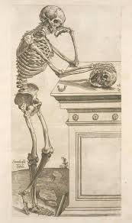
We often think of rhetoric in terms of the spoken or written word, but rhetoric does not just exist in words, it exists in and through bodies. Our bodies are marked by gender, race, abilities, and sexuality and set against standards and norms of cultures. Just by sitting here in this room, we are aware of our own bodies and the bodies surrounding us. As much as we think we know what bodies should be like, we are often frustrated, even confused, when these bodies don’t conform to what we perceive. This seminar will investigate theoretical and rhetorical approaches to the body and how the body has been shaped by public perceptions over time. Our readings will explore the intersections of embodiment, gender, physical abilities, sexuality, race, power, and more. We will investigate how cultural manifestations of the body and (mis)representations of bodies reflect and or challenge ideologies of Western culture.

A few questions to consider:
- What do we mean by rhetorics? What is the body? What are the body’s capabilities?
- What does it mean to represent the body? When we discuss the body, whose body is represented?
- What is a “raced” body? How does a body become gendered or sexed?
- What does the “universal” or “ideal” body look like?
- In what ways does the body become modified? How are these modifications represented?
- How does age, weight, ability, height, physique, etc. shape our perceptions of the body? Who decides what a “normal” body is or should be?

Some objectives include, but are not limited to, the following:

- Demonstrate an understanding of critical concepts and theories of rhetorics and embodied rhetorics.
- Demonstrate and understanding of how representations of the body have an historical legacy, and how these representations sought to privilege and control bodies.
- Experience and negotiate thinking through questions in the field.
- Bring a variety of theories into conversations with each other.
- Demonstrate an ability to conduct research and situate your own scholarly projects.
- Gain experience in written scholarship and conference presentations.

Required Texts and Materials:
A set of readings will be available on a webpage www.joycerain.com (you should bring the readings to class by either printing them or on your laptop or tablet).

Read around on this:
http://embodythis.wordpress.com/

Class Assignments and Projects:

Critical responses: For each set of readings, you are expected to write a single-spaced one-page critical response. These one-pagers are assigned to express your active engagement with the readings: what you glean from the readings, how you make connections to your own experiences, other readings, your writing, work of the class and so on. You may consider how the readings contribute to your understanding of Embodied Rhetorics, what relationships they might have to your learning, identity, and other aspects of your experiences, and/or connections among the class readings and your own readings. You might also create a list of questions that these readings raise which can be brought to our class discussions. These responses must be posted to our Blackboard discussion forum before each class, and you must bring a hard copy to each class for peer response. My expectation is that you will use these to contribute to class discussions each time we meet. You will also keep these to comment on in the reflective paper.

Inkshedding: Inkshedding is a social form of freewriting that encourages deeper engagement with concepts through written dialogue. In this class, we will use inkshedding with our one-pagers at the beginning of class. Procedure: Pass your one-pager to the right. Read your neighbor’s writing all the way through and then underline a sentence or two that stands out as interesting or intriguing. Then, flip the page over, and write a response. This response should not be evaluative (i.e. “good job!”), but written to continue the conversation on paper – to continue the writer’s thinking, pose questions raised by the writer’s thoughts, reflect on what the writer said. When you’re done, look for another person who has finished writing and swap one-pagers. The goal is for each one-pager to receive at least two responses. Once each piece has two sets of responses, we will return the one-pagers to the writers. We will then use these written conversations to start the class discussion, and I will collect the one-pagers at the end of class (assignment and description written by Dr. Michelle Cox).

Embodied Rhetorics Presentation: For this assignment, you will research a visual/media representation of the body. Prepare a ten-minute presentation for the class. Each day one-two of you will present. Your may pair up with someone for this presentation.

Mapping the Body: We are mostly taught how to analyze discourses and rhetorical situations without understanding our own. This project allows you to think critically about your own practices and the spaces from which they emerge. It’s about learning to understand spaces and places you occupy as power systems. It requires you create a map of your physical space and how you are situated in that space. While you may use a variety of ways to produce your map, a handout will be provided and will contain more details and suggestions. Due: September 25.

Mid-term Short Essay (5-6 pages): This assignment gives you two options:
- Write an essay that brings at least four of our readings together around a theme we have been discussing.
- Write an extended film review or a rhetorical analysis of any contemporary film. Develop an argument as to how bodies are situated in this film and what are the responsibilities of a filmmaker. Use at least two scholarly sources to support your claims.
Due: October 16

Final Project: You have a choice of these options:
- A fifteen-minute conference presentation that explores some aspect of Embodied Rhetorics as you have come to understand these and as drawn upon through scholarly research. Because you are preparing conference presentation, this option requires that you include the following:
  - A conference proposal (ideally for the Undergraduate Conference at BSU or another conference)
  - A 150-200 word abstract
  - A literature/materials review or annotated bibliography using primary and secondary sources (Note: a literature review is a discussion of the resources you are using).
  - A written conference paper (12-15 pages) or multigenre project (with an equivalency of writing) which will be presented along with visuals or tactiles (see next)
  - Visuals: PPT , Prezi, digital movie, overheads, handouts, digital, visual or material rhetorics which will be presented with your paper
- A case study using primary and secondary sources on embodied rhetorics which takes into account the following:
- A project which incorporates the study of one or more bodies, e.g. a study on diet or working out or a study of a body in film (if you are working with real bodies, you will need to go through an IRB process)
- A proposal of 200-250 words describing the purpose of the project
- A literature/scholarship review
- Demonstration/presentation of your project
- The completed case study
- A one-two page reflection on the research and process of the project.

- Create a multi-genre project using primary and secondary sources on embodied rhetorics which takes into account the following:
- A project which includes multi-forms (this may take shape as a performance or video. If you choose this form, let’s talk)
- A proposal of 200-250 words describing the purpose of the project
- A literature/scholarship review
- Demonstration/presentation of your project
- The completed multi-genre project
- A one-two page reflection on the research and process of the project.
DUE: In my office on December 12 by noon.

Reflection on the Course: At the end of the course and included with your final project, you must write a reflection on the course. This can be in the form of a letter or essay or any other creative way you would like to present it. In it, you should discuss your understanding of embodied rheotrics before and after the course. You should also specifically mention which articles, films, events, discussions (etc.) helped to shape your thinking around the issues. Also discuss which were not as useful and what you think might be valuable as the course is taught again. As well, discuss your participation and contributions along with the work you did.
DUE: In my office on December 12 by noon.
Evaluating Your Work

15% Class Participation: In a senior seminar, you should be actively engaged in the class, and I expect you will have something to say in every class. This means reading all the materials, responding in a critical manner, taking part in discussions and workshops and being prepared. I value your insights regarding class materials and the nature of our discussions. This kind of participation allows us as scholars to engage in thoughtful discussions and, ultimately, new levels of learning.
10% Homework: Homework is a priority and includes anything you are asked to do before the next class meeting. Unless you have a strong reason, no late homework will be accepted. Not coming to workshops with a draft of your project steps will result in a zero. One pagers not posted will receive the same. If the responses are less than a page or do not show evidence of thoughtful response, they will receive half or zero credit.
15% Map Project
20% Midterm Short Essay
40% Final Project and Course Reflection Project: Your final project and presentations as well as your course reflection will constitute this grade.

Note: I have marked several places on the tentative schedule as extra credit* opportunities. To obtain extra credit for these, you must attend the event (for full time if a film/speaker; for at least two hours of powwow) and then write a two-page, single-spaced response to be handed in. The response must include what you observed and how it informed you. Let me know beforehand if you are taking advantage of this opportunity; likewise, if you hear of an event that may also qualify for extra credit, get permission to use it as such before you attend.

Attendance, Plagiarism and Other Suggestions
1. You must come to class on time. While things happen such as illness, car troubles, unplanned events, try to make every class. After four missed classes (equally two weeks), your grade will be affected; miss six classes and do not expect to pass the course. If you are habitually late or you are not taking the class seriously, your grade will be affected.
2. Plagiarism—we all know that this is intellectual theft. Bottom line, don’t do it. It’s a serious offense that could not only jeopardize your grade, but has other serious consequences.
3. Respect—a most important part of a class is respectful behavior. While we may disagree, and I hope we will, there are ways to challenge and ask difficult questions in ways that do not devalue anyone in the room.
4. Feel challenged—one of the great things about this work is that we are still breaking some new ground. While the reading load is very heavy, there is still so much more. If you find something that looks interesting, bring it in or discuss it in your responses. Enjoy the learning, work hard at it, and open yourself to thinking in challenging ways.
5. Talk to me—I make myself available in multiple ways. Let me know if there are any issues before they grow.
6. Have a sense of humor.
7. Take risks

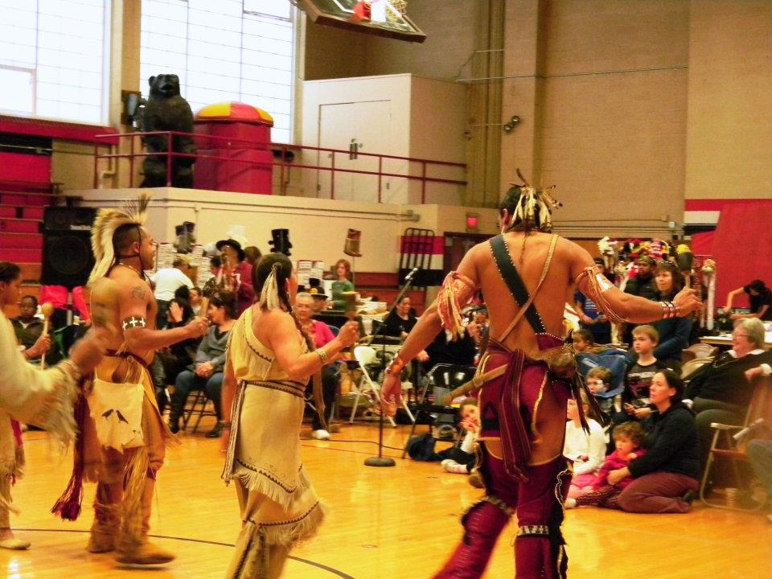

<>Tentative Schedule<>
(This schedule is subject to change with sufficient notice to participants.) *To receive extra credit, see the section on Evaluating Your Work.”

 | WEEK 1 Introduction to the course
September 3 | Introductions; go over syllabus; Prior knowledge. “This Book Called My Body” (sent to your email) discussion. “The Cycle of Socialization: and “Power and Privilege” A little writing about the body.  Homework: Read—Descartes “Meditation IV” andTodd from The Thinking Body and “Food Meditation.” Write and post a one-page response on W; bring a copy to class
 | WEEK 2
September 8 | Reintroduce ourselves  Inkshedding and discussion.  Select dates for mini-presentation  Writing Groups to discuss Project 1  Homework: Read—from Rhetorical Bodies introduction and afterword. Write and post a one-page response on W; bring a copy to class
September 10 | Inkshedding and discussion.  Homework: Read “The Symbolic Body and the Rhetoric of Power,” Symbolizing Motion…,” and “Foucault’s Body Tropes” Write and post a one-page response on W; bring a copy to class
 | WEEK 3
September 15 | Mini presentation by __________________  Inkshedding and discussion.  Homework: Read “Corporeality and culture rhetoric” Write and post a one-page response on W; bring a copy to class
September 17 | Mini presentation by __________________  Inkshedding and discussion.  Homework: Read “Becoming White..,” and “A White Woman of Color.” Write and post a one-page response on W; bring a copy to class
 | WEEK 4
September 22 | Mini presentation by __________________  Inkshedding and discussion.  Homework: Read The Monsterization of Trayvon Martin,” and “Reparations for Ferguson.” Write and post a one-page response on W; bring a copy to class
September 24  * | Mini presentation by __________________  Inkshedding and discussion.  Homework: Read “The mismeasure of masculinity…,” Write and post a one-page response on W; bring a copy to class
 | WEEK 5
September 29 | Mini presentation by __________________  Inkshedding and discussion.  Homework: Read Read “Shrinking Women” (listen to this at https://www.youtube.com/watch?v=zQueWXWXp3k ) and “Cultural Rhetorics of Women’s Corsets” Write and post a one-page response on W; bring a copy to class
October 1 | Mini presentation by __________________  Inkshedding and discussion.  Homework: Read “Constructing Rhetorical Borders” Write and post a one-page response on W; bring a copy to class
 | WEEK 6
October 6 | Ethnic and Indigenous Studies Panel—meet in the Heritage Room  Inkshedding and discussion.  Homework: Read “Acts of Institution.” Write and post a one-page response on W; bring a copy to class
October 8 | Mini presentation by __________________  Inkshedding and discussion.  Homework: Read “What Makes the Man?,” and “’They Say I’m like that but they don’t know me,’” Write and post a one-page response on W; bring a copy to class
 | WEEK 7
October 13* | Holiday (Indigenous Peoples Day)—NO CLASS
October 15 | Mini presentation by __________________  Inkshedding and discussion.  Homework: Read “The Dynamics of Gender Hegemony,” “Speaking the Body/Mind Juncture,” and “Branding Teena” Write and post a one-page response on W; bring a copy to class
 | WEEK 8
October 20 | Mini presentation by __________________  Inkshedding and discussion.  Homework: Read “The Tattoos of Epimenides” Write and post a one-page response on W; bring a copy to class
October 22 | Mini presentation by __________________  Inkshedding and discussion.  Homework: Read “Breathe Upon Us an Uneven Flame” Write and post a one-page response on W; bring a copy to class
 | WEEK 9
October 27 | Mini presentation by __________________  Inkshedding and discussion.  Homework: Read “Unruly Bodies” Write and post a one-page response on W; bring a copy to class
October 29 | Mini presentation by __________________  Inkshedding and discussion.  Homework: Read “Imprisoned Bodies” and excerpt from Discipline and Punish and excerpt from Asylums. Write and post a one-page response on W; bring a copy to class
October 30 | Two Spirit Program in Dunn B (extra credit*)
 | WEEK 10
November 3 | Mini presentation by __________________  Inkshedding and discussion.  Homework: Read Attitudes toward Cosmetic Surgery” and “International Data on Cosmetic Surgery” Write and post a one-page response on W; bring a copy to class
November 5 | Mini presentation by __________________  Inkshedding and discussion.  Homework Homework: Read “Corporeal Knowledges and Deviant Bodies” Write and post a one-page response on W; bring a copy to class
 | WEEK 11
November 10 | Mini presentation by __________________  Inkshedding and discussion.  Homework: Read “Anorexia” —Post a one-page response on W:bring a copy to class
November 12 | Mini presentation by __________________  Inkshedding and discussion.  Homework: Read excerpt from the People Have Never Stopped Dancing Write and post a one-page response on W; bring a copy to class
 | WEEK 12
November 16 | BSU’s 6th Powwow in the Kelly Gym (extra credit*)
November 17 | Mini presentation by __________________  Inkshedding and discussion.  Homework: Read “Age Transcended” Write and post a one-page response on W; bring a copy to class
November 19 | Mini presentation by __________________  Inkshedding and discussion.  Homework: Read “Representing Bodies in Virtual Space” Write and post a one-page response on W; bring a copy to class
 | WEEK 13
November 24 | Mini presentation by __________________  Inkshedding and discussion.  Homework: Read “The hypertext of photography” Write and post a one-page response on W; bring a copy to class
November 26 | Mini presentation by __________________  Inkshedding and discussion.  Homework: Read “The Body and Technology” Write and post a one-page response on W; bring a copy to class
 | WEEK 14
December 1 | Mini presentation by __________________  Inkshedding and discussion.  Homework: Read an article from your research. Write and post a one-page response on W; bring a copy to class
December 3 | Mini presentation by __________________  Inkshedding and discussion.
 | WEEK 15
December 8 | Presentations
December 10 | Presentations
December 12 | Final Projects and Reflection due in my office by noon

