Summer II 2022 Dr. Joyce Rain Anderson

T/TH 4:30-8:15 Tillinghast 320

Synchronous Online Office Hours by appointment

ZOOM LINK: <https://bridgew.zoom.us/j/95686127700?pwd=MngzSFMxUnlBWjREQ1dwZkNxaUZNdz09>

*Rhetoric is not rhetoric until it is uttered, written or otherwise manifested or given presence*—Carole Blair (18).

*…we have to learn to rely on rhetorical understanding different from that singular, inevitable origin story. We have to try harder and overcome the behaviors that sustain colonial discourse in our contemporary practices…. We need, in fact, to move our practices toward “things” toward a wider understanding of how all made things are rhetorical, and how cultures make, and are made by the rhetoricity of things—*Malea Powell (2-3)

<http://www.kb.dk/permalink/2006/poma/titlepage/en/text/>

Kennepeum (Welcome) to Cultural Rhetorics.

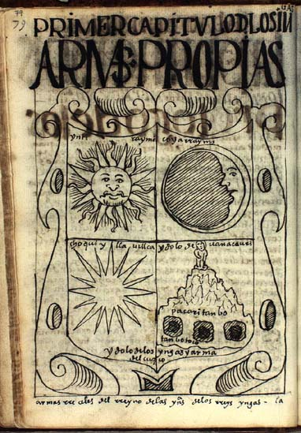

Rhetoric, as we will discuss, is described in broad terms as the creation and analysis of an act of communication or the transmission of emotion and thought to persuade others. Classical rhetoric is usually thought of as the art of persuasion, and most often is studied in terms of speech or writing. Jay Dolmage sees rhetoric as the strategic study of the circulation of power through communication. Ralph Cintron writes, “ For Aristotle, *teckhne*, ‘art’ or ‘craft,’ was associated with a ‘reasoned habit of mind in making something.’” Similarly, Malea Powell argues that we must move from a narrow definition of rhetoric to include “things” and their makings. I understand “things” to mean anything from a speech to an essay to a beaded object to a memorial. In this class, our particular focus on cultural rhetorics means exploring the intersections of rhetorics, cultures .We do so based on the space from which we operate and the ways in which we negotiate and make meanings in this space and how this space has the power to shape our perceptions. We will read about and examine the relationships of rhetoric to race, ethnicity, cultures, gender, class, abilities and so on to understand rhetoric’s

relationship to these constructions and how they intersect and relate to one another. We will explore categories of writing, texts, digital rhetorics, performance, popular culture, material rhetorics, visual rhetorics, race and ethnicity. We will consider decolonial practices and how these interrogate current systems of oppression. Each of you will observe and find examples to help our understanding and lead a class. Our reading will cast a broad and deep net, and you will be expected to do some independent reading to share that with the class through sharing your responses, contributing to class discussions, and making connections to our common readings. Our class discussions will, I hope, be engaging and challenging as we read, write, talk, imagine and create. While you may not always “agree” with what the authors are offering, it is expected that you critically engage with the materials.

As a summer class, the schedule will be packed with reading and writing and other activities. After all, we are condensing a fifteen-week course into five weeks, so be pace your work accordingly. Some readings will take time to digest, so give yourself time to engage with these (not an hour before class).

Some objectives include, but are not limited to, the following:

* Identifying and exploring your own relationship with language, culture, and power.
* Broad general knowledge of the field of cultural rhetorics.
* Experience of negotiating and thinking through questions of the field.
* Develop an understanding of the manifestations of cultural rhetorics within a variety of communities.
* Develop an understanding of the role of rhetorics in maintaining and or disrupting social systems of power and control.
* Bring a variety of theories into conversations with each other.
* Situate your own scholarly projects and pedagogy.
* Gain professional training in conference presentations and/or classroom practices.

A few questions to consider:

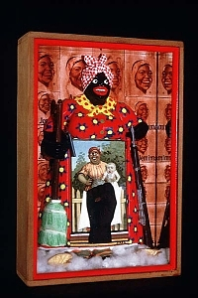

* What do we mean by rhetoric(s)?
* How do we define things like writing, texts, digital,

visuals, performance, makings and materials?

* What is it to represent? (what are the relationships

between the representation and the something that it is of?)

* How do our cultural biases influence our interpretations?
* How does power shape our perceptions?
* How do “marginalized” groups deal with power?
* What is privilege, and how do we use our privilege?
* How do we become more aware of inscribed images?
* How do we re-inscribe a variety of images or materials to *The Liberation of* *Aunt Jemima*

better represent cultural perspectives? *—Betye Saar*

* How does understanding of cultural rhetorics constellate/

influence/enhance teaching, researching, and learning?

Required Texts and Materials:

* A set of readings which will be posted to Blackboard and to my website: [www.joycerain.com](http://www.joycerain.com) (you should create your own file for these readings or print them out to easily access during class)

Class Assignments and Projects:

Critical responses: For each set of readings, you are expected to write a one-page critical response. These one-pagers are assigned to express your active engagement with the readings: what you glean from the readings, how you make connections to your own experiences, other readings, your writing, work of the class and so on. You may consider how the readings contribute to your understanding of cultural rhetorics, what relationships they might have to your teaching, learning, identity, and other aspects of your experiences, and/or connections among the class readings and your own readings. You might also create a list of questions that these readings raise which can be brought to our class discussions. Ideally, you will find intersections of the readings, but you may write more about one than others. You will post these to the discussion board and your peers will respond, so it is important to submit these early enough to give your colleagues time to respond.

Inkshedding*:* Inkshedding is a social form of freewriting that encourages deeper engagement with concepts through written dialogue. In this class, we will use a form of inkshedding with our one-pagers at the beginning of class. Procedure: To do this for an online class, we will use the discussion board. Once you read your peer’s response all the way through, choose one or two sentences/phrases that stand out as interesting or intriguing. This response should not be evaluative (i.e. “good job!”), but written to continue the conversation on paper – to continue the writer’s thinking, pose questions raised by the writer’s thoughts, and/or reflect on what the writer has said. We will use these as points of departure for our class discussions.

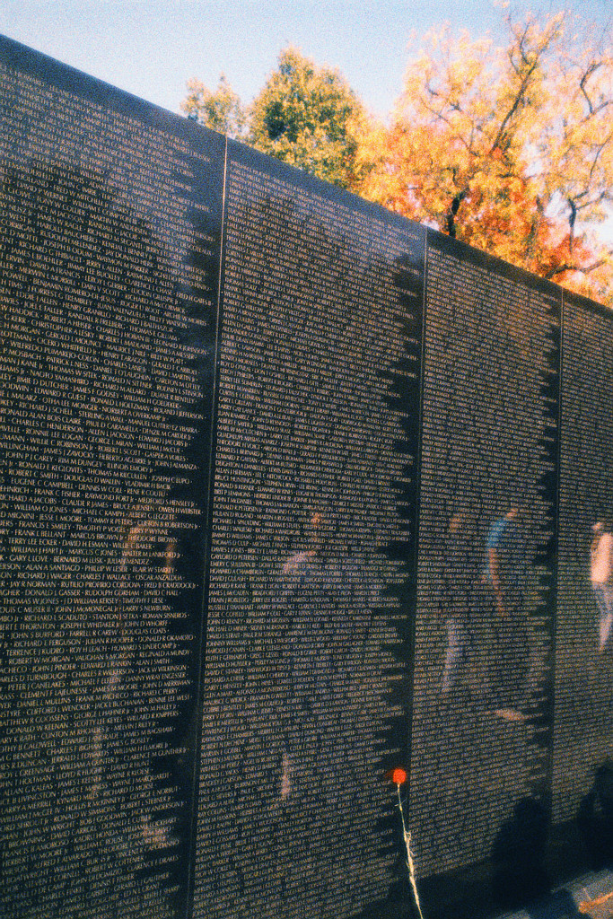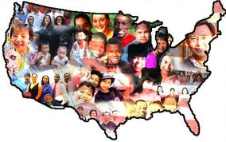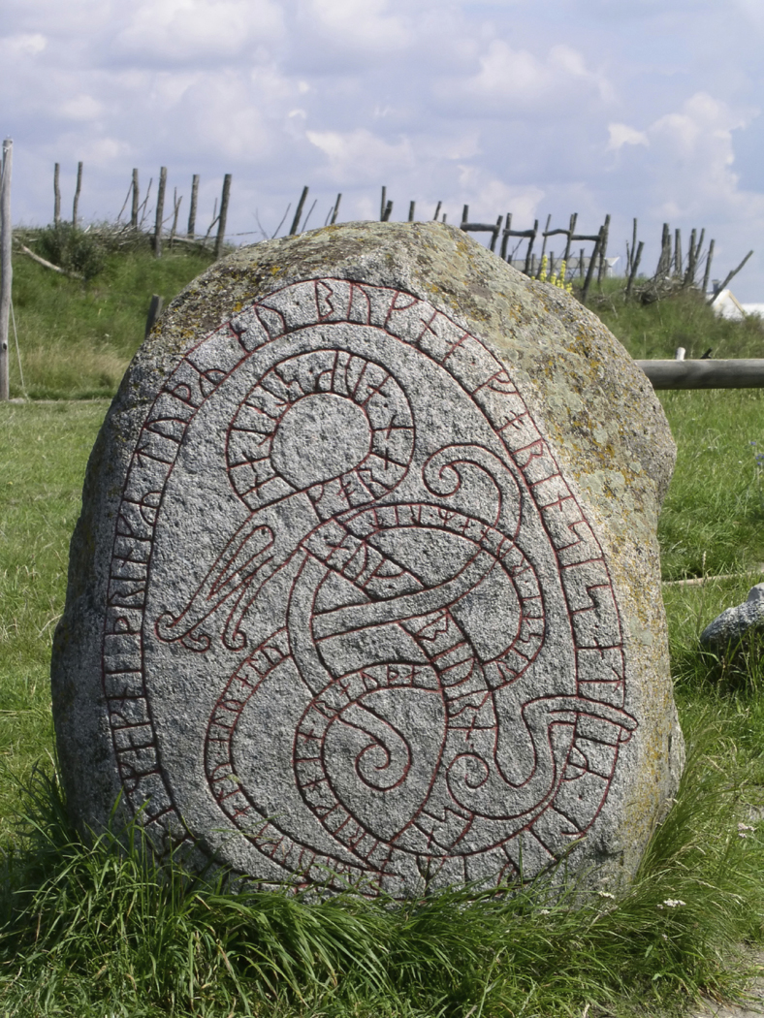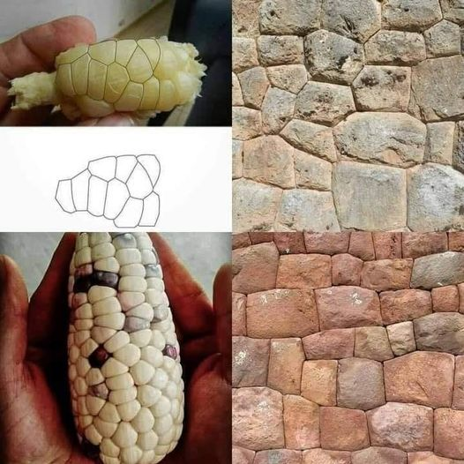

Project 1: A Found Example of Cultural Rhetorics (ongoing, due at end of course)

Each class, one of you will lead with a found example of cultural rhetorics. Look around you when you are out and about, surf the internet and social media, scan and read, observe, listen to find something you might un/re-cover as an artifact of cultural rhetorics. Consider how we’ve been defining cultural rhetorics and explain your artifact. Plan a short presentation on your example. How and why do you see this as an example of cultural rhetorics? Where are the intersections of culture, rhetoric, and power? For example, consider the controversial topic of weed killers and how large corporations like Monsanto control the narrative. Here are some resources:

<https://www.theguardian.com/us-news/2022/jul/09/weedkiller-glyphosate-cdc-study-urine-samples>

<https://www.sierraclub.org/sierra/monsanto-s-big-lie-about-roundup-and-system-enabled-it#:~:text=The%20internal%20communications%20made%20clear,Roundup%2C%20glyphosate%2C%20were%20probably%20carcinogenic>

Project 2: Language and Culture Autobiography (Due July 19)

Many of us identify with our cultural and linguistic history(ies), and exploring these are important to our engagement with many of the readings and theories for this course. When we consider our cultural and linguistic identities, we learn about the space(s) from which we operate, how and why we develop and maintain certain values, beliefs, attitudes and biases. This assignment asks you to create a personal narrative of your relationship to your culture(s) and language(s), both present and historic. You should look at “The Cycle of Socialization” and the “Power and Privilege Checklist” to gain a better understanding of why you have come to understand things as you currently do. You also might consider looking at some of the readings which address language and culture and refer to them although the attention here is on your own. The writing should be a focused narrative, but may take a variety of forms (encouraged): multigenre essay, memoir, personal experience essay, blog, a series of snapshot writing, or other forms including material and visual rhetorics. The presentation is your choice. (For some ideas you might look at the following website: <http://writing.colostate.edu/gallery/multigenre/toc.htm> or see the Romano article.) A former student used a suitcase filled with documents to demonstrate her grandparents’ immigration process.

You will have an opportunity to brainstorm some ideas for the project in breakout groups and share writing/progress. You may also get feedback from me. The final draft will be due July 19.

Project 3: Rhetorical Analysis (Due August 2)

This assignment asks you to look at two-three documents which have been used to shape our perceptions of a culture. At least one of these should be a written text, and at least one should be a visual representation. For example, using a Native American mascot is highly controversial. How do these images promote and maintain the stereotypes of Native peoples? For this example, you can use an image of how fans use “red face” or the “tomahawk chop” along with statements from the American Psychological Association and the National Congress of American Indians.

Be sure to consider documents that span time and not just contemporary representations. Once you have your documents and have studies them, write a 2-4 page analysis of the particular representation: What tactics are in place? Who wields the power? Why has this representation “held up” over time? How may it have changed in contemporary times (if it has)?

You will have an opportunity to brainstorm some ideas for the project. You will work with your writing group on this project, and you will take this project through some workshops and get feedback from me. The final draft will be due August 2.



Project 4: Final Researched Project (Proposals due August 5; Project due August 12)

The final project for this class should ideally be something useful to you in your career and/or to support your scholarly goals. To that end, you will have some options:

1. A fifteen-minute conference presentation that explores some aspect of cultural rhetorics as you have come to understand them and draw upon scholarly research. Because you are preparing conference presentation, this option requires that you include the following:
   * A conference proposal (ideally for a future conference) of 200-250 words describing the purpose of the project
   * A 150-200 word abstract which is on the first page of your paper
   * A written conference paper (6-8 pages) which will be read along with visuals or tactiles (see next)
   * Visuals: Slideshow, overheads, handouts, digital, visual or material rhetorics which will be presented with your paper
2. Create a teaching unit on cultural rhetorics. Include the following with your project:

* A proposal of 200-250 words describing the purpose of the project
* A cover letter which offers a description of the teaching unit. Include the institutional and curricular contexts and a review of the components (literature review, material review, etc).
* A description of the unit which includes the following:
  + An overview
  + Weekly schedule with descriptions of the focus and approaches used
  + Assignments and activities as written for the students
  + List of materials needed/provided
  + Assessment tool

1. Create a multi-genre case study using primary and secondary sources on cultural rhetorics which takes into account the following:

* A proposal of 200-250 words describing the purpose of the project
* A project which includes multi-forms (this may take shape as a performance. If you choose this form, let’s talk)
* A literature/scholarship review
* A one-page reflection on the research and process of the project.

You will have an opportunity to brainstorm some ideas for the project. You will work in breakout group on this project, and you will take this project through some workshops and get feedback from me. We will have short presentations and the final draft along with a reflective cover piece will be due August 12 -14.

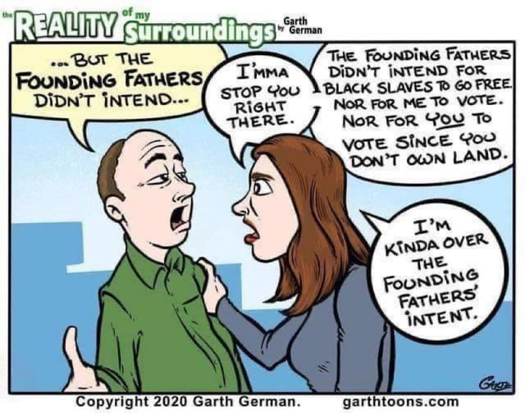

Evaluating Your Work

10% Class Participation: At the graduate level, you should be actively engaged in the class. This means reading all the materials, responding in a critical manner, taking part in discussions and workshops and being prepared. I value your insights regarding class materials and the nature of our discussions. This kind of participation allows us as scholars to engage in thoughtful discussions and, ultimately, new levels of learning.

20% Homework: Again, at the graduate level, homework is a priority and includes anything you are asked to do before the next class meeting.

70% Four MajorProjects as follows: 15%, 15%, 15% and 25%.

Attendance, Academic Honesty, Relationships to Each Other, and Suggestions

1. In Native communities, we talk about the four Rs: Reverence, Reciprocity, Respect, and Responsibility that make up our relationships. I make every attempt to conduct my personal and professional life under these four Rs. I hold great admiration for each of you and for the work we will do together. We are in a space of sharing gifts of learning with one another. As with any endeavor, there are responsibilities that we take on and expectations that need to be fulfilled. It goes without saying that respectful behavior is expected from all of us. Respecting one another includes coming to class on time and prepared as well as being present and engaging in deep listening as well as contributing. While we may disagree, and I hope we will, there are ways to challenge and ask difficult questions in ways that do not devalue anyone in the room.

2. At the graduate level, I shouldn’t have to have an attendance policy, but it is sometimes necessary to put things in writing. Attendance is mandatory. You must come to every class and be a full participant. If something major happens let me know and, if necessary, get documentation. In that event, it is up to you to get all the work done and in on time. Please take the class seriously through your attendance and participation; it makes the atmosphere better for all of us.

3. Plagiarism—we all know that this is intellectual theft, and it should not be necessary to discuss. Bottom line, don’t do it. It’s a serious offense that could not only jeopardize your grade, but has other serious consequences. This is a link to BSU’s Academic Integrity Policy: <http://catalog.bridgew.edu/content.php?catoid=10&navoid=970>

4. Please let me know if you have a preferred name or preferred pronouns. I will expect the class to respect your preferences.

5. Feel challenged—one of the great things about this work is that we are still breaking some new ground. While the reading load is very heavy, there is still so much more. If you find something that looks interesting, bring it in or discuss it in your responses. Enjoy the learning, work hard at it, and open yourself to thinking in challenging ways.

6. Talk to me—I make myself available in multiple ways. Let me know if there are any issues before they grow.

7. Have a sense of humor.

8. Take risks



Tentative Schedule

Notes:

1. All readings for the course are available on Blackboard. However, on my website ([www.joycerain.com](http://www.joycerain.com)) the readings are set up for each week’s work and there are additional readings that may be used as resources. For some first pages I copied the front matter for documentation. In some cases, chapters may be taken from the same text, so go to the second page to be sure you have the assigned text.
2. This schedule is a draft and subject to revisions with sufficient notification to the class.

|  |
| --- |
| Week 1 July 12 and 14 |
| I have sent out readings via email for the first class; these include “Meaning Rhetoric and Story”, “Interfacing Cultural Rhetorics” and “The Truth about Stories.”  JULY 12  Introductions  Power Point on Cultural Rhetorics  Discuss Syllabus and Assignments  Discussion of Readings  What is rhetoric? What are cultural rhetorics? What is power/privilege?  Breakout groups to brainstorm for first projects.  Homework for next class:  Read, post, respond: “Constellating Cultural Rhetorics” Adichie “The Danger of a Single Story.”  Erdrich. “Writers on Writing: Two Languages in Mind, but Just One Heart.” “Before There Was Light”  Prep your Found Cultural Rhetorics Project  Jot down notes/thoughts for your Language and Culture Autobiography  JULY 14  Found Cultural Rhetorics Example (I will provide)  Opportunity for follow-up questions on syllabus and assignments  Discussion of Readings  Breakout groups  Homework for next class:  Read, post, respond: “Land-based Pedagogies” “Hearing the Language of Trees”  Prep your Found Cultural Rhetorics Project  Write Project 2 and be prepared to share drafts next class |
| Week 2: July 19 and 21 |
|  |
| JULY 19  Found Cultural Rhetorics Presentation _____________________  Discussion of Readings  Breakout groups  The Making of Things: project and writing  Discussion of production  Found Rhetorics sign-up  Breakout groups to discuss Language and Culture Autobiography  Homework for next class:  Read, post, respond: Villanueva “Rhetorics of Racism” and “Constructing Rhetorical Borders”  Prep your Found Cultural Rhetorics Project  Write Language and Cultural Autobiography to hand in  JULY 21  Language and Culture Autobiography Due in Assignments  Found Cultural Rhetorics Presentation _____________________  Discussion  Breakout groups  Discussion of Readings  Breakout groups  Homework for next class:  Read, post, respond:  Seltzer, Jack and Sharon Crowley. *Rhetorical Bodies*. “Habeus Corpus: An Introduction.”  Crowley, Sharon. “The Material of Rhetoric” *Rhetorical Bodies*.  Levy, Daisy. “This Book Called My Body”  Eady, Cornelius. Selected poems from *Brutal Imagination.*  Prep your Found Cultural Rhetorics Project  Write ides for Project 3—Rhetorical Analysis to share groups |
| Week 3: July 26 and 28 |
| JULY 26  Found Cultural Rhetorics Presentation _____________________  Discussion  Breakout groups  Discussion of Readings  Breakout groups  Homework for next class:  Read, post, respond: DoBois, Page. “The Tattoos of Epidimes” “Stories on the Skin” “Kerri Helme Is Reviving Native Tattooing Traditions in Her Community”  Prep your Found Cultural Rhetorics Project  Write draft of Project 3—Rhetorical Analysis to share  JULY 28  Found Cultural Rhetorics Presentation _____________________  Discussion  Breakout groups  Discussion of Readings  Breakout groups  Homework for next class:  Read, post, respond: “How Cultural Rhetorics Can Change the Conversation: Towards New Communication Spaces to Address Human Trafficking” and “Patriotism and the impact on perceived threat and immigration attitudes”  Prep your Found Cultural Rhetorics Project  Write Project 3—Rhetorical Analysis to hand in under Assignments  Write Proposal for Project 4 to share in groups |
| Week 4 August 2 and 4 |
| AUGUST 2  Found Cultural Rhetorics Presentation _____________________  Discussion  Breakout groups  Discussion of Readings  Breakout groups  Homework for next class:  Read, post, respond: Rohan, Liz. “I remember Mamma: Material Rhetoric, Mneumonic Activity, and One Woman’s Turn-of-the-Twentieth-Century Quilt”  Walker, Alice. “Everyday Use”  Draft for Project 4 to share in groups  AUGUST 4  Found Cultural Rhetorics Presentation _____________________  Discussion  Breakout groups  Discussion of Readings  Breakout groups  Homework for next class:  Read, post, respond: Blair, Carole. “Contemporary U.S. Memorial Sites as Exemplar’s of Rhetoric’s Materiality” Wright, Elizabeth A “Rhetorical Spaces in Memorial Places” “Reappropriating Public Memory”  Write Draft of Project 4 Proposal and to share |

|  |
| --- |
| Week 5: August 9 and 11 |
| AUGUST 9  Found Cultural Rhetorics Presentation _____________________  Discussion  Breakout groups  Discussion of Readings  Breakout groups  Homework for next class: Prep presentation on Project 4  AUGUST 11  Found Cultural Rhetorics Presentation _____________________  Presentations on Project 4: 10 minutes each  Project 4 due August 12-14 |

Bibliography of Readings and Suggested Readings

Anzaldúa, Gloria. *Borderlands/La Frontera: The New Mestiza. Third Edition.* San Francisco: Aunt Lute, 2007.

Baca, Damián. *Metiza@ Scripts, Digital Migrations, and the Territories of Writing.*New York: Palgrave McMiliian, 2008.

Clifford, James. *The Predicament of Culture: Twentieth-Century Ethnography, Literature and Art.* Cambridge: Harvard University Press, 1988.

Cooke, Miriam “Islamic Feminist Rhetorical Strategies” *Nepantla: Views from the South* 1:1. Duke University Press, 2000.

Driskill, Qwo-Li. "Shaking Our Shells: Cherokee Two-Spirits Rebalancing the World." [*Beyond Masculinity: Essays by Queer Men on Gender and Politics.*](http://www.beyondmasculinity.com/)Hoppe, Trevor. Ed. Ann Arbor, 2008.

Driskill, Qwo-Li. Breaking Precedent Wiki <http://breakingprecedent.wetpaint.com/>

Driskill, Qwo-Li. *Walking with Ghosts*. Salt Publishing.

DuBois, Page. *Out of Athens*

Eady, Cornelius. *Brutal Imagination*

Haas, Angela M. "Wampum as Hypertext: An American Indian Intellectual Tradition of Multimedia Theory and Practice." *Studies in American Indian Literatures.* 19.4 (2007): 77-100.

Harjo, Joy. *A Map to the Next World.*

Harjo Joy. *How We Became Human.*

Heno, Talia. <https://www.allure.com/story/native-tattoo-art-revival> 2022

Jasinski, James. *Sourcebook on Rhetoric: Key Terms in Contemporary Rhetorical Studies.* London: Sage Publications, 2001.

Kimmerer, Robin Wall <https://www.yesmagazine.org/environment/2021/10/29/hearing-the-language-of-trees?utm_term=Autofeed&utm_medium=Social&utm_source=Facebook&fbclid=IwAR3cK7-RgwERxfGXT662NS0S-WyHBqGN6Z1CxfbMhO1_olHr4U-oDH68Vx8#Echobox=1655016721> 2022

Lepore, Jill. *Encounters in the New World: A History in Documents.* New York: Oxford University Press, 2000.

Lipson, Carol S. and Roberta A. Binkley, eds. *Rhetoric Before and Beyond the Greeks*. Albany: State University of New York, 2004.

Lyons, Scott Richard. “Rhetorical Sovereignty: What DO American Indians Want from Writing. *College Composition and Communication* 51.3. February 2000, 447-467.

Masi de Casanova, Erynn “Women’s Magazines in Ecuador: Re-reading ‘la Chica Cosmo.”*Studies in Latin American Popular Culture, 20__.*

Mao, LuMing. "Studying the Chinese Rhetorical Tradition in the Present." *College English.* 69. 3 (2007): 216-237.

O’Brien, Tim. *The Things They Carried.*

Poma, Guaman. *Nueva corónica y buen gobierno*. The Guaman Poma Website. Det Kongelige Bibliotek. 5 May 2009. [http://www.kb.dk/permalink/2006/poma/info/en/frontpage.htm.](http://www.kb.dk/permalink/2006/poma/info/en/frontpage.htm)

Powell, Malea. “Listening to Ghosts.” In *Alt/Dis: Alternative Discourses and the Academy*. Edited by Christian Schroeder, Helen Fox and Patricia Bizzell. Portsmouth< NH: Heinneman, 2002.

Powell, Malea. “Blood and Scholarship: One Mixed-Blood’s Story.” In *Race, Rhetoric and Composition.* Edited by Keith Gilyard. Portsmouth, NH: Heinneman, 1999.

Powell, Malea. Hetorical Powwows. Purdue University, 2010.

Prelli, Robert, Ed. *The Rhetorics of Display*. Columbia, SC: University of South Carolina Press, 2006.

Rallin, Aneil. “(Im)migrant Crossings.” In *Crossing Borderlands: Composition and Post Colonial Studies.* Andrea Lunsford and Lahoucine Ouzgane, Eds. Pittsburgh: University of Pittsburgh Press, 2004.

Roberts, Kathleen Glenister. “Visual Argument in Intercultural Contexts: Perspectives on Folk/Traditional Art.” In *Argumentation and Advocacy* 43. Winter and Spring 2007, 152-163.

Rohan, Liz. “I remember Mamma: Material Rhetoric, Mneumonic Activity, and One Woman’s Turn-of-the-Twentieth-Century Quilt” *Rhetoric Review* 23.4. 2004, 368-87.

Royster, Jacqueline Jones. “Academic Discourses or Small Boats on a Big Sea.” Edited by Christian Schroeder, Helen Fox and Patricia Bizzell. Portsmouth< NH: Heinneman, 2002.

Seltzer, Jack and Sharon Crowley, Eds. *Rhetorical Bodies.* Madison, WI: The University of Wisconsin Press, 1999.

Schreffler, Michael J. “Vespucci Rediscovers America: The Pictorial Rhetoric of Cannibalism in Early Modern Culture. *Art History* 28.3. June 2005:295-310.

Schroeder, Christian, Helen Fox and Patricia Bizzell, Eds. *Alt/Dis: Alternative Discourses and the Academy*. Portsmouth, NH: Heinneman, 2002.

Smith, Linda Tuhiwai. *Decolonizing Methodologies: Research and Indigenous Peoples.*London: Zed Books Ltd.,1999.

Stromberg, Ernest, Ed. *American Indians’ Rhetorics of Survivance:Word Medicine, Word Magic.* Pittsburgh: University of Pittsburgh Press, 2006.

Villanueva, Victor. "On the Rhetorics and Precedents of Racism." *College Composition and Communication*. 50.4. June, 1999: 645-661.

Walker, Alice. “Everyday Use”

Wang, Bo. “A Survey of Research in Asian Rhetoric.” *Rhetoric Review* 23.2. 2004:171-81.

Wright, Elizabeth A. “Rhetorical Space in Memorial Places: The Cemetery as a Rhetorical Memory Place/Space.” Rhetoric Society Quarterly 35:4, Fall 2005.



Joyce Rain Anderson is inviting you to a scheduled Zoom meeting.

Topic: Cultural Rhetorics Summer Course

Time: Jul 12, 2022 04:30 PM Eastern Time (US and Canada)

Every week on Tue, Thu, until Aug 11, 2022, 10 occurrence(s)

Jul 12, 2022 04:30 PM

Jul 14, 2022 04:30 PM

Jul 19, 2022 04:30 PM

Jul 21, 2022 04:30 PM

Jul 26, 2022 04:30 PM

Jul 28, 2022 04:30 PM

Aug 2, 2022 04:30 PM

Aug 4, 2022 04:30 PM

Aug 9, 2022 04:30 PM

Aug 11, 2022 04:30 PM

Please download and import the following iCalendar (.ics) files to your calendar system.

Weekly: https://bridgew.zoom.us/meeting/tJErf--prDwtGtTifuet9BD5pjThmP4aI2oP/ics?icsToken=98tyKuCtqDMsG9aStxmHRowMBIqgM-vzpmZajbdplRnwBjQKQCejJuh2Or9PRNn5

Join Zoom Meeting

https://bridgew.zoom.us/j/95686127700?pwd=MngzSFMxUnlBWjREQ1dwZkNxaUZNdz09

Meeting ID: 956 8612 7700

Passcode: 474296

One tap mobile

+13017158592,,95686127700# US (Washington DC)

+13126266799,,95686127700# US (Chicago)

Meeting ID: 956 8612 7700

Find your local number: https://bridgew.zoom.us/u/abobNne79R