ENGL 326: Native Writing and Rhetorics Dr. Joyce Rain Anderson
FALL 2019 Tillinghast Hall 320
TTH in LIB 204 508.531.2508
Office hours: M 3:30-4:30 (Tilly 320) joycerain.anderson@bridgew.edu
TTH 8:15-9:15 (Tilly 320)
T 11:00-12:00 in CMA (RCC 101)
and by appointment
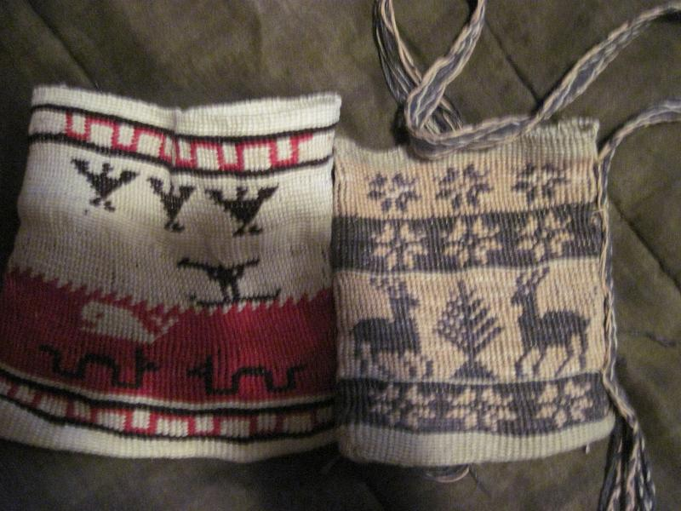
Kunepeum (welcome) to Native Writing and Rhetorics. Many of you will enter this course with preconceived notions of Native peoples primarily because of the many misrepresentations that have shaped our perceptions. We will begin with some of these ideas to explore how and why you have come to internalize them, and we will work to a fuller and richer understanding of Native peoples and cultures. We will read broadly and deeply and still will not be able to read or experience everything. Yet, we will read a substantial amount for each class. In this course we will be reading a variety of writings which move across
traditional boundaries (such as poetry, fiction, theory, activist and so on) and doing projects to experience a broader scope of Indigenous rhetorics. You will also explore something on your own to share with the class, and you will each find an area which warrants more attention for the final projects. We will sometimes have guests from local native communities or see presentations from Native peoples who will provide their own perspectives on Native peoples of southeastern Massachusetts. We will also talk and read and listen and make and write. We will see how Native peoples engage in meaning-making, and we will learn new stories about Native writing and rhetorics.
Some objectives include, but are not limited to, the following:
- Identifying and exploring your own understanding of Native peoples and places, particularly in southeastern MA.
- Broad general knowledge of the field Indigenous rhetorics.
- Experience of negotiating and thinking through questions of the field.
- Develop an understanding of Native men’s and women’s roles within a variety of communities.
- Develop an understanding of writings by Native peoples and what constitutes writing.
- Bring a variety of theories into conversations with each other.
- Situate your own scholarly projects.
- Gain professional training in conference presentations.

A few questions to consider:

- What do we mean by Indigenous rhetorics?

- How do we define things like writing, texts, digital, visuals, performance, and materials?

- How do our cultural biases influence our interpretations?

- How do Native peoples present their worldviews?

- How do “marginalized” groups deal with colonization and dominance?

- How do we become more aware of inscribed images and stereotypes?

- How do we re-inscribe a variety of images or materials to better represent Native perspectives?

Required Texts and Materials:
A set of readings will be posted to my website www.joycerain.com . You are responsible for bringing these readings to class.
A way of taking notes (notebook or digital)
A pen or pencil
Materials for map and final project.

Class Assignments and Projects:

Readings: For each class you will be asked to read one or more pieces which will enrich our understanding. Each of you will be assigned a day where you will begin our class discussion around these readings. You are also expected to write a critical response to the set of readings (see next description).

Critical responses: For each set of readings, you are expected to write a single-spaced one-page critical response (approximately 500 words). The content is what is important here, so no big headings with unnecessary spaces. These one-pagers are assigned to express your active engagement with the readings: what you pull from the reading; what you struggle with (if you struggle say why); what surprises you and makes you reconsider preconceived notions; how you make connections to your experiences, other readings, your writing, work of the class and so on. You may consider how the readings contribute to your understanding of Indigenous rhetorics and the writings by Native peoples, what relationships they might have to your learning, identity, and other aspects of your experiences, and/or connections among the class readings and your own readings. You might also create a list of questions that these readings raise which can be brought to our class discussions. These responses must be completed before each class, and you must bring a hard copy to each class for peer response. You will also keep these to comment on in the reflective paper.

Inkshedding: Inkshedding is a social form of freewriting that encourages deeper engagement with concepts through written dialogue. In this class, we will use inkshedding with our one-pagers at the beginning of class. Procedure: Pass your one-pager to the right. Read your neighbor’s writing all the way through and then underline a sentence or two that stands out as interesting or intriguing. Then, flip the page over, and write a response. This response should not be evaluative (i.e. “good job!”) or corrective, but substantial and written to continue the conversation on paper – to continue the writer’s thinking, pose questions raised by the writer’s thoughts, reflect on what the writer said, and/or compare to your own writing and thinking. This exercise is not intended to correct grammar. After you respond, we will return the one-pagers to the writers. We will then use these written conversations to start the class discussion, and I will collect the one-pagers at the end of class, and you will receive a check-plus, check, or check-minus (assignment and description written by Dr. Michelle Cox). Due: As homework for each class

Stereotypes and Realities Presentation: For this assignment, ala Dunbar-Ortiz’s and Gilio Whitaker’s “All the Real Indians Died Off” and 20 Other Myths about Native Americans, you will be given a list of commonly-held beliefs about Native peoples and cultures. You will draw one of these topics from a hat, and you will read that particular chapter as well as do some independent research on your topic. You will prepare a ten-minute presentation for the class on how you expand your understanding of Native Writing and Rhetorics through this particular piece. Each day one-two of you will present. Your may pair up with someone for this presentation (15 minutes). You will also need to write a one-page summary of your presentation and hand it in. Note: As you research for this presentation, be careful to vet you resources. Much of what is found online contributes to the perpetuation of the mythology. If you aren’t sure, please ask before you present. Due: as assigned

You Must Make Your Own Map: We are mostly taught how to analyze discourses and rhetorical situations without understanding our own. This project allows you to think critically about your own practices and the spaces from which they emerge. It’s about learning to understand spaces and places you occupy as power systems. It requires you create a map of your homeland or a physical space that holds meaning for you. Once you have done so, you will begin to overlay Indigenous spaces onto your map, understand the meaning of these spaces, and to see how the land and power structures shifted. It will also require you to examine the ways in which these influence your physical space. While you may use a variety of ways to produce your map, a handout will be provided to offer more details and suggestions. Due: October 3 (mini presentation)

Mid-term A take-home mid-term will be handed out during week four with several short essay questions.
Due: November 5

Final Project: There will be handouts available to explain writing a proposal, abstract, annotated bibliography, and literature review. I will provide some examples for you to review before you decide on your own topic. You must meet with me to get approval of your project:
A fifteen-minute conference presentation that explores some aspect of Native Writing and Rhetorics as you have come to understand these and as drawn upon through scholarly research. Because you are preparing conference presentation, this option requires that you include the following:
  - A 200-250 word conference proposal (ideally for a future conference such as the BSU symposium)
  - A 150-200 word abstract to be included with your paper
  - A literature/materials review or annotated bibliography using primary and secondary sources (3-5 pages)
  - A written conference paper (10-12 pages) which will be read/orated along with visuals or tactiles (see next)
  - Visuals: PPT , overheads, handouts, digital, visual or material rhetorics which will be presented with your paper
You should consider presenting your work at the mid-year symposium or another conference. We will discuss options in class.
Final copy DUE: December 16 by noon in my office

Reflection on the Course: At the end of the course and included with your final project, you must write a reflection on the course. This can be in the form of a letter or essay or any other creative way you would like to present it. In it, you should discuss your understanding of Native peoples and cultures before and after the course. You should also specifically mention which articles, films, events, discussions (etc.) helped to shape your thinking around the issues. Also discuss which were not as useful and what you think might be valuable as the course is taught again. As well, discuss your participation and contributions along with the work you did.
DUE: December 16 by noon in my office

Evaluating Your Work

20% Class Participation: At the upper-levels of college, you should be actively engaged in the class. This means reading all the materials, responding in a critical manner, taking part in discussions and workshops and being prepared. I value your insights regarding class materials and the nature of our discussions. This kind of participation allows us as scholars to engage in thoughtful discussions and, ultimately, new levels of learning. This also means up to a twenty-point difference in your final grade.

10% Homework: Homework is a priority and includes anything you are asked to do before the next class meeting. Unless you have a strong reason, no late homework will be accepted. Not coming to workshops with a draft of your project steps will result in a zero. One pagers not Writeed will receive the same. If the responses are less than a page(500 words) or do not show evidence of thoughtful response, they will receive half or zero credit.
20% Map Project
20% Midterm 30% Final Project and Course Reflection Project: Your final project and presentations as well as your course reflection will constitute this grade.
Note: I have marked several places on the tentative schedule as extra credit opportunities. To obtain extra credit for these, you must attend the event (for full time if a film/speaker; for at least two hours of powwow) and then write a one-page, single-spaced response to be handed in. The response must include what you observed and how it informed you. Let me know beforehand if you are taking advantage of this opportunity.
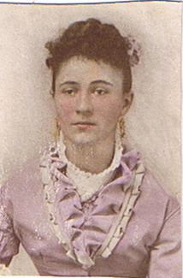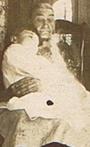
Your ancestors sit on your shoulders to keep your feet on the ground.

Attendance, Plagiarism and Other Suggestions
1. In Native communities, we talk about the four Rs: Reverence, Reciprocity, Respect, and Responsibility. I make every attempt to conduct my personal and professional life under these four Rs. I hold great admiration for each of you and for the work we will do together. We are in a space of sharing gifts of learning with one another. As with any endeavor, there are responsibilities that we take on and expectations that need to be fulfilled. It goes without saying that respectful behavior is expected from all of us. Respecting one another includes coming to class on time and prepared as well as being present and engaging in deep listening as well as contributing. While we may disagree, and I hope we will, there are ways to challenge and ask difficult questions in ways that do not devalue anyone in the room.
2. You must come to class on time. While things happen such as illness, car troubles, unplanned events, try to make every class. After four missed classes (equally two weeks), your grade will be affected; miss six classes and do not expect to pass the course. If you are habitually late or you are not taking the class seriously, your grade will be affected. Likewise, please do not make appointments for advising during our class time
3. Plagiarism—we all know that this is intellectual theft. Bottom line, don’t do it. It’s a serious offense that could not only jeopardize your grade, but has other serious consequences. This is a link to BSU’s Academic Integrity Policy: http://catalog.bridgew.edu/content.php?catoid=10&navoid=970

4. Electronic devices are a huge distraction, but sometimes necessary to the classroom. Unless your laptop or tablet is open to the reading we are discussing or being used in sharing writing for this class, you must keep it closed or put away. Too often, I’ve had to ask students to close their laptops because they are not present in this class, and I do not like to embarrass you or me by doing so. Likewise, your cellphones should also be used for purposes of our class. While I know people expect you to be on call 24/7, most things can wait. If there is a pressing reason why you must have access to your phone, let me know.
5. Please let me know if you have a preferred name or preferred pronouns. I will expect the class to respect your preferences.
6. Feel challenged—one of the great things about this work is that we are still breaking some new ground. While the reading load is very heavy, there is still so much more. If you find something that looks interesting, bring it in or discuss it in your responses. Enjoy the learning, work hard at it, and open yourself to thinking in challenging ways.
7. Talk to me—I make myself available in multiple ways. Let me know if there are any issues before they grow.
8. Have a sense of humor.
9. Take risks

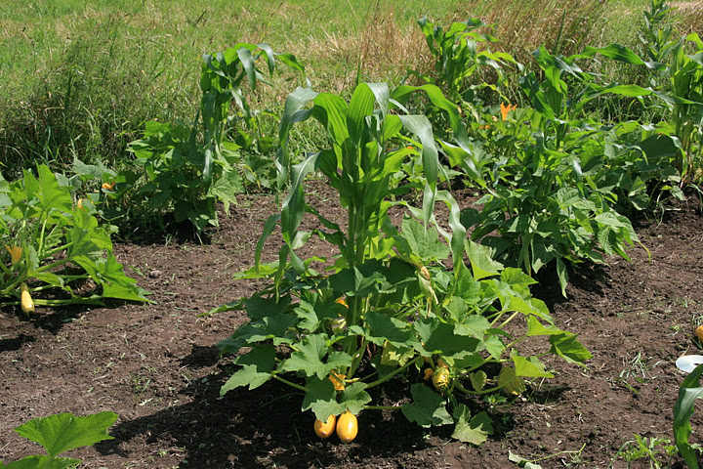
Three Sisters Garden

<->Tentative Schedule<->
(This schedule is subject to change with sufficient notice to participants.)

 | WEEK 1 Introduction to the course
September 5 | Smudging… Ceremony  Prior knowledge activity –what do we know?  Introductions  Brief Overview; go over syllabus.  Homework for next class: Read—(1) Firsting and Lasting and (2) the Introduction to “All the Real Indians Died Off.” Watch--We Shall Remain: After the Mayflower. Revist OUR STORY: 400 Years https://www.plymouth400inc.org/our-story-exhibit-wampanoag-history/  Write a one-page response; bring a hard copy to class.
 | WEEK 2
 | Last Day for Add/Drop 9-11
September 10 | Reintroduce ourselves  Some background: Doctrine of Discovery; Contact: 1621 “treaty”  Inkshedding and discussion.  Sign up for S&R Presentation  What is Rhetorical Mapping?  Writing Groups to discuss Project 1: You Must Make Your Own Map  Homework for next class: Read—(1) The Land has Memory, and (2)“Land as Pedagogy.” Write a one-page response; bring a hard copy to class
September 12 | Inkshedding and discussion.  Rhetorical Mapping Examples  Project I discussion  Homework for next class: Read excerpts from Brooks A Common Pot and excerpts from Braiding Sweet Grass (Kimmerer) Write a one-page; bring a hard copy to class. Research Project 1 and bring ideas to class
 | WEEK 3
September 17 | S&R Presentation by _____________________________  Inkshedding and discussion.  Making Project  Groups to discuss Project 1  Homework for next class: Read Gould, Poems as Maps; Harjo, “Map to the Next World,” Driskill “Map of the Americas,” and Miranda’s “Indian Cartography” Write a one-page response; bring a hard copy to class.
September 19 | S&R Presentation by _____________________________  Inkshedding and discussion.  Writing Groups to discuss Project 1  Homework for next class: Read excerpts from Brooks, “Our Beloved Kin”; and Delucia, “Past and Present/ Write a one-page response; bring a hard copy to class
 | WEEK 4
September 22 | S&R Presentation by _____________________________  Inkshedding and discussion.  Homework for next class: Read Susan Powell, “First Fruits” and information on the Harvard Indian School. Write a one-page response and bring a hard copy to class. Prepare Project I for Peer Review.
September 26 | S&R Presentation by _____________________________  Inkshedding and discussion.  Peer Review Project I  Homework for next class: Read Lyons “Rhetorical Sovereignty,” and Powell “River” Write a one-page response and bring a copy to class. Prepare Project I for handing in.
 | WEEK 5
October 1 | S&R Presentation by _____________________________  Inkshedding and discussion.  Discuss Midterm Project  Homework for next class: Read King, The Truth about Stories and articles on the Bering Strait.  Write a one-page response; bring a hard copy to class.
October 3  *Map Project Due | S&R Presentation by _____________________________  Inkshedding and Discussion  Homework for next class: Read excerpts from Rethinking Columbus and “Re-Encounter”  Columbus Day: https://time.com/4523330/columbus-day-indigenous-peoples-day-history/  Visit Debbie Reese’s page American Indians in Children’s Literature https://americanindiansinchildrensliterature.blogspot.com/  Write a one-page response; bring a copy to class.
 | WEEK 6
October 8 | S&R Presentation by _____________________________  Inkshedding and Discussion  Homework for next class: “Why Educators Can’t Ignore Mascots” “Native Images in Schools and the Racially Hostile Environment,” and watch some of the Smithsonian conference (https://www.youtube.com/watch?v=NWpy7ozOwTU ).  Write a one-page response; bring a hard copy to class.
October 10 | S&R Presentation by _____________________________  Inkshedding and Discussion  Midterm Handout  Homework for next class: Standing Bear; Zitkala Sa; and Erdrich, “Indian Boarding School” . Read and Explore The Carlisle Indian School website: http://carlisleindian.dickinson.edu/ and Background on “Indian Boarding School..” http://www.english.illinois.edu/maps/poets/a_f/erdrich/boarding/index.htm Write a one-page response; bring a hard copy to class.
 | WEEK 7
October 15 | S&R Presentation by _____________________________  Inkshedding and Discussion  Homework for next class: hh
October 17 | S&R Presentation by _____________________________  Inkshedding and discussion.  Homework for next class: Read handouts from the Upstander Project and Dawnland. And ICWA. Prepare 2-3 questions for our guest speakers.
 | WEEK 8 OCTOBER 22 at 5:00 pm screening of Dawnland in the DMF Auditorium
October 22  Extra Credit for attending tonight’s screening | Dawnland Guests: Mishy Lesser, Esther Anne, and Dawn Neptune  Homework for next class: Read excerpt from Native Women’s History. Write a one-page response; bring a hard copy to class. Also write a response to our guest speakers and film (if attended).
October 24 | S&R Presentation by _____________________________  Inkshedding and discussion.  Homework for next class: Read excerpts from Playing Indian and Lisa King “Revisiting Winnetou”. Read and Explore: Native Appropriations: http://nativeappropriations.com/ Write a one-page response; bring a copy to class.
 | WEEK 9
October 29 | S&R Presentation by _____________________________  Inkshedding and Discussion  Homework for next class: Read “From Tomahawk Chop…” Write a one-page response; bring a hard copy to class. Work on midterm due next Tuesday (November 5).
October 31 | S&R Presentation by _____________________________  Inkshedding and Discussion  Groups to Discuss Final Project proposals.  Homework for next class: Read excerpts from Bruchac’s Savage Kin and Bruchac Article. Write two-three questions to ask our guest speaker (the author). I will collect these after the talk.  Revise proposal and gather resources
 | WEEK 10
November 5 | Dr. Marge Bruchac presentation in Library Heritage Room—attendance will be taken!  Homework for next class: Read “New World of Indian Museum” Visit On the Wampum Trail https://wampumtrail.wordpress.com/ Write a one-page response on reading and bring a hard copy to class. Also please write a short response to the event and hand in next Tuesday.
November 7  *Mid-terms DUE | S&R Presentation by _____________________________  Inkshedding and Discussion  Final Project discussion  Homework for next class: Read “Hear Our Languages” and watch We Still Live Here. Write a one-page response; bring a copy to class. Also bring in two-three ideas for a final project.
 | WEEK 11
November 12 | S&R Presentation by _____________________________  Inkshedding and Discussion  Guest Speaker  Groups to discuss final project resources  Homework for next class: Read Like a Hurricane” and “Walking with Our Relatives” Watch Wounded Knee: https://www.youtube.com/watch?v=Opbxnuw0Dw0 Write your proposal for Final Project (see handout)
November 14 | S&R Presentation by _____________________________  Inkshedding and Discussion  Groups to discuss final project  Homework for next class: Read Like a Hurricane” and “Walking with Our Relatives” Watch Wounded Knee: https://www.youtube.com/watch?v=Opbxnuw0Dw0 Write a one-page response; bring a copy to class. Prepare Final Project for Peer Review.
 | November 15th is the last day to withdraw from a class
November 17 | BSU/MCNAA National Native American Heritage Month Powwow 11:00-5:00 Kelly Gym. You need to attend, interview a dancer, vendor, or demonstrator and write a 1-2 page report. We are also looking for volunteers to help that day!
 | WEEK 12
November 19 | S&R Presentation by _____________________________  Inkshedding and Discussion  Homework for next class: Read excerpts from Indigenous Food Sovereignty in the United States and “Seeds and Soil” Write a one-page; bring a copy to class. Prepare Final Project for Peer Review.
November 21 | S&R Presentation by _____________________________  Inkshedding and Discussion  Homework for next class: Prepare questions on any of readings/speakers/discussions we have had. Be prepared to share next class.
 | WEEK 13
November 26 | S&R Presentation by _____________________________  Catch-up Discussion  Updates on Final Projects  Homework for next class: Read “Indigenous Ways of Knowing for 21st Century” and “Stitching Sovereignty” Write a one-page; bring a copy to class.  Prepare Final Project for Peer Review.
November 28* | FALLFEAST—NO CLASS Fall Feast Holiday Break. Enjoy connecting with relations
 | WEEK 14
December 3 | Inkshedding and Discussion  Final Project Peer Review  Homework for next class: Read Carceri vs. Salazar and “Indian Gaming.” Write a one-page; bring a copy to class.
December 5 | Inkshedding and Discussion  Prepare Mini reports on final projects
December 9  Extra Credit | Student Research Symposium—Extra Credit for presenting
 | WEEK 15
December 10 | Final Reflections and Gathering
 | Classes end on December 11: Reading Day is December 12: Finals are December 13-19
December 16 | Final Projects and Reflection Due in my office (Tillinghast 320) by 2:00 pm

