ENGL 511: Native Writing and Rhetorics Dr. Joyce Rain Anderson
Summer II 2015 (7/6-8/5) Tillinghast Hall 320
MW 1:30-5:15 in LIB 309 508.531.2508
Office hours: MW 12:30-1:00 joycerain.anderson@bridgew.edu

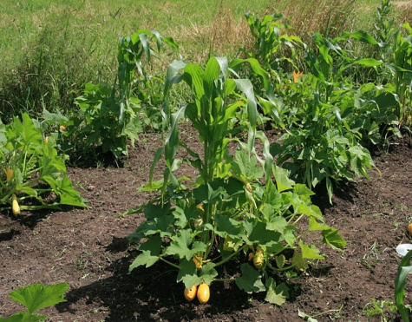
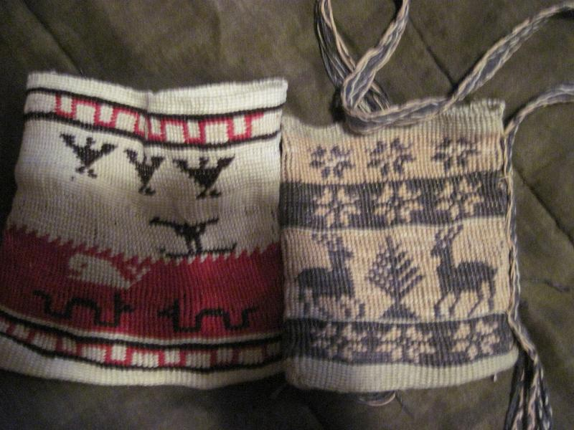
Kunepeum (welcome) to Native Writing and Rhetorics. In this course we will be reading a variety of writings which move across traditional boundaries (poetry, fiction, environmental work, treaties, theory, activist work, and so on) and doing projects to experience a broader scope of Indigenous rhetorics. Many of you will enter this course with preconceived notions of Native peoples primarily because of the many misrepresentations that have shaped our perceptions. We will begin with some of these ideas to explore how and why you have come to internalize them, and we will work to a fuller and richer understanding of Native peoples and cultures. We will read broadly and deeply and still will not be able to read everything. Yet, we will read a substantial amount for each class. You will also explore something on your own to share with the class, and you will each find an area which warrants more attention for the final projects. We will sometimes have guests from local native communities who will provide their own perspectives on Native peoples of southeastern Massachusetts We will also talk and read and listen and make and write. We will see how Native peoples engage in meaning-making and learn new stories about Native writing and rhetorics.

Some objectives include, but are not limited to, the following:

- Identify and explore your own understanding of Native peoples and places.
- Broad general knowledge of the field Indigenous rhetorics.
- Experience of negotiating and thinking through questions of the field.
- Develop and understanding of environmental issues and sustainability among Native peoples
- Develop an understanding of Native men’s and women’s roles within a variety of communities.
- Develop an understanding of writings by Native peoples and what constitutes writing.
- Bring a variety of theories into conversations with each other.
- Situate your own scholarly projects.

A few questions to consider:

- What do we mean by Indigenous rhetorics?
- How do our cultural biases influence our interpretations?
- How do Native peoples present their worldviews?
- How do we define colonialism and settler colonialism?
- How have environmental changes affected Native peoples?
- What are the relationships of Native Americans with land?
- How do we re-inscribe a variety of images or materials to better represent Native perspectives?

Required Texts and Materials:

❖ A set of readings which will be posted to a website: www.joycerain.com ( print or electronically and bring to class so that you can refer to them in discussion)

Class Assignments and Projects:

Critical responses: For each set of readings, you are expected to write a single-spaced one-page critical response. These one-pagers are assigned to express your active engagement with the readings: what you glean from the readings, how you make connections to your own experiences, other readings, your writing, work of the class and so on. You may consider how the readings contribute to your understanding of Indigenous rhetorics and the writings by Native peoples, what relationships they might have to your learning, identity, and other aspects of your experiences, and/or connections among the class readings and your own readings. You might also create a list of questions that these readings raise which can be brought to our class discussions. You must bring a hard copy of your one-pager to each class for peer response. You will also keep these to comment on in the reflective paper.

Inkshedding: Inkshedding is a social form of freewriting that encourages deeper engagement with concepts through written dialogue. In this class, we will use inkshedding with our one-pagers at the beginning of class. Procedure: Pass your one-pager to the right. Read your neighbor’s writing all the way through and then underline a sentence or two that stands out as interesting or intriguing. Then, flip the page over, and write a response. This response should not be evaluative (i.e. “good job!”), but written to continue the conversation on paper – to continue the writer’s thinking, pose questions raised by the writer’s thoughts, reflect on what the writer said. When you’re done, look for another person who has finished writing and swap one-pagers. The goal is for each one-pager to receive at least two responses. Once each piece has two sets of responses, we will return the one-pagers to the writers. We will then use these written conversations to start the class discussion, and I will collect the one-pagers at the end of class (assignment and description written by Dr. Michelle Cox).

You Must Make Your Own Map: We are mostly taught how to analyze discourses and rhetorical situations without understanding our own. This project allows you to think critically about your own practices and the spaces from which they emerge. It’s about learning to understand spaces and places you occupy as power systems. It requires you create a map of your homeland or a physical space that holds meaning for you. Once you have done so, you will begin to overlay Indigenous spaces onto your map to see how the land and power structures shifted. It will also require you to create a cultural “map” as you examine the ways in which these influence your physical space. While you may use a variety of ways to produce your map, a handout will be provided to offer more details and suggestions. You must also include a 1-2 page write-up on your research and process of creating this map.

Due: July 15.

5-6 Page Rhetorical Analysis of any contemporary film or book about Native peoples or Native issues. Use at least three scholarly sources to support your claims.

Due: July 22

Final Project: You have a choice of these options:
- A fifteen-minute conference presentation that explores some aspect of Native Writing and Rhetorics as you have come to understand these and as drawn upon through scholarly research. Because you are preparing conference presentation, this option requires that you include the following:
  - A conference proposal (ideally for a future conference)
  - A 150-200 word abstract
  - A literature/materials review or annotated bibliography using primary and secondary sources
  - A written conference paper (8-10 pages) or multigenre project which will be read/orated along with visuals or tactiles (see next)
  - Visuals: PPT , overheads, handouts, digital, visual or material rhetorics which will be presented with your paper
- Create a teaching unit on Native rhetorics. Include the following with your project:
- A cover letter which offers a description of the teaching unit. Include the institutional and curricular contexts and a review of the components (literature review, material review, etc).
- A description of the unit which includes the following:
  - An overview
  - Weekly schedule with descriptions of the focus and approaches used
  - Assignments and activities as written for the students
  - List of materials needed/provided
  - Assessment tool
- Create a multi-genre case study using primary and secondary sources on Native rhetorics which takes into account the following:
- A project which includes multi-forms (this may take shape as a performance or video. If you choose this form, let’s talk)
- A proposal of 200-250 words describing the purpose of the project
- A literature/scholarship review
- Demonstration/presentation of your project
- The completed multi-genre project
- A one-two page reflection on the research and process of the project.
DUE: August 5

Reflection on the Course: At the end of the course and included with your final project, you must write a reflection on the course. This can be in the form of a letter or essay or any other creative way you would like to present it. In it, you should discuss your understanding of Native peoples and cultures before and after the course. You should also specifically mention which articles, films, events, discussions (etc.) helped to shape your thinking around the issues. Also discuss which were not as useful and what you think might be valuable as the course is taught again. As well, discuss your participation and contributions along with the work you did.
DUE: August 5.

Evaluating Your Work

10% Class Participation: At the graduate level, you should be actively engaged in the class. This means reading all the materials, responding in a critical manner, taking part in discussions and workshops and being prepared. I value your insights regarding class materials and the nature of our discussions. This kind of participation allows us as scholars to engage in thoughtful discussions and, ultimately, new levels of learning.
15% Homework: Homework is a priority and includes anything you are asked to do before the next class meeting. Unless you have a strong reason, no late homework will be accepted. Not coming to workshops with a draft of your project steps will result in a zero. One pagers not posted will receive the same. If the responses are less than a page or do not show evidence of thoughtful response, they will receive half or zero credit.
15% Map Project
20% Rhetorical Analysis
40% Final Project and Course Reflection Project: Your final project and presentations as well as your course reflection will constitute this grade.

Attendance, Plagiarism and Other Suggestions
1. You must come to class on time. While things happen such as illness, car troubles, unplanned events, try to make every class. After two missed classes, your grade will be affected; miss three classes and do not expect to pass the course. If it seems that you are not taking the class seriously, your grade will be affected.
3. Respect—a most important part of a class is respectful behavior. While we may disagree, and I hope we will, there are ways to challenge and ask difficult questions in ways that do not devalue anyone in the room.
4. Feel challenged—one of the great things about this work is that we are still breaking
some new ground. While the reading load is very heavy, there is still so much more. If you
find something that looks interesting, bring it in or discuss it in your responses. Enjoy
the learning, work hard at it, and open yourself to thinking in challenging ways.
5. Talk to me—I make myself available in multiple ways. Let me know if there are
any issues before they grow.
6. Have a sense of humor.
7. Take risks
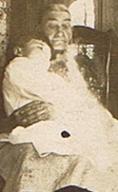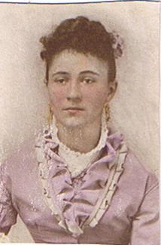

Your Ancestors sit on your shoulders to keep your feet on the ground.

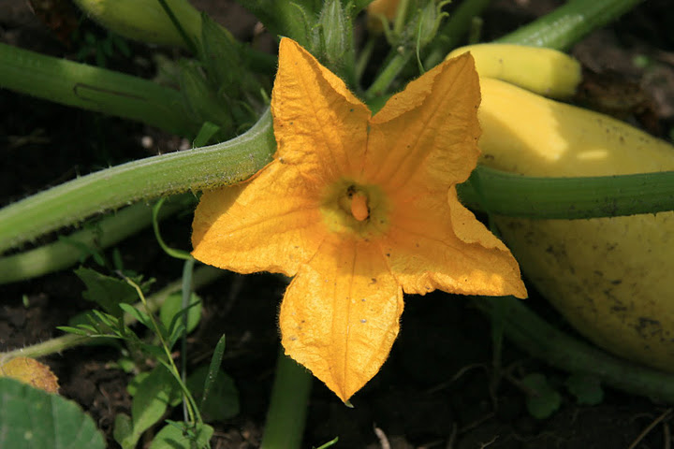

Tentative Schedule (This schedule is subject to change with sufficient notice to participants.)

Readings sent out for first class | Read: excerpt from The White Man’s Indian, and the Introduction to American Indians: Stereotypes and Realities And skim through the rest. Watch We Shall Remain: After the Mayflower (film)  Write a one-page response (incorporating all), bring a copy to class.
 | WEEK 1 Introduction to the course
July 6 | Introductions; go over syllabus; discussion of stereotypes. Corn Mother and Makings  Homework: Read excerpts from The Land Has Memory (2 sets), Firstings and Lastings, and A Common Pot check out http://archive.org/stream/indianplacenames00hude/indianplacenames00hude_djvu.txt  Write a one-page response; bring hard copy to class
July 8 | Inkshedding and discussion.  Writing groups for Project 1  Homework: Read “Rhetorical Sovereignty,” “Down by the River,” Gould, “Map to the Next World,” and Silko Write a one-page response; bring hard copy to class Work on Project 1
 | WEEK 2
July 13 | Inkshedding and discussion.  Homework: Read “Rhetorical Powwows,” “Corn Culture,” and excerpts from Selu: Seeking the Corn Mother’s Wisdom. Write a one-page response; bring hard copy to class Complete Project 1 to hand in
July 15  Project 1 Due | Inkshedding and discussion.  Groups to discuss Project 2  Homework: Read The Truth about Stories, excerpt from God Is Red, “Expanding the Boundaries of Environmental Justice,” and excerpts from All Our Relations. Write a one-page response; bring hard copy to class
 | WEEK 3
July 20 | Inkshedding and discussion.  Groups to share Project 2;Making project  Homework: Read Standing Bear and Zitkala Sa. Check out http://carlisleindian.dickinson.edu/ and http://www.english.illinois.edu/maps/poets/a_f/erdrich/boarding/carlisle.htm a one-page response; bring hard copy to class Complete Project 2 to hand in.
July 22**  Project 2 Due  FIELD TRIP | Inkshedding and discussion. Plan to go on a field trip to Plimoth or Mashantucket  Groups to discuss research  Excerpts from In the White Man’s Image  Homework: Read “Sarah Simon,” “Performing Native Women.” excerpts from Native Women’s History” Write a one-page response; bring hard copy to class Work on Final Proposal and bibliography to hand in.
 | WEEK 4
July 27  Proposal due | Inkshedding and discussion.  Groups to discuss Final Project  Making project  Homework: Read Rethinking Columbus, Re-Encounter, and from Debbie Reese’s Blog American Indians in Children’s Literature. Write a one-page response; bring hard copy to class. Find resources for final project and annotate.
July 29  FIELD TRIP | Inkshedding and discussion. Plan to go on a field trip to Plimoth or Mashantucket  Groups to share Final Projects  Homework: Read “Wampum as Hypertext,” “Visual Folk Art,” “Moose Hair Embroidery” Write a one-page response; bring hard copy to class
 | WEEK 5
August 3 | Inkshedding and discussion.  Homework: Read excerpts from Like a Hurricane, “Joining the Round Dance” and “The Rhetoric of Activism” Write a one-page response; bring hard copy to class Prepare Final Project to hand in.
August 5  Final Projects and Reflections Due | Inkshedding and discussion.  Brief highlights of your final projects

