ENGL 326: Native Writing and Rhetorics Dr. Joyce Rain Anderson
Summer I Tillinghast Hall 320
TTH 1:30-5:15 in Maxwell Library 214 508.531.2508
Office hours: T 12:30-1:30 joycerain.anderson@bridgew.edu
And by appointment
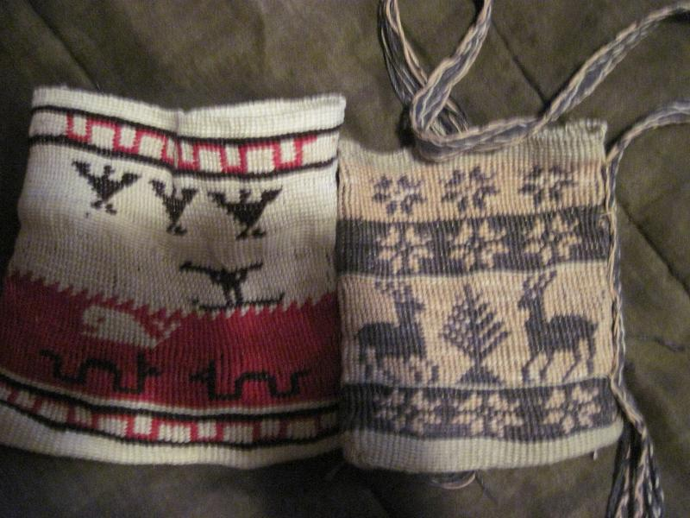
Kunepeum (welcome) to Native Writing and Rhetorics. In this course we will be reading a variety of writings which move across traditional boundaries (such as poetry, fiction, theory, activist and so on) and doing projects to experience a broader scope of Indigenous rhetorics. Many of you will enter this
course with preconceived notions of Native peoples primarily because of the many misrepresentations that have shaped our perceptions. We will begin with some of these ideas to explore how and why you have come to internalize them, and we will work to a fuller and richer understanding of Native peoples and cultures. We will read broadly and deeply and still will not be able to read everything. Yet, we will read a substantial
amount for each class. You will also explore something on your own to share with the class, and you will each find an area which warrants more attention for the final projects. We will sometimes have guests from local native communities who will provide their own perspectives on Native peoples of southeastern Massachusetts We will also talk and read and listen and make and write. We will see how Native peoples engage in meaning-making and learn new stories about Native writing and rhetorics.

Some objectives include, but are not limited to, the following:
- Identifying and exploring your own understanding of Native peoples and places, particularly in southeastern MA.
- Broad general knowledge of the field Indigenous rhetorics.
- Experience of negotiating and thinking through questions of the field.
- Develop an understanding of Native men’s and women’s roles within a variety of communities.
- Develop an understanding of writings by Native peoples and what constitutes writing.
- Develop an understanding of Indigenous practices
- Bring a variety of theories into conversations with each other.
- Situate your own scholarly projects.
- Gain professional training in conference presentations.

A few questions to consider:
- What do we mean by Indigenous rhetorics?
- How do we engage with Indigenous practices including writing, making, digital, visual, performance, and material?
- How do our cultural biases influence our interpretations?
- How do Native peoples present their worldviews?
- How do “marginalized” groups deal with colonization and dominance?
- How do we become more aware of inscribed images and stereotypes?
- How do we re-inscribe a variety of images or materials to better represent Native perspectives?

Required Texts and Materials:
- A set of readings which will be posted to a website: www. joycerain.com (you may print them or use your laptop in class)

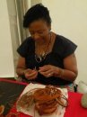

Class Assignments and Projects:

Critical responses: For each set of readings, you are expected to write a single-spaced one-page critical response. These one-pagers are assigned to express your active engagement with the readings: what you glean from the readings, how you make connections to your own experiences, other readings, your writing, work of the class and so on. You may consider how the readings contribute to your understanding of Indigenous rhetorics and the writings by Native peoples, what relationships they might have to your learning, identity, and other aspects of your experiences, and/or connections among the class readings and your own readings. You might also create a list of questions that these readings raise which can be brought to our class discussions. These responses must be posted to our Blackboard discussion forum before each class, and you must bring a hard copy to each class for peer response. You will also keep these to comment on in the reflective paper.

Inkshedding: Inkshedding is a social form of freewriting that encourages deeper engagement with concepts through written dialogue. In this class, we will use inkshedding with our one-pagers at the beginning of class. Procedure: Pass your one-pager to the right. Read your neighbor’s writing all the way through and then underline a sentence or two that stands out as interesting or intriguing. Then, flip the page over, and write a response. This response should not be evaluative (i.e. “good job!”), but written to continue the conversation on paper – to continue the writer’s thinking, pose questions raised by the writer’s thoughts, reflect on what the writer said. When you’re done, look for another person who has finished writing and swap one-pagers. The goal is for each one-pager to receive at least two responses. Once each piece has two sets of responses, we will return the one-pagers to the writers. We will then use these written conversations to start the class discussion, and I will collect the one-pagers at the end of class (assignment and description written by Dr. Michelle Cox).

Stereotypes and Realities Presentation: For this assignment, you will draw from Mihesuah’s American Indians; Stereotypes and Realities and do a little research. Prepare a ten-minute presentation for the class on how you expand your understanding of Native Writing and Rhetorics through this particular piece. Each day two of you will present. Your may pair up with someone for this presentation.

You Must Make Your Own Map: We are mostly taught how to analyze discourses and rhetorical situations without understanding our own. This project allows you to think critically about your own practices and the spaces from which they emerge. It’s about learning to understand spaces and places you occupy as power systems. It requires you create a map of your homeland or a physical space that holds meaning for you. Once you have done so, you will begin to overlay Indigenous spaces onto your map to see how the land and power structures shifted. It will also require you to create a cultural “map” as you examine the ways in which Indigenous aspects influence your physical space. While you may use a variety of ways to produce your map, a handout will be provided to offer more details and suggestions, and you will write a one-page reflection on your process. Due: June 5.

Mid-term Short Essay (3-4 pages): This assignment gives you options:
- Write an essay that brings at least four of our readings together around a theme we have been discussing (sovereignty, land, gender, etc.)
- Write an extended film review or a rhetorical analysis of any contemporary film about Native peoples. Develop an argument as to the authenticity of this film or the responsibilities of the filmmaker. Use at least four scholarly sources to support your claims.
- Write a paper concerning the relationship between Native peoples and the government of the United States or Canada. Use at least four scholarly sources to support your claims.
Due: June 12

Final Project: You have a choice of these options:
- A fifteen-minute conference presentation that explores some aspect of Native Writing and Rhetorics as you have come to understand these and as drawn upon through scholarly research. Because you are preparing conference presentation, this option requires that you include the following:
  - A conference proposal (ideally for a future conference)
  - A 150-200 word abstract
  - A literature/materials review or annotated bibliography using primary and secondary sources
  - A written conference paper (approx. 8 pages) or multigenre project which will be read/orated along with visuals or tactiles (see next)
  - Visuals: PPT , Prezi, overheads, handouts, digital, visual or material rhetorics which will be presented with your paper
- Create a teaching unit on Native rhetorics. Include the following with your project:
- A cover letter which offers a description of the teaching unit. Include the institutional and curricular contexts and a review of the components (literature review, material review, etc).
- A description of the unit which includes the following:
  - An overview
  - Weekly schedule with descriptions of the focus and approaches used
  - Assignments and activities as written for the students
  - List of materials needed/provided
  - Assessment tool
- Create a multi-genre case study using primary and secondary sources on Native rhetorics which takes into account the following:
- A project which includes multi-forms (this may take shape as a performance or video. If you choose this form, let’s talk)
- A proposal of 200-250 words describing the purpose of the project
- A literature/scholarship review
- Demonstration/presentation of your project
- The completed multi-genre project
- A one-two page reflection on the research and process of the project.
DUE: June 26.

Reflection on the Course: At the end of the course and included with your final project, you must write a reflection on the course. This can be in the form of a letter or essay or any other creative way you would like to present it. In it, you should discuss your understanding of Native peoples and cultures before and after the course. You should also specifically mention which articles, films, events, discussions (etc.) helped to shape your thinking around the issues. Also discuss which were not as useful and what you think might be valuable as the course is taught again. As well, discuss your participation and contributions along with the work you did.
DUE: June 26.

Evaluating Your Work

10% Class Participation: At the upper-levels of college, you should be actively engaged in the class. This means reading all the materials, responding in a critical manner, taking part in discussions and workshops and being prepared. I value your insights regarding class materials and the nature of our discussions. This kind of participation allows us as scholars to engage in thoughtful discussions and, ultimately, new levels of learning.
15% Homework: Homework is a priority and includes anything you are asked to do before the next class meeting. Unless you have a strong reason, no late homework will be accepted. Not coming to workshops with a draft of your project steps will result in a zero. One pagers not posted will receive the same. If the responses are less than a page or do not show evidence of thoughtful response, they will receive half or zero credit.
15% Map Project
20% Midterm Short Essay
40% Final Project and Course Reflection Project: Your final project and presentations as well as your course reflection will constitute this grade.

Attendance, Plagiarism and Other Suggestions
1. You must come to class on time. While things happen such as illness, car troubles, unplanned events, try to make every class. After four missed classes (equally two weeks), your grade will be affected; miss six classes and do not expect to pass the course. If you are habitually late or you are not taking the class seriously, your grade will be affected.
2. Plagiarism—we all know that this is intellectual theft. Bottom line, don’t do it. It’s a serious offense that could not only jeopardize your grade, but has other serious consequences.
3. Respect—a most important part of a class is respectful behavior. While we may disagree, and I hope we will, there are ways to challenge and ask difficult questions in ways that do not devalue anyone in the room.
4. Feel challenged—one of the great things about this work is that we are still breaking some new ground. While the reading load is very heavy, there is still so much more. If you find something that looks interesting, bring it in or discuss it in your responses. Enjoy the learning, work hard at it, and open yourself to thinking in challenging ways.
5. Talk to me—I make myself available in multiple ways. Let me know if there are any issues before they grow.
6. Have a sense of humor.
7. Take risks
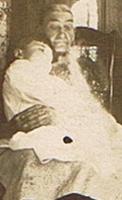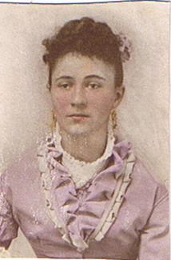

Your Ancestors sit on your shoulders to keep your feet on the ground.

Tentative Schedule (This schedule is subject to change with sufficient notice to participants.)

May 27 | With Dr. Carson. Introductions to one another; syllabus; After the Mayflower
 | Homework:Note, there are a number of readings for this week. Some are to provide context and others to help with your first project. Read: Firsting and Lasting, A Common Pot, The Land Has Memory, Lepore and Gould. Post a one-page response on 326BLOG; You may also include an additional page on the film and trip.
May 29 | With Dr. Carson. Trip to Plymouth for a tour from a Native perspective. Please meet Dr. Carson at the Chapel Lot across from the library.  Possible Guest: Donna Mitchell of the Perry Clan Wattuppa Reservation
 | Homework for 6/3: Read “Rhetorical Powwows,” King and Awiakta Post a one-page response on 326BLOG; bring a copy to class.
June 3 | Inkshedding and discussion.  Making project  Discussion of Map Project
 | Homework for 6/5: Read “Down by the River,” “Rhetorical Sovereignty” Post a one-page response on 326BLOG; bring a copy to class.
June 5 | Presentation by__________________  Inkshedding and discussion.  Mapping Project due  Discussion of Midterm Projects
 | Homework for 6/10 Read “Rethinking Columbus,” “Playing Indian” and in American Indians in Children’s Literature Blog. Post a one-page response on 326BLOG; bring a copy to class.
June 10 | Presentation by__________________  Inkshedding and discussion.  Video—In the Whiteman’s Image
 | Homework: Read “School Days” and “My People the Sioux” Post a one-page response on 326BLOG; bring a copy to class.
June 12 | Presentation by__________________  Inkshedding and discussion.  Midterm Essay Due  Writing Groups discuss research proposal  Guest: Kerri Helme (Mashpee Wampanoag) making project
Homework: Read “Divorced from the Land” and “Indigenous Women” and LaDuke. Post a one-page response on 326BLOG; bring a copy to class
Making Project or Three Sister’s Garden
June 17 | Presentation by__________________  Inkshedding and discussion.  Webinar by Shawn Wilson on Research  Writing Groups discuss research
Homework: Read “Double Weave” Driskill Poems “Wampum as Hypertext” Post a one-page response on 326BLOG; bring a copy to class
Kerri Helme, Mashpee Wampanoag—quillwork on deerskin
June 19 | Presentation by__________________  Inkshedding and discussion.  Making project  Writing Groups to discuss final projects
 | Homework: Read “American Indian Activism” “Like a Hurricane” and “Joining the Roundddance” Post a one-page response on 326BLOG; bring a copy to class.
June 24 | Presentation by__________________  Inkshedding and discussion.  Review of final projects—bring copies to class  Making Project
 | Homework: Prepare presentations
June 26 | Class presentations  Potluck

