Engl 326: Native Writing and Rhetoric
Dr. Joyce Rain Anderson
16 December 2014
Pan-Indianism: the Native Experience
Abstract: Pan-Indianism refers to the phenomena that is lumping all of the indigenous people of the Americas’ into one solitary nation. The problem posed by Pan-Indianism surfaces in the stereotypes surrounding Indians, the vast culture that is neglected one categorizing hundreds of tribes as Indians, and the oppression of a huge group of people in order to impress Christian ideals and Western Expansion. Pan-Indianism isn’t entirely a problem, however, due to the assertion of Native peoples and their identities. Having been oppressed for so many years has resulted in a vast number of cultural assertions: modern-day powwows, Indian representation in our federal government, vast literature concerning their identity. To think that something that was initially so detrimental has resulted in the beautiful cultural revolution that is taking place is astounding. As solitary nations, they were powerless in asserting their identities, but as an entire nation of people, they have gained power and promise in their efforts to remain true to their ancestors and culture.
Since the dawn of Western exploration, Native Americans have been dubbed savages, brutes, inhabitants of the West Indies, and among other things, a solitary group. Due to misinterpretations on behalf of explorers, which led to the current phenomena that is the Indian, we now have a group of Native Americans that are subject to harsh stereotypes, overlooked in the literary canon, and overall, misunderstood. It is entirely beneficial to the Native experience to make cultural distinctions between tribes, as the differences among them are vast and noteworthy. On the contrary, however, it appears as though the development of the “Pan-Indian” has sparked both a literary movement and ascent of the present-day Native American. For the purposes of this paper, the “Pan-Indian” identity will be dissected: the creation of such an identity, the cultural impact of the identity, and the political impact of such an identity.
First, it is important to note that this identity was cultivated mostly on behalf of the White man. In summation, Berkhofer writes, concerning the perpetuation of the Indian stereotype: “Since the original inhabitants of the Western Hemisphere neither called themselves by a single term nor understood themselves as a collectivity, the idea and the image of the Indian must be a White conception” (Berkhofer 3). Just as Europe is divided into a vast number of countries, each with their own unique culture and language, Indian tribes paralleled that structure. However, with the start of Spanish exploration in the late 15th century, concurrent with the invention of the printing press, initial accounts for exploration resulted in perpetuated stereotypes. Whatever was written concerning these people, dubbed savages for their bare exteriors and lack of technology, concerned all of Natives in the eyes of the Europeans. It is self-evident that these stereotypes were not only preposterous, as the term Indian reached present-day, but completely unsubstantiated. Columbus, the most prominent of the Spanish explorers as has been perpetuated by historical literature, thought he was in an entirely different part of the world upon discovering these people. The term Indian would be similar to what we would presently call Asians. If a term that was completely incorrect lasted throughout history, wouldn’t that lead one to believe that the observations that ensued were also incorrect?
Among the many accounts of Spanish explorers publishing hearsay in regards to the discovery of the Indians, some concerned the treatment, enslavement, and slaughtering of their people. On one side, Indians were described as obedient and capable of serving their masters, the Christians, without any formal religion or education of their own. On the other hand, some sought to justify the slaughter of these people. Juan Gines de Selpulveda, proponent of the slaughter and enslavement of Indians, wrote:
… those little men in whom you will scarcely find traces of humanity; who not only lack culture but do not even know how to write, who keep no records of their history except certain obscure and vague reminiscences of some things put down in certain pictures, and who do not have written laws but only barbarous institutions and customs. (Berkhofer 12).
To claim that one does not have any culture or custom based merely on the fact that they do not share a similar culture or set of customs is completely senseless. It was publications such as these that garnished attention in Europe, as they were in favor of the expansion of a Spanish empire. It is plain to see how such stereotypes, such as being barbarians or savages, were perpetuated among the Europeans and later colonies.
Aside from the historical context surrounding the Pan-Indian identity, one might wonder how such a label persisted throughout history. As a society, we take the time to distinguish cultures in nearly all parts of the world. For example, though one might associate the term Latino with all Spanish-speaking people, the educated mind knows the term only pertains to people of Latin-American descent. On the contrary, if one were to ask a set of Americans, educated or not, about the origins of the Wampanoag, they would most likely be stumped. We don’t make the attempt to distinguish tribes as much as we do other ethnic backgrounds. And though Native American tribes exhibit vastly different cultures, we still fail to acknowledge them as individual races. Therefore, terms such as Indian persist solely because we fail to make the attempt to distinguish peoples who have yet to achieve national recognition.
Considering the appropriated stereotype, how has being an Indian served Native Americans throughout history? Through relocation, removal, assimilation, and other tactics on behalf of colonists and the federal government, Native American cultures have been virtually eradicated. Though this may be the case, Native Americans have taken advantage of the Pan-Indian identity and sparked a cultural revolution. Indians have turned the White man’s education into a means of building an identity for themselves and reconnecting with their ancestors’ culture.
One of the more notable crises that struck the Indian people was the Indian Removal Act of 1830. Under Andrew Jackson, the act was passed in order to move a number of tribes from fertile, Native territories to Oklahoma, where they were not only forced to live in closer proximity to one another but subject to work lands that were less than fruitful. What was particularly interesting were some of the controversies that sparked the act. According to recent interpretations, some of the arguments surrounding the debate of Indian Removal were concerning the development of a written language. The unlettered Sequoyah had written a syllabic alphabet for the Cherokee language. Politicians were concerned that the writing and development of such a language would be detrimental to the assimilation process that was undergoing in America. Among other things, “understanding the emergence of a linguistic precursor to biological essentialism suggests why the federal government began demanding English-only education even as race science gained ascendance” (Harvey 507). What better to stop a revolution of Indian involvement and patriotism than by unearthing them from their very roots? It is apparent that the Indian Removal Act was not only passed in a greedy attempt to obtain land under federal law, but to disseminate Indian’s at a pivotal time in the development of their language system. As was stated by director of the Indian office Thomas L. McKenney, he thought “esteemed language to be the very centre of power that will reform and bless our Indians” (Harvey 506). In this instance, the Pan-Indian identity proved to be beneficial to developing Native education but resulted in harsh efforts to reduce that growing Native identity.
Another attack on the Pan-Indian Identity, similar to the halt on Natives drafting their own languages, were the Indian Boarding Schools. These schools were built to test a hypothesis: were Native Americans capable of learning in the same manner by which White men had learned. More importantly, the schools were built in effort to assimilate Native Americans into productive members of a White man’s society. Regardless of if it sounds like this may have been beneficial to the Native American, the methods by which Natives were assimilated were rather heinous coming from a country that boasts its pride of personal freedom. Specific accounts of the Carlisle Indian School were addressed in a book by Luther Standing Bear, where as a young man he was sent off to school to assimilate into an industrializing society. Though there was nothing particularly horrendous or abusive going on at the school, Luther Standing Bear recalls not being able to speak his Native tongue, even though the children of the school had yet to learn English. Gathering a group of Native American youth and making communication virtually impossible sounds like a tactic in effort to brainwash the culture out of these children. He also recalls upon entering the school getting his haircut, something which violates cultural values of Native Americans. More shocking than the narration of these stories might be the photographs of the time, where you can see the difference in appearance before and entering the school quite profoundly.
Regardless of the numerous attacks on the Pan-Indian identity, there were beneficial outcomes from having an inflated sense of being one of a group that is Native Americans. Among them was the conquest for a voice in the literary canon. Primacy, which has been discussed by numerous Native authors, refers to a literary canon or historical context drafted by those who were essentially in power. Basically, the White man wrote the history books, published “relevant” texts, and crafted our educational system. Being part of an oppressed people, many Natives spoke out against such primacy and wrote beautiful works of literature in efforts to express their Native identity. Aside from the brilliant works of literature that came from this period, Americans were even drawing inspiration from their Native peers. In Roofwalker by Susan Power, we see this at the end of her tale. Having boarded with a White roommate, she finds that not only is she learning to immerse herself in American culture, but she wishes to immerse her roommate in Native culture. At the end, she says “I shall carry them with me, coast above Harvard Yard high enough to see our shadows stretch across the buildings. I will their arms to follow mine, their every movement to match my own so that we can merge, the strings and needles flashing swiftly between us, stitching us together” (137). To be able to integrate Native cultures with American cultures in a way that doesn’t neglect either appears to be the fairest approach to assimilating without losing one’s identity. Had Jackson considered some of Powers’ policies, than maybe he too would understand the atrocities in relocating Natives from their home.
Maybe more uniquely than fighting their way into the literary canon, Pan-Indianism has perpetuated stereotypes that was beneficial to Native Americans participating in our wars. In Gerald Vizenor’s Blue Raven, Vizenor alongside a few of his cousins were assigned to be recognizance scouts for the Americans. Though this doesn’t seem particularly relevant, the stereotype that Native American’s had some innate mastery over the wilderness and the art of concealment lead to this assignment. It served them well, as they ran into another group of Native American recognizance scouts. There were much worse jobs that could have been assigned to such a people, and the fact that they were given their missions due to their status as Indians was, if anything, beneficial to their being in the war. They even managed to incorporate war-paint, and had an entire band of militants eager to receive their war paint: another example of incorporating American and Native American cultures in a way respective to both races.
Aside from the major cultural progression in manufacturing this Pan-Indian identity, politics has been huge in the lives of Indians. Attempting to remain a sovereign nation, Native Americans have struggled to keep their land and their ideologies. Presently, Obama has been active in efforts to reform Native reservations and assure that Natives have equal opportunity in reaching success in this country. In 2011, he said:
I believe that one day, we’re going to be able to look back on these years and say this was a turning point. This was the moment when we began to build a strong middle class in Indian country; the moment when businesses, large and small, began opening up in reservations; the moment when we stopped building the mistakes of the past, and began building a better future together, one that honors old traditions and welcomes every Native American into the American dream (Obama).
Regardless of being an eloquent speaker, Obama has managed to make an impact on Native American families through his policies. In response to middle-class tax hikes, Obama ensures that an increase in taxes will not occur for its threat posed to Native American families. Even the attorney general, Eric Garner, released a statement in regards to the increasing sexual violence against Native American women. He cites many acts in effort to protect Native women, from the reauthorization of the Violence Against Women Act to the creation of an American Indian/Alaska Native Sexual Assault Nurse Examiner-Sexual Assault Response Team Initiative through the Department’s Office for Victims of Crime (Garner).
Columbus has been romanticized by educators and popular holiday festivities into some heroic figure that discovered the Americas, regardless of the inhabitants that were already thriving there. Actions taken on behalf of the federal government to minimize Native territories has been completely overlooked in US History, or again romanticized into some less than barbaric action on behalf of our forefathers. To think that a man can be credited for the discovery of a continent littered with inhabitants, or that an entire nation can be stricken from their homeland without compensation is quite disturbing. As a result, the indigenous people that came along with the Americas were not only overlooked historically, but wrongfully dubbed a solitary nation of people. This Pan-Indian identity has proven to be detrimental to the Native experience, as it was the Indians that stood in the way of European expansion. But, this Indian identity also proved to be fruitful for its people. Natives have banned together in ways they hadn’t before, by learning their rights and approaching the government as a solitary unit. Or by making their way into the literary canon and depicting the stories of their ancestors. In either instance, we see that though the Pan-Indian Identity was drafted under false assumptions, it has served the Indians in numerous ways.
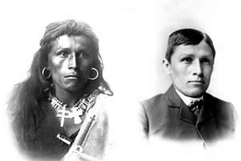
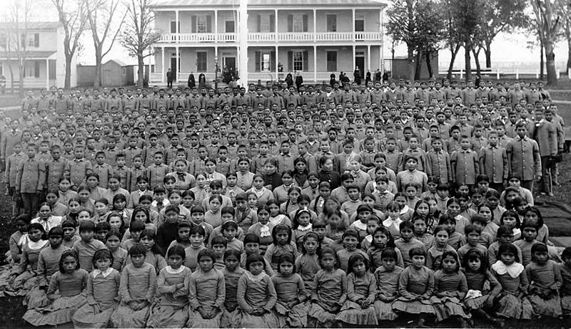

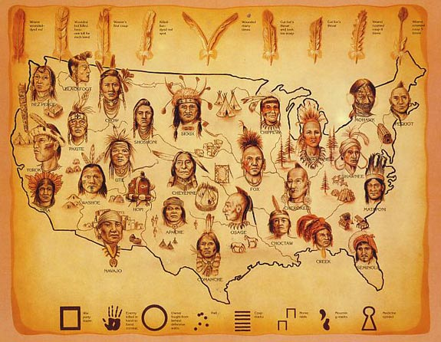

Works Cited
Bear, Luther Standing. My People, the Sioux. Lincoln: U of Nebraska, 1975. Print.
Excerpts from this book were vital, not only in understanding the early Native American experience, but also for purposes of understanding the detriment to being an Indian in an industrializing nation. Luther Standing Bear’s accounts of the Carlisle School provided information regarding the cultural annihilation of the Native American. His accounts were referenced in my paper.
Berkhofer, Robert F. The White Man's Indian: Images of the American Indian from Columbus to the Present. New York: Knopf, 1978. Print.
Berkhofer’s The White Man’s Indian provided historical context concerning the discovery of the Native American. His information was also vital in understanding the accounts relayed back to European and the invention of the printing press. His work was cited multiple times throughout my paper.
Harvey, Sean P. “Must Not Their Languages be Savage and Barbarous Like Them?” Journal of the Early Republic December 2010: 506-507. Web. 6 December 2014.
Harvey’s “Must Not Their Languages Be Savage and Barabarous Like Them?” offered insight into a different take of what sparked Native American Removal. Rather than for selfish purposes which I had initially assumed, he shed light on the truth that was the development of a Native writing system. Among other things, his work was cited in my paper and provided a different take one what I had initially thought.
Power, Susan. "Roofwalker." (2002): n. pag. Web. 08 December 2014.
Excerpts from Power’s book provided cultural context for what it means to be a Native American in present day. I used the story narrated by her protagonist as an example of assimilating American and Native American culture in a peaceful manner. Also, the book showed how a Native can assimilate into white culture and education without entirely neglecting their roots.
"President Obama and the Native American Community." The White House. The White House, n.d. Web. 15 Dec. 2014.
This website provided current information regarding what is being done about Native Americans on reservation land. Obama is attempting to build more viable options for Natives into joining the Middle Class and improving reservation land. The website also cited an article concerning what the attorney general plans to do about the spike in sexual violence against Native American women.
Vizenor, Gerald Robert. Blue Ravens: A Historical Novel. Middletown, Connecticut: Wesleyan UP, 2014. Print.
Excerpts from Vizenor’s Blue Ravens were vital in expressing a method by which Pan-Indianism was effective for the Native Americans. It also provided another example of American and Native American culture combining in a peaceful manner. The source was directly addressed in my paper.

