Metacom(ic) Moments: Written and Visual Representations of King Philip
Images and symbolic constructs of the past are imprinted, almost in the manner of genetic information, on our sensibility. Each new historical era mirrors itself in the picture and active mythology of its past or a past borrowed from other cultures. (George Steiner as qtd in Gerald Vizenor’s Fugitive Poses 145)

‘Otherness’ is constructed on bodies Racism uses the physicality of bodies to punish, to expunge, and isolate certain bodies and construct them as others. (Zillah Einstein 21)

For round his brow, with symbols meet,
In wampum wrought with various die,
Entwined a studded coronet,
With circling plumage waving high. . .
Quaintly embossed with bird and flower,
The belt that marked the Sachem’s power. (from Yamoyden John Wallis Eastburn

This is a story, or it is a story among the many stories.

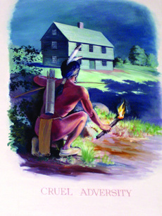
When I was at the University of New Hampshire in Durham, we sat in a seminar room in Hamilton Smith Hall. On the wall, one of the three WPA Art Project murals painted at UNH depicted a typical New England scene: farmers plowing fields, cows being milked, a preacher delivering a sermon and an idyllic picnic scene. Farming in New Hampshire seemed to fit the colonial building and institution of learning. Yet, in the bushes the Indians were hiding. Then after speaking with a colleague, I found out that down the
street at the Durham Post Office, existed another mural
(one of fourteen) called Cruel Adversity. This mural
poses the hidden Indian, torch in hand, as ready to strike the
supposedly innocent colonial settlers. At least in recent years,
it has been the source of controversy as a 2007 newspaper
article discusses. The inspiration for the mural is the 1694

Oyster River Massacre which reportedly “devastated a settlement near the present-day Durham” (LeMire 1). While the post office Pages from the Past project was completed in 1959 (following the WPA project), Native peoples attacking white settlers is a common theme in these murals still seen in public offices.
Now WPA and other commissioned murals are certainly a subject I would like to investigate one day, but they await another project. However, I start with this one to show how images in words and visuals from early New England and discovery narratives have had the power to shape a collective mindset about the Indigenous peoples of the Americas.

In November 2007, my grandson Hunter came home from kindergarten and showed me the teepee he had made in school; he was very excited that they talked about Native Americans. While complimenting his work, I explained that the teepee was one type of Native home, but tht our ancestors built a wetu. We looked at some pictures, and I explained how the wetu was constructed and how there were different homes for different tribes. Later that same week, I arrived with my daughter to pick up Hunter from school; out came children with Pilgrim hats and headbands with feathers. My daughter looked at me with horror—a look that said both “what are they doing?” and “please, Momma, don’t say anything.” Watching this impromptu procession, I was incensed that the monolithic Indian—in history, dress and lifestyle—is the only school education about Indians Hunter is receiving. The Wampanoag have created some programs through the Children’s Museum in Boston that teachers can access, but not all teachers do. And I remembered my own pain in school and to no avail wished things had changed.
These repeated attempts to make Indians into some imagined other are rooted in settler colonial tracks. Gerald Vizenor writes, the indian is an imprinted picture, the pose of a continental fugitive” (145). In Fugitive Poses: Native American Indian Scenes of Absence and Presence, Vizenor makes a distinction between the words Native and indian by his deliberate use of italics and lower-case i, he intends to show this indian as a simulation of the real, one that has been constructed following contact by the deluge of documents and visuals which distort the realities of Native peoples. Likewise, Jean M. O’Brien discusses “replacement narratives” in her book Firsting and Lasting: Writing Indians Out of Existence in New England. She describes an illustration which shows a Native man selling land for a suit of clothes, and writes, “Culture meets nature, culture replaces nature, and the land is purified of Indians in a stark break with the past” xxvi). From the earliest colonial texts we see evidence of replacement as settler colonists took more land and renamed Native spaces. And, even earlier representations depicted America as a strange and exotic place, there for the taking.
These early accounts on Indigenous peoples fired the imaginations of the Europeans and provided them with ideas about the new world as a fertile yet a dangerous place, and the early images that still have persistent power today. Through Columbus, we hear about the naked bodies and how Natives are “so guileless and so generous with all they possess, that no one would believe it who has not seen it (1493 letter in Berkofer 6). Other accounts report Indians as either peaceful or kind or as “cannibals capable of barabarous institutions or customs” (Berkofer 11).
Disputed Discovery In the late sixteenth century, Jan Van der Straet’s drawing Amerigo Vespuccci Discovers America became widely known in Europe due to being reproduced in a 1580 publication, Nova Reperta or New Discoveries. While most of these new discoveries in the text were inventions such as the printing press, this particular print shows the “discovery” of the “New World.” In it a sleeping America wakes to Vespucci’s call. In Novo Reperta,the accompanying caption reads, “America. Americus rediscovers America-he called her but once and thenceforth she was always awake.” (Schreffler 297). While there are other fantastic things going on in this print, my
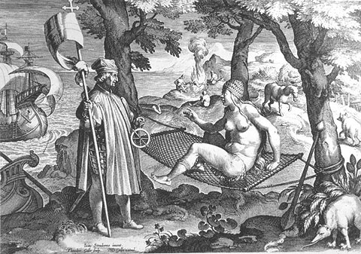
purpose in using this image is to demonstrate the colonizing mindset following such an impression. The artist uses metaphors of sexuality and gender to represent exploration and conquest, a common trope for these conquest narratives. Moreover, the assumption is that naked America wakes from sleep and prepares, even welcomes the opportunity, to be “discovered.” Viewers cannot help but notice the oppositions of male/female, clothed/naked, standing/ reclining, culture/nature which weave into the fantasy aspects of the scene (for more see Schreffler). All the elements in the scene construct the mindset of those who would follow Vespucci. According to Drew Lopenzina, “To the European adventurer, explorer, or settler of the sixteenth, seventeenth and eighteenth centuries, the indigenous peoples of America had no real culture of which to speak” (Red Ink 6).
Among the stories believed and told by Indigenous peoples run these grand counter narratives of discovery and conquest which capture the minds and imaginations of people. The Indigenous body is characterized as a simplistic icon, that which welcomes the invaders or needs help from them. In the process, Indigenous peoples are stereotyped and misrepresented throughout history. Devon Mihesuah tells us, “No other ethnic group in the United States has endured greater and more varied distortions of its cultural identity than American Indians” (9). Early writings and drawings by explorers and colonists abound, and, unfortunately, have had profound impact on writings, images, and living people today. In many cases, these images contribute to the historical and psychological trauma for Native people (see Duran and Duran). In some cases the perpetuation of such ideas contributes to an ongoing genocide of Native peoples. As well, this impact makes it difficult to promote teachings/scholarship about real Indians or to teach your grandchildren about their ancestors and cultures.
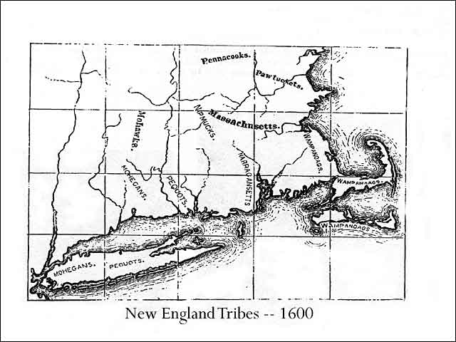
Rhetorical Indigenous Bodies
It is obvious that there is not a university [or other site] in this country that is not built upon what was once native land [native bodies]. We should reflect on this over and over. . . . Janice Gould
My intent here is to look at Indigenous studies from a New England lens. In particular, I will focus on representations of southern New England Indians through interrogating written and visual images of Metacom who is also known as Pometacom and King Philip. Throughout the years, there have been marked changes in these representations, and more particularly in the body of Philip, depending on the author and the sentiment of the nation. In this way, I am aligning with Jay Dolmage’s affirmation of the rhetorical power of the body and Julie Nagan’s research in (re) mapping the colonial body. Further, I consider the Indigenous body as rooted to place. In my conversations with Kerri Helme, who is Mashpee Wampanoag, I have learned that the Algonquian word for land was akeem, with an m which indicated that the land is connected to the body. Following contact and particularly in the religious tracts in the Algonquian language, the –m was dropped from the word. Disconnecting the body from the land is also connected to the way maps of the ‘new world” were constructed showing vacant spaces. As Julie Nagam points out, “Colonial maps describe the [“new world”] space as void or terra nullis by the lack of bodies and their focus on the vast ‘empty’ space. In these land surveys, the purported lack of bodies denies the embodied or living knowledge situated in the land and the indigenous bodies” (149). This concept of the Indigenous body being an extension of the land is important to what prompts King Philip’s War. Then in the quest for nationhood, (re)connecting the body to native soil is desired by whites during the American Revolution and its nationalistic terms (see Jones). Thus, Pometacom’s body is a powerful study because of the ways that it has been imagined by his peoples and their descendants, his enemies and allies, and the public.
My interest in Metacom/Philip’s body stems not only from Indigenous rhetorics, but also from studies of feminized body and the racialized body as well as the the edited collection Rhetorical Bodies. In the afterword of that collection, Sharon Crowley writes
Bodies are sexed, raced, gendered, abled or disabled, whole or fragmented, aged or young, fat thin or anorexic. In other words bodies are marked in ways that carry a great deal of cultural freight. Identities are also marked by cultural constructions of bodies, and hence bodies extend to the subjects who inhabit them and with whose limits they are supposedly con-terminous (361).
In writing and drawings, images of Pometacom/Philip are raced and gendered. They are shaped from squat to tall and muscular, from unattractive to attractive. His body was “fragmented” literally being cut into pieces immediately after his death and distributed around New England. As leader of his peoples, his body represents them; as an enemy of the English, his body opposes them. Zillah Einstein claims, “Identities are constructed on bodies, for bodies, by political discourse” (32-33). So too, his body becomes something larger than life through being dramatized on stage, being eulogized in Boston, on screen—pictures of him become what Vizenor calls interimages, simulations of the real. In colonists’ writing, Philip’s body (and actions) is likened to some kind of animal and is constructed to represent all Indian people as “a treacherous and perfidious Caitiff” (Hubbard). In subsequent decades, Pometacom/Philip’s body becomes a popular culture phenomenon.
Before the War
When the Pilgrims arrived in 1620, the myth of generosity grew as the native peoples actually help them survive the first winter. Following their meeting Massasoit, the Pilgrims immediately urged him to sign an agreement. That 1621 treaty allowed for a peaceful existence between those two groups. However, that didn't prevent the English from warring with other tribes, as the 1937 Pequot Massacre indicates, nor did that peace prevent the English from being suspicious of Indians in general. In fact, many of the writings from this colonial period describe the Indians as savages as heathens who were in great need of being saved. Because of the missionary efforts of Thomas Mayhew, John Eliot and others, vernacular and English literacy grew among Natives and Praying towns were established, yet the land grabs and injustices toward Indians continued.
During this time of supposed peace, there are few reports about Metacom now sometimes referred to as Prince Philip. In fact, “White colonists paid little attention to him (Lafantasie 6). He is said to have been born about 1639. In The Red King’s Rebellion, Russell Bourne notes, little is known about the youthful character or the training of him (96). However, Bourne describes how a young warrior would have been trained. Metacom married Wootonekanuske, sister of Weetamoo, Squaw Sachem, who is married to Wamsutta. They settled in the village of Sowams, not far from Montaup (Mt. Hope). While the couple surely had other children, only one son is ever mentioned in the war narratives. Metacom/Philip was in his early twenties when his father passed over in 1660 (by some accounts 1661) and his brother Wamsutta became sachem. In the Plymouth Colony deeds, it is reported that the two brothers were given English names:
...[A]t the earnest request of Wamsitta, desiring that in regard’s to his father’s lately deceased, an hee being desirous, according to the customs of the natives, to change his name, that the Court would infer an English name upon him, which accordingly they did, and therefore ordered, that for the future hee shalbee called by the name Alexander Pokanokett; and desiring the same in behalf of his brother, they named him Philip. (Bangs)
Ironically, efforts to Christianize the Indians were based on the Apostle Paul’s vision in Acts 16:2 where Paul has a dream that a man from Macedonia said, come to Macedonia and help us. Thus the first seal of the Mass Bay Colony had the image of an Indian with “come over and help us” coming from his mouth. Given this missionary charge, it is unlikely that this image was not in the mind of Governor Prince who renamed Wamsutta and Metacom Alexander and Philip like the royalty of Macedonia. In doing so, it provided an erroneous record that Native peoples had the same system of monarchy as the Europeans. During Wamsutta/Alexander’s leadership, Philip’s activities were not closely watched or recorded, but some that did mentioned his “royal” standing. In 1663, John Josselyn describes his sighting: “Prince Philip … had a coat on and buskins set thick with these Beads [wampum] in pleasant wild works and a broad Belt of the same, his Accoutrements were valued at twenty pounds (Josselyn 144). Because of the significant value of this wampum, Josselyn registers Philip’s body as having royal status.
When Massasoit died, and the English feared that his heir, Wamsutta/Alexander, was preparing to strike against them. Therefore, in 1662, they brought Wamsutta under force to a meeting in Plymouth where he agreed to keep peace. On the way home, however, Wamsutta became ill and died; the Indians believe he had been poisoned by the English. English accounts opposed this claim saying that Wamsutta was feeling feverish after spending the night at John Winslow’s house in Duxbury and before entering the colony. Whatever the case, Pometacom/Philip was now sachem of the Pokanokets. He signed multiple transactions with P,

his mark which may indicate both Philip and Pometacom; often a scribe or Englishman would add “Philip alias Metacom” to his mark. In 1662, Philip was called to Plymouth; at that meeting he said he desired to keep the peace as his father had made. Yet, each time the colonists would hear disturbing rumor, they would call Philip to meet with them and make him promise to keep peaceful relationships. One time they fined Philip for taking action on a colonist. Thus, after signing at least two more agreements with the English, Philip’s distrust grew. Varying accounts report that on April 12, 1671, Philip entered a Taunton church with his men “with their faces and bodies painted after their savage manner” (Plymouth Records/Ellis and Morris 40) where he was once more called to meet. Then in 1675, the body of John Sassamon, a Christian Indian, was found under the ice at Assawomsett Pond. Sassamon had been a favored student of John Eliot whose mission was to convert the Indians to Christianity. There is much speculation about Sassamon leaving the Christian community to become Philip’s scribe. Some suggest it was through Eliot’s encouragement and greatest desire was to convert Philip. At one point, Eliot writes that Philip “did this winter past upon solicitations and means used, send to me for books to learne to read, in order to praying unto God, which I did send, and presents with all (qtd. in Lepore 39). So fervent was Eliot in this mission to convert the Indian king, that he created an imagined dialogue in which Philip speaks,
Who can oppose or gainsay the mountainous weight of these arguments? I am more than satisfied. I am ashamed of my ignorance, and I abhor myself that I ever doubted of this point. And I desire wholly to give myself to the knowledge of, and obedience to the Word of God, and to abandon and forsake these sins which the word of God reproveth and condemeth. (qtd in Gray 74).
Eliot’s purpose was to bring the gospel to the Indians and thus moving them from a savage to civilized state; as mentioned earlier, the Europeans believed the Indians to exist in an uncivilized state. Eliot deemed that if their leader converted, there was more hope to covert the followers. His fantasy “makes life bearable,” as Zillah Einstein points out, “because it enforces borders and limits. It makes the unimaginable manageable through forced enclosure” (21). The explorers and colonists believed the souls of the inhabitants of the “New World” needed saving; they also feared this “unimaginable” state of New England which they saw as overtaken by the devil. By forcing conversion on the Natives, they both justified and could endure their settlement there. However, Philip’s conversion would only remain a wish for Eliot.
Having a Christian Indian as Philip’s counsel, then, was seen as tactical; things changed with Sassamon’s death. However, the means by which Sassamon’s occurred are still debatable. His body was ordered exhumed by the English when a witness came forth, and they determined that Sassamon was hit over the head and his body was hidden under the ice. Many colonial accounts blame Philip and his men for murdering Sassamon. John Easton’s 1675 account questions whether Sassamon was murdered or accidentally feel through the ice injuring his head (4) in part because the Indians considered the witness to be untrustworthy. Russell Bourne reports that Sassamon was equally respected by both the English and the Indians (104). In Red Ink, Lopenzina offers that “it is quite possible that he [Sassamon] moved comfortably from one realm to the next, not in flight, but existing in both simultaneously” (165). Despite this possibility, in June 1675 two of Philip’s men were hanged for the murder, and this act added to the breakdown of trust between the English and Indians. That August in Rhode Island, Easton and others met with Philip and his chief men who gave their complaints regarding the English. They said that the English would not believe the testimony of “twenty honest Indians,” but if “one wrong Indian” made an accusation “it was sufficient” (Easton 4-6). Two weeks following the hanging, a “young lad” shot an Indian. Wampanoags responded in attacking Swansea and the conflict began (see Easton, Hubbard, Lepore, Mather, Saltonstall, and others). Easton’s account tells us that the Commissioners in Boston declared war on September 9, 1675.
Writing on King Philip’s Body
Once war broke out, it gave colonists additional motive to continue with their inscribed perceptions of Indians. In fact, one could argue that the war served to justify their opinions and they were quick to record them. They write on the bodies of Indigenous peoples making them , as Foucault does, “a central site for cultural inscription and social regulation” (in Seltzer 7).
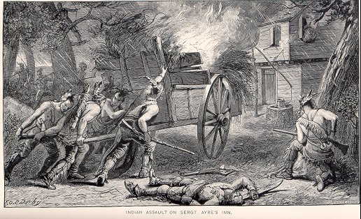
Nathaniel Saltonstall’s Present State of New-England with Respect to the Indian War was followed by John Easton’s A Relation of the Indian War, by Mr. Easton, of Rhode Island, 1675 both available in December 1675. Jill Lepore details that during and up to eight years after the war more than twenty-one accounts were written “many in more than one edition, for a total of no fewer than thirty separate printings in Boston, London, and Cambridge” (Lepore 51). It seems that there was competition among some to get their “true” account to readers before others. In these, the Indians were now not just “heathens,” but rather “hell hounds” and “bloodthirsty savages.” Thus, as Einstein writes, “the physicality of the body becomes a horribly powerful resource for those who wish to conquer, violate, humiliate, and shame” (33). Within these accounts, Indians who attacked and killed settlers were decried as barbarians who committed torturous acts. In contrast when describing English attacks, the tone is matter-of-fact indicating that the “barbarians” deserved their fate. Mary Rowlandson describes the attack on her town on Lancaster where “Christians lying in their blood… like a company of sheep torn by wolves. All of them stripped naked by a company of hell-hounds” (in Lepore 92). Yet, the English give no descriptions of their own such behavior during the Great Swamp Massacre on December 19, 1675 where hundreds of Native women, children and elderly were burned to death. Rather , they “emphasized the justness of the attack and celebrated it as one of the few ‘fair’ contests of the war (Lepore 88-89). Rarely do the English call their own acts brutal. However, John Easton does levy criticism on the English: “It is true that the Indians are very barbarous people, but in this war I have not herd [sic] of their tormenting any; but that the English army caught an old man
and tormented him” (9). As Jill Leporeand others point out, acts of cruelty happened on both sides. The English and Indians both mutilated bodies as well as displayed body parts, albeit for different purposes (174). Despite the balance in Easton’s account, the racism against and hatred of Indians in many of these accounts are clear. On the one hand the English are now immersed in their worst fear—that they would fall back into an uncivilized state. Their accounts, then, attempt to make distinctions between themselves and the Indians. In her book Hatreds, Zillah Einstein observes, “Racism uses the physicality of bodies to punish, to expunge, and isolate certain bodies and contrast them as outsiders” (21). I argue that these accounts do so with Pometacom/Philip’s body. In his1671 narrative, William Hubbard, writes of Philip, “the devil had so filled the heart of this savage miscreant with envy and malice against the English that he was ready to break open in war” (Hubbard 163-64). At other points, Hubbard calls Philip “this treacherous and perfidious caitiff” and asserts that Philip never wanted peace but had been “plotting all along with Indians to mount a general insurrection” (79). Increase Mather, who rushed in 1676 to get his account published before Hubbard’s, names Philip as the “blasphemous, murderous heathen who is the perfidious and bloody author of war and woeful history” (71). Richard Hutchinson calls Philip “a pestilent Ringleader” (Lincoln 104). By casting Philip in this way, the authors ignore their complicity in bringing about war and their similar behaviors in contests of the war. Rather, their rhetorical strategy is to use Pometacom\Philip’s body as the scapegoat.
Benjamin Church is credited with bringing Philip to his death. In 1772, his son Thomas publishes Church’s Entertaining History. In a footnote the younger Church criticizes former authors to create a credible ethos for his father: “our author is by no means lavish of ill names as many early writers. Hellhounds, fiends, serpents, caitiffs, dogs &c., were the common appellations” (Church footnote † 26). It is true that accounts by others are “lavish” with names which mark Philip as a brute. Each author takes great delight in telling of Philip’s eventual end on August 12, 1676 in a swamp near Mount Hope. Increase Mather exhorts in comparing the destruction of Philip’s body to the Biblical Agag who was “hewn to pieces before the Lord.” Likewise, Philip was “cut into four quarters, and is now hanged up as a monument of revenging Justice, his head being cut off and carried to Plymouth, his hands were brought to Boston” (Mather 72). Hubbard writes, “Philip like a wild savage beast, having been hunted by the English, forced his way through the woods . . . [and] at last was driven to his own den (233). So perhaps it is the fervor of victory when Philip is slain that gives license to Church’s joining the others as he describes Philip’s body. He orders the Indians to drag the body out of the mud, “so some . . . Indians took hold of him by his stockings and some by his small breeches (being otherwise naked) and drew him out through the mud to the upland and a doleful, great, naked, dirty beast he looked like” (125). This description marks not only Church’s disgust, but also Philip’s inability to ever be civilized in the eyes of the English. For them, the naked body signifies “both cultural and spiritual depravity.” Lepore reminds us that for the colonists, the move from “Barbarism to Civilite” could only be accomplished by the Indians “forsaking their filthy nakedness” (Lepore 80). In his description, Church marks Philip’s muddied body as literally filthy and naked, thus marking him “a dirty beast.”
Capturing Philip’s Body
Given these accounts by the colonists, it is of little surprise that one of the earliest pictures we have of Philip makes us recoil. The cover of Church’s Entertaining History has an engraving by Paul Revere called Phillip of Pokanoket. The figure is “pygmy-like’ in a mix of garb depicting both the native and European style. It was called by Charles Deane in 1882 “a fanciful and frightful looking picture.” In 1959, Bradford F. Swan published a short book on the image called An Indian’s and Indian, or, the Several Sources of Paul Revere’s Engraved Portrait of King Philip. His book investigates the creation of the etching after hearing from Charles
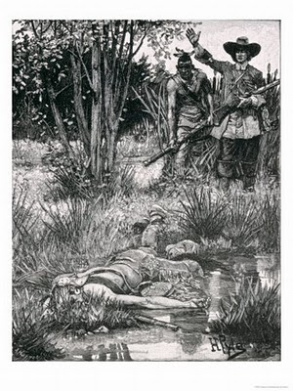
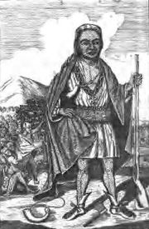
Deane, that it was “copied” by Revere. Swan proceeds to uncover the sources of Revere’s work explaining that the engraving was modeled after a series of mezzotints called the “Four Kings of Canada” published in 1710 in England. Two pictures bear a striking resemblance to Revere’s. The primary basis for Philip is Ho Nee Yeath Taw No Row Mohawk chief John of Canajohaire, and other details were taken from of Sa Ga Yeath Qua Pieth Tow or Mohawk Chief Brant (seen below). Those who know Native history
understand that the Mohawks were enemies of Philip (Swan).
Revere borrows heavily from the Ho Nee Yeath Tah No Row portrait using the stance, clothing and mantle as well as the facial features. As Swan points out, “This Indian, alone of the four… has what might be called Negroid features—the broad somewhat flattened nose with prominent nostrils and heavy lines to either side, the wide-set dark, luminous eyes and the broad rather thick-lipped mouth. All these characteristics can be seen… albeit crudely handled” (Swan). While it is clear that Revere took his ideas from these portraits and one other image, a
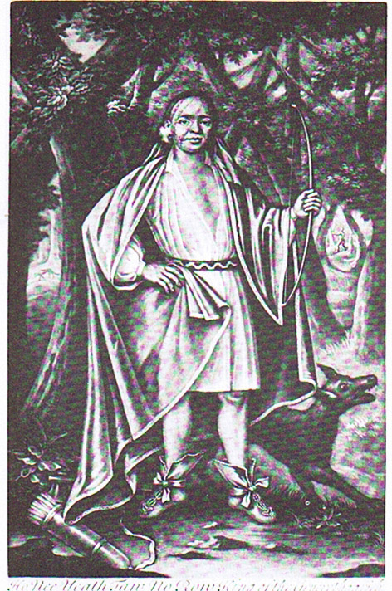
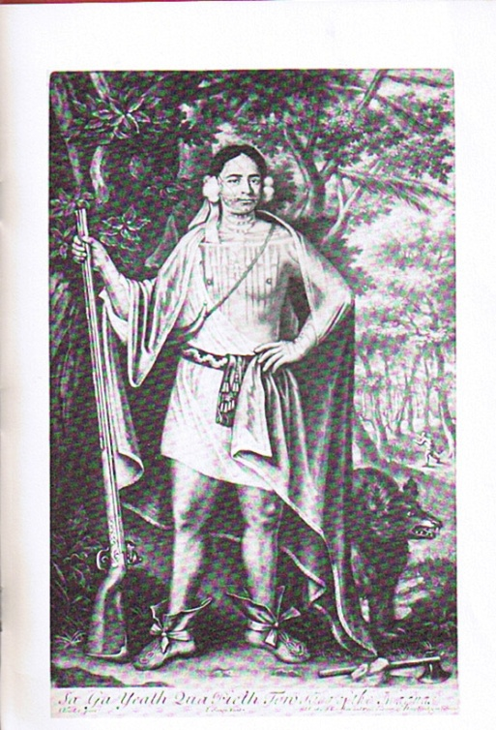

1764 engraving of an Indian council in Ohio, some details are likely “imaginative touches” by Revere (Swan). I would suggest that the idea for Philip’s headband and belt are such as described in Josselyn, Church, and Rowlandson. All three discuss wampum belts which are “wrought” with various birds, flowers and other figures
What’s more important about this image is that it is the earliest print to shape Philip’s body for a consuming public. After the war many made pilgrimages to Plymouth to view Philip’s head; Cotton Mather rips the jawbone from the decaying skull (Lepore 180). Philip’s hand was also on display in Boston. Yet, this print is the initial mass media image of Philip, and reminds contemporary viewers of how the physicality of the body is used to punish (see Einstein). The image is repulsive to any one as Bourne points out, “making the point that enemies deserve nothing but contempt” (4). The stature, too, is deliberate marking Philip as small. In this picture, Philip’s body does compare to what we know of Algonquian men from earlier accounts. William Wood describes the men’s bodies as “black haired, out nosed, out breasted, lank bellied, well heeled, flat kneed with handsome grown legs and small feet” with “bronze and tawny” complexions (Russell 30). Russell Howard in Indians before the Mayflower notes that the average height of skeletal remains in shore burials is 5’10” and some reaching 6.5 feet; other Europeans describe the males as “taller than their own countrymen, and very straight” (Russell 30). Other pictures which may or may not be of Philip depict a more accurate height for Indian men. Of Revere’s Austin Meredith writes, “This crude and derivative engraving would subsequently be used by New England whites to demonstrate that the sachem Metacom had indeed been in his person quite as hideous and malformed and dwarfish as his white enemies in his generation had been pleased to suppose” (Meredith 3) . By all accounts it is a hideous portrayal as if all the venomous words of the colonial writers found their way into the hands of Revere as he made the engraving.
One can only imagine the state of mind of the engraver. Some argue that the images done of Phillip were based on the diary of Benjamin Church who led the forces that eventually killed Philip, but as Church’s son insists, his father used few of those appellations. It is possible that Revere read or heard the public sentiment which speak of Philip’s barbarism.
Other engravings of the time show groups of English and Indians with the taller and more assertive figure. One engraving could be of Metacom telling the Englishman to go, to get away as an attack on that area is eminent. Easton’s account mentions, “As for Philip we have Good evidence that he advised some English to be gone from their out-places where they lived or otherwise they were in danger of being killed (10). The engraving depicts a figure who is in charge, assertive, and strong. His body aligns more with descriptions of Algonquian men.
. 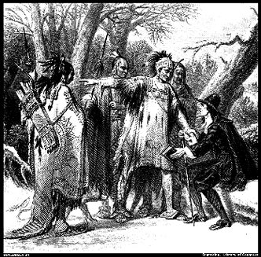
There are many images of Pometacom/Philip which beg interrogation. Some are included for purposes of showing the differences. Two of images worth mentioning. One shows a figure arms crossed with one foot up on a stone creating a more defiant body. The other has Philip’s signature or his mark. While it is unclear if Philip himself was literate, we are sure that he had several Indian interpreters including John Sassamon); his mark, however, is an important reminder of the literacy acquired by the Indians of New England which may have been a contributing factor of the war (see Lepore). Many of these images used features from others, including the earlier Revere image, often in pose or style of clothing. Of course some were used as illustrations for continued stories and articles about King Philip’s War; even to this day, new images of Philip appear.
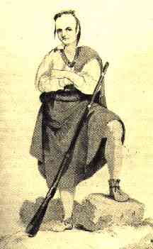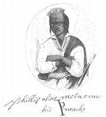

Adapted from a lithograph by T. Sinclair appeared in Events in Indian History, 1842.
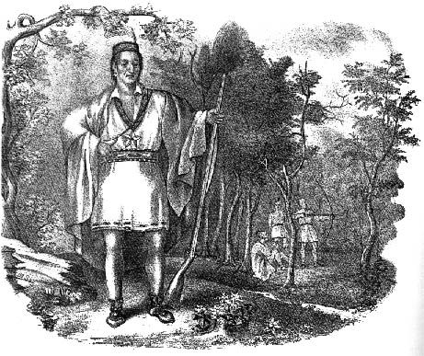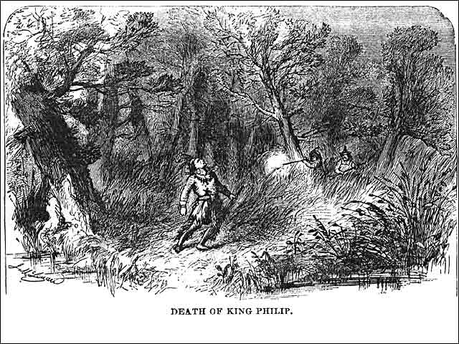

Staging Philip’s Body
The story of Phillip doesn’t end with his death in the swamp, nor does it end with the savage image. While these early accounts of Metacom persist in shaping the past and present, Metacom becomes an interesting figure as national perceptions of Indians undergo change. In fact, Philip becomes a complex historical and literary figure by the 1800s—a hero and patriot. Indeed, as Lepore writes, “Philip … became a central figure in the search for American identity and an American past” (224). This search and recuperation of Philip’s body is what Patrick Wolfe sees imbedded in settler-colonialism ideology. He writes, “On the one hand, the settler society required the practical elimination for the natives in order to establish itself on their territory. On the symbolic level, however, settler society subsequently sought to recuperate indigeneity in order to express its difference –and accordingly its independence—from the mother country” (Wolfe 389). The reshaping of Philip’s body serves that purpose for the citizens of the new nation. As that nation works to establish itself, Philip’s body becomes part of its rhetorical strategy.
Leading up the nationhood, colonies created by the French, Spanish, Dutch and English completed with one another to buy up and settled upon native lands, and by that time of the Revolution were using Indians to help them fight their battles or were fighting against them. Moving closer to nationhood and the years that followed, Indians were seen as a vanishing race, a group that needed to be pushed out of the way for the progress of the whites. In 1830, the Indian removal act, proposed by Andrew Jackson, was approved by Congress and began the forced removal of Indian tribes to the west. As B. Donald Grose writes, “the removal of the Indians east of the Mississippi . . . had been viewed by some American statesmen as the final solution of the was viewed as the Indian problem (181). . . . Removal of tribes was opposed by church missionary groups, some national and regional politicians, and most of the involved Indians. Those tribes that experienced early colonization such as those in Massachusetts and other New England states were seen as relics of the past and in some cases declared extinct. As Herdon and Sekatu state, “The number of native people living in southern New England had been drastically reduced by war, disease, and outmigration; now those who remained struggles to exist on paper—and to obtain the rights of continued freedom . . . (125). Meanwhile as Native peoples struggle to maintain lands and identities, the United States declares its independence and struggles to remake its own history. Thus, recasting King Philip as a cultural icon revives his body and its rhetorical nature. His body comes to represent the dying Indian, the last of his race. During the 1800s “the phenomenon of ‘lasting,’” as Jean O’Brien names it, became “a rhetorical strategy” (107). Seeing themselves in relationship to an Indian past, writers and others ignored the existence of real Indians and instead developed this Noble savage motif. By the early 1800s, a tragic, romantic Indian hero would settle into the American mind. As the noble savage, Philip dies over and over again and not just for his nation, but for the image of a new country.
For his contribution to this genre, Washington Irving writes Philip of Pokanoket: An Indian Memoir in 1820 in which he criticizes early accounts for not giving a more accurate picture of those who “flourished in the savage life” (75). He writes,
The imagination shrinks at the idea of how many intellectual beings were hunted from the earth—how many brave and noble hearts of Nature’s sterling coinage were broken down and trampled in the dust!”
Such was the fate of PHILIP OF THE POKANOKET, an Indian warrior whose name was once a terror throughout Massachusett and Connecticut. He was the most distinguished of a number of contemporary sachems… (75-76).
Irving’s use of “intellectual beings” interests me. While I understand his essay to be mourning the demise of the Native, very few whites would connect intellect with Native peoples. Throughout, he glorifies Philip while nullifying that any Natives exist is his area of the country. Irving has read accounts of the war, no doubt, and criticizes how the authors most often “applaud” their own brutal actions and condemn Philip’s. He writes that they are“reviling Philip as a murderer and a traitor, without considering that he was a true-born prince, gallantly fighting… (77). In typical form of this new genre, his essay ends with the noble savage theme, “such is the story of the brave, but unfortunate King Philip” who dies “without a pitying eye to weep his fall...” (80). Throughout Irving builds the story, calling Philip a patriot, a prince; describing Philip as brave, proud of heart, and heroic. Then Philip dies without “a friendly hand to record his struggle” (80). With his essay, Sally L. Jones notes that Washington Irving “rehabilitates Philip in nationalistic a lens as ‘but a patriot attached to his native soil’” (Jones 15).
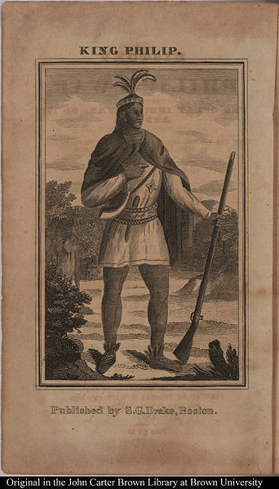
It is interesting that the northeast, where Indians were considered by whites to be extinct, that a New England Natives became the resource for Indian heroes. In the late 1820s and 1830s Indian removal became one of the most debated national issues (Grose 183). This search for a hero resulted in a stark change in body for King Philip. In 1825, Samuel G. Drake republishes Benjamin Church’s account of King Philip’s War with a new image on the cover. Philip’s body is transformed
from the ugly, squat, dark image to a tall and robust figure. His legs are long and muscular as he stands in a patriotic pose with his hand over his heart. This body reshapes the public perception of Philip. According to Alan and Mary Simpson, “the public response was so favorable,” and Drake published a larger volume in 1827 (see Jones). These publications recuperated Philip’s body bringing him and the romantic idea of the Indian to higher status.
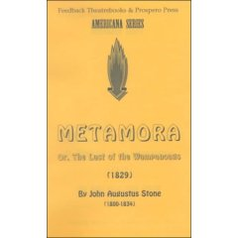
Not to be outdone, James Fenimore Cooper publishes his The Last of the Mohicans in 1828. That same year a young actor puts out a competitive call for a playscript to be written which has an Indian hero. The stage was set. With the debate on Indian removal reaching its climax, this decision to create a play “could not have been more opportune” (Grose 183). Twenty-two-year-old, Edwin Forrest had been a member of a theatrical company in New Orleans in 1824. As the story goes, Forrest after a dispute with the manager of the theatrical company befriended Push ma Taha who was a Choctaw chief. He then “departed with Push ma taha to spend a month with the Indians” (184). The script competition was won by John Augustus Stone, a relatively unknown playwright, who used Metacom /King Philip as the play’s hero and of the historical background of King Philip’s war as the setting. Of interest is that another playwright, Robert Montgomery, submitted a script, King Philip or the Sagamore, to Stone for comment. It was returned to Montgomery without comment (Grose 186). Stone, like Revere, may have benefitted from someone else’s idea. However, since Montgomery’s play is not available for comparison, there is currently no way to know. Further connecting this play to Indian Removal and American identity is the fact that the selection committee and Forrest were all “ardent supporters of General Andrew Jackson” (184). Forrest
used “the knowledge he gained from this stay [with Push ma Taha] to
shape his portrayal of Metamora” (184). Metamora, the last of the
Wampanoags, opened on December 15, 1829 and “has remained the
most performed Indian play in the history of the American theater” (185).
Its “phenomenal success made Forrest into a star” and, as Grose contends, all other roles he performed “were extensions of his stage Indian, Metamora, the proud doomed individual” (185).
While role of Metamora made Forrest into a star of the stage, it also transformed the persona of Metacom. Forrest’s portrayal of Metamora engraved his interpreted figure into the
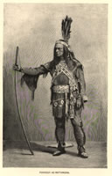
minds of the audience. Stone creates a “King Philip [who] impetuous and highly bombastic. Jones writes that “the character of Metamora was thus constructed to instill a sense of the exotic and ‘otherness,’ while at the same time retaining attributes with which the audience would identify” (16). These attributes include “bravery, justice and patriotism” while being devoted to his wife and child (17). Additionally, all these ideals, including his spirituality “spring from nature” 17 and flow from his heart as the character Walter states. This King Philip, known as Metamora, sees heroic immortality in defeat: ‘We are destroyed—not vanquished; we are no more, yet we are forever’” (Grose 186).
According to studies of the play, the complexity of the main character creates a complicated noble savage stereotype. “Metamora not only exhibits all the stereotypical traits of the noble savage, he also incorporates the attributes of the noble savage’s antithesis, the red devil” (186). Jones claims that Metamora is “the Jacksonian child of nature on a grand scale” (17). At the end of the play, Metamora turned to the hero and dies as the noble savage and the last of his race. The audiences cheered when viewing the play; they appreciate Metamora as defiance but expect and accept his destruction in the end, “ he was after all only an Indian” (190.) White Indian relations of the 19th century would embrace a play about the tragic fate of an American Indian. However when the Cherokee nation was appealing its case to the Supreme Court the character of Metamora was introduced in Augusta Georgia. When Metamora criticizes the puritans for the cruel treatment of of Indians, the Georgia audience reacted with boos and hisses. Forrest was charged with assaulting the people of Augusta by portraying an Indian who could be considered to condemn the actions been taken against that claims of the Cherokees. Metamora played on stage for over 50 years. As Grose claims, “Metamora the last of the Wampanoags had been rolled in the service of white America’s vision of manifest destiny” (191). Sally Jones writes, “the wish for filling myth of the vanishing breed… was very important to the ideology and expanded the new country and established white hegemony” (22).
However, like the crowd in Georgia, there were others who scorned the actor for his role. In many cases, the responses revealed the mass of deeply held racist attitudes toward Indians that lay beneath the surface of the quest for a romantic Indian past. Despite the play’s popularity, according to Lepore, one critic compared that the grunting and high-pitched yelling of Forrest as he played Indian to noises made by a “gorilla” or “ferocious baboon” (Lepore 223). Yet, Forrest believed “it was the genuine Indian who was on the stage” (Grose 189) as his biographer reports. Many in the audience probably thought so as well as the stereotypical Indian was being etched into their minds. Metamora/Philip died over and over on the stage, they were both saddened but knew this was the only fate an Indian could have.
An 1830 painting by Frederich Styles Agate depicting Forrest as
Metamora hangs in the national portrait gallery at the
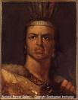
Smithsonian. It, too, portrays Philip’s body as far different from
Revere’s engraving. Displaying physical beauty, this body
subverts the original image inviting the public to gaze upon it.
As Matthew Rebourn claims, “Forrest’s ‘redding up’ as Meta-
mora was therefore transformed from impressive stage act to a
popular culture performance” (460). This particular image fits
that of an icon. [MORE Actor=Philip/or put this is concluding materials?]
Eulogizing Philip’s Body 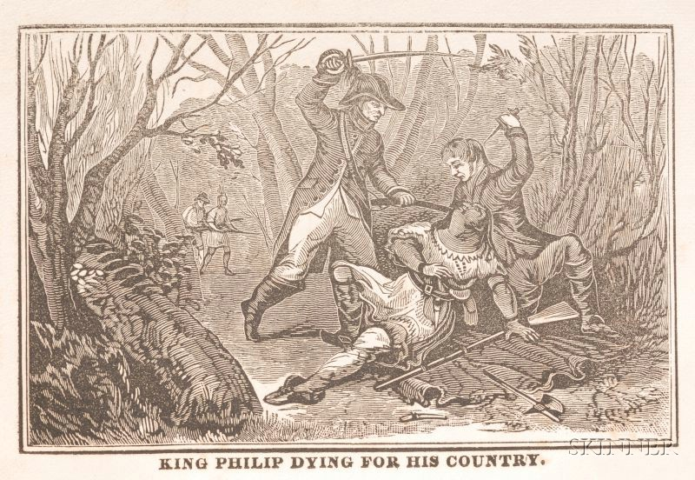

It would be 160 years after Philip’s death that he would have a public mourning. Philip’s body, as described earlier, was mutilated upon his death with the quartered pieces hung in four trees in Rhode Island, his head sent to Plymouth and his hands to Boston. William Apess, wrote the Eulogy on King Philip as Pronounced at the Odeon, in Federal Street, Boston, by the Rev. William Apess, Indian, January 8, 1836.” Robert Warrior rightly calls Apess an Indian intellectual and insists that the Eulogy is the “pinnacle of Apess’ intellectual career” (1). Even though 160 years had passed, Philip was still thought of as that “cruel and bloody author” of the insurrection in 1675. With the popularity of Metamora, he was also now seen as the tragic hero of and the last of his race. However, in his Eulogy, Apess reassembles Philip’s body and presents it to a public audience. Apess, a Pequot, delivered his eulogy twice, the first time at the Odeon, an event which he paid and advertised for himself. At that moment, Apess’ body stood there as proof that Indians did not die out with King Philip, an act of survivance (survival + resistance), as he connects heart and blood to Philip’s body. During the second presentation, Apess also recited the Lord’s Prayer in the Massachusett language (see Apess, Lepore). In the Eulogy, Apess exercises rhetorical sovereignty, which Scott Lyons defines as “the inherent right and ability of peoples to determine their own communicative needs and desires in this pursuit, to decide for themselves the goals, modes, styles, and languages of public discourse” (449). Since the writing in the colonists accounts attempted to erase the Indian from existence and whitewash history, Apess steps in to speak of these injustices in the past and present. He “raises questions of history by arguing that Metacom was as great as Philip of Macedonia, Alexander the Great and George Washington” (Warrior 36).
Further, Apess uses Philip’s body to condemn the political actions taken against Indian peoples. The Eulogy is delivered just five years after the Cherokee Nation v. Georgia case in which the Cherokee drafted their constitution and laws to exist as a nation within the United States. Georgia determined all these laws void, and the Cherokee Nation brought their case to the Supreme Court. Chief Justice John Marshall wrote the opinion that the court was not the authority in this case. However, when a second case, Worcester v. Georgia, came before the court, Georgia was found to violate the Constitution in blocking Cherokee sovereignty (see E. Wolfe). In writing his Eulogy, Apess addresses Native sovereignty when he describes transactions between settlers and Indians which recognized Wampanoag sovereignty (see E Wolfe). As discussed earlier in this piece, the word for land was akeem, which meant the body and land are connected. In showing the loss of Native lands in the Eulogy, Apess resurrects Indian bodies in significant ways to reveal the injustices still being enacted on Native bodies in his present, and his words live on in our present.
Apess' Eulogy for King Philip also resurrects Philip’s body by defying the traditional interpretation of Philip and his reasons for entering into the war. Apess works to recover King Philip's reputation and draw attention to distinctions between two groups of people. He writes, “the Pilgrims landed at Plymouth, and without asking liberty from anyone they possessed of themselves of a portion of the country, and built themselves houses, and then made a treaty and commanded them [Indians] to accede to it” (280). He goes on, “And yet for their kindness and resignation toward the whites, they were called savages and made by God on purpose for them to destroy” (280-81). He recounts “savage” actions of the settlers who then “gave thanks to God for [their] murders” (280).
In restoring Philip’s body for his larger purpose and not merely to mourn Philip, Apess invokes his presence to honor the existence of Native people as well as to help whites to see their own complicity in actions taken against Indians. He states, “Justice and humanity for the remaining few prompt me to vindicate the character of him who yet lives in their hearts, and if possible to melt the prejudice that exists in the hearts of those who are in possession of his soil . . .” (277). In true epidictic fashion, Apess points to the honor, nobility, and courage of Philip calling him "the greatest man that ever lived on American soil." (276). Before this white audience, he takes the opportunity to revise Philip’s image comparing him to their heroes:
[T]he never to be forgottenimmortal [George] Washington lives lovedendeared and printedengraven on the hearts of every white in America, never to be forgotten in time,—even such is the never to be forgottenimmortal Philip honored, and held in memory by the made to feel less worthydegraded who appreciate his character; so will every patriot… respect the simple, primitiverude yet all-accomplished son of the forest, that died a someone who dies for a causemartyr to his cause, though unsuccessful, yet as glorious as the American Revolution. Where, then, shall we place the hero of the wilderness? ( 276 ).
Throughout the Eulogy he constructs King Philip’s ethos and constructs an image of a great leader. As Eric Wolfe contends, Apess present’s “King Philip’s story as on that has yet to be properly written, despite the Euroamerican histories that purported to do so” (E. Wolfe 6). In first describing Philip for his audience, he tells of Philip’s descendancy from “one of the most celebrated chiefs in the known world” (Apess 278). He commends Philip for taking the responsibilities of his office, after his father’s and brother’s deaths, and for knowing that “his honor [would be] put to the test” (Apess 288). He maintains that Philip did not set out to go to war, but when it was inevitable, “no warrior of any age was known to pursue such plans as Philip did” (306). As well, he speaks to Philip’s benevolence which was “very great” noting that Mrs. Rowlandson attested that Philip was “not cruel to his foes” (306). Further Apess explains Philip’s generosity when the leader cuts up his coat “nearly wrought with mampampeag [wampum]” to distribute among his men (296). Apess uses rhetorical strategies to demonstrate how Philip embodies republican ideals as he allies tribes, exhibits benevolence, and demonstrates knowledge and forethought (see Gussman). In evoking this heroism, Apess forces his audience to identify with Philip. His words are in sharp contradiction to those in colonists’ accounts (Apess, in particular, criticizes Dr. Mather), subverting the body of Philip from cruel barbarian to a hero who gives his life for his country.
Reshaping Philip’s Body in the 21st Century
As we consider Metacom/Philip in the twenty-first century, it should be noted that his strong presence still roams. Hundreds of books from histories to children’s volumes have been written along with countless articles. In April of 2009, a new image of Philip appears in the first episode of We Shall Remain: After the Mayflower. Played by Annawon Weedon (named after Philip’s friend and council), Weedon presents us with a new Philip. Weeden’s image is likely one of the most accurate we have of Philip to date. The Mashpee Wampanoag man, who stands over six feet tall, is adorned with a nine-inch wide wampum belt which surely would have reached Church’s ankles when it was draped on him. This new telling of the Pilgrim-Indian story, however, still ends with Philip’s head on a pole at Plymouth and evokes controvesy.

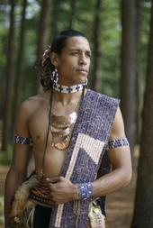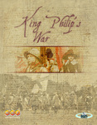
In addition, a new board game, a war game called King Philip’s War was designed by a NJ social studies teacher. The game is played with major figures in the original conflict. To win on the Indian side, the player must capture major settlements; to in on the colonists side you msut capture Connicut or King Philip. The production sparked protest from area Natives and began a dialogue between the game’s producer and local Native peoples.
Lessons from Philip’s Body
My cousins Donna Mitchell and Kerri Helme and I like to take roadtrips around southeastern New England. We stop at Awashonks Woods, Weetamoo’s Woods, Wattupa Pond, King Philip’s Cave, Council Oak and other Native historical sites, sites we consider sacred. We offer tobacco, say prayers and honor ancestors. We speak to each other about what happened at that place, who may have walked the lands, imagine our ancestors. Together we give presentations that help right a history that paints our peoples in erroneous ways. We plant and tend a garden and create weavings, pots, and other artworks in traditional ways. We teach our children and grandchildren the same.
So what is to be said of all this? Why explore these images? It goes back to the story of my grandson and to the fact that bodies of Indian peoples are still being manipulated today in sports, entertainment, popular culture, and politics. Today, sports teams still use racist mascots. It is appalling that the football team representing the Nation’s capital has a name which is a racial slur to a majority of Natives. So, too, the actions of these sports fans perpetuate the images in the colonial accounts. In examining films from Dances with Wolves to Avatar, the mentality of the white savior still exists. Even in documentaries meant to correct a past, Native people are not consulted. Take the Aquinnah Wampanoag response to After the Mayflower: “We have not struggled to maintain our tribal cultural identities for nearly 400 years since colonization to be disrespectfully ignored and dismissed or to have our history misrepresented for the purpose of entertainment” (letter from Aquinnah Wampanoag). Furthermore, when the United States went into Pakistan and killed Osama Bin Laden, the code name for the terrorist leader was Geronimo. More recently a new trend in clothing has a Native theme; models come on stage sporting replicas of sacred objects such as Native headdresses. Lines of clothing with Native designs are attributed to tribes. And this year Ekco is combining the popularity of the skull motif with Indian headdresses. The misrepresentations and racism don’t stop. Thus it is imperative to have a rhetorical and historically understanding. Gloria Anzaldúa writes, “for images, words, stories to have . . . transformative power, they must arise from the human body—flesh and bone” (97). Pometacom/Philip’s body has transformed throughout history and helps us to understand why we must act to transform these erroneous images on Indians so we can participate in a more just world.

Works Cited
Anzaldúa, Gloria. Borderlands/La Frontera: The New Mestiza. Third Edition. San Francisco: Aunt Lute, 2007.
Apess, William. On Our Own Ground: The Complete Writings of William Apess, a Pequot. Amerst: University of Massachusetts Press, 1992.
Bangs, Jeremy. Indian Deeds: Land Transactions in Plymouth Colony, 1620-1691. New England Historic Genealogical Society, 2002.
Bank, Rosemarie K. “Staging the’ Native’: Making History in American Theater Culture.” Theater Journal 45:4, Disciplinary Disruptions. The Johns Hopkins University Press, Decemebr 1993. pp 461-486.
Berkhofer, Robert F. The white man's Indian: the images of the American Indian from Columbus to the present. New York: vintage books, 1978.
Bourne, Russell. The Rd King’s Rebellion: Racial Politics in New England 1675-1678. New York: Atheneum, 1990.
Bird, S. Elizabeth, Ed. Dressing in Feathers: The Construction of the Indian in Popular Culture. Bolder Colorado: Westview Press, 1998.
Brooks, Lisa. The Common Pot: Recovering Native Spaces in the Northeast. Mineapolis: University of Minnesota Press, 2008.
Church, Benjamin. The entertaining history of King Philip's war : which began in the month of June, 1675 ; as also of expeditions more lately made against the common enemy, and Indian rebels, in the eastern parts of New-England ; with some account of the divine providence towards Col. Benjamin Church. Newport, RI: Solomon Southwick, 1772.
Church, Benjamin. The History of King Philip’s War; Also of Expeditions against the French and Indians in the Eastern Parts of New England, in the Years 1689, 1690, 1692, 1696, and 1704. With Some Account of the Divine Providence towards Col. Benjamin Church. Boston: Howe and Norton Printers, 1822.
Crowley, Sharon. “The Material of Rhetoric.” Afterword in Rhetorical Bodies. Jack Seltzer and Sharon Crowley, Eds. Madison, WI: The University of Wisconsin Press, 1999.
Drake, James D.. King Philip’s War: Civil War in New England. Amherst, MA: University of Massachusetts Press, 1999.
Duran, Eduardo and Bonnie Duran. Native American Postcolonial Psychology. Albany New York: state university of New York Press. 1995.
Eastburn, James Wallis. Yamoyden, a Tale of the Wars of King Philip. In Six Cantos. New York: Clayton and Kinglands Printers, 1820.
Easton, John and Royster, Paul (editor), "A Relation of the Indian War, by Mr. Easton, of Rhode Island, 1675" (1675). FacultyPublications, UNL Libraries. Paper 33.
http://digitalcommons.unl.edu/libraryscience/33
Einstein, Zillah. Hatreds: Racilized and Sexualized Conflicts in the 21st Century. New York: Routledge, 1996.
Ellis, George W. and John E. Morris. King Philip’s War (1906 New York: Grafton Press). Digital Reproduction. Scituate, MA: Digital Scanning Inc.
Gray, Kathryn. “’How may wee come to serve God’: Spaces of Religious Utterances in John Eliot’s Indian Tracts.” Seventeenth Century, 2009.
Grose, B. Donald. " Edwin Forrest, 'Metamora,'and of the Indian removal act of 1830." Theater journal volume of 37, number two (May, 1985), PP. 181 to 191.

Herndon, Ruth Wallis and Ella Wilcox Sekatu. “ The Right to a Name: The Narragansett People and Rhode Island Officials in the Revolutionary Era.” In After King Philip’s War” Persistence and Presence in Indian New England. Colin G. Calloway, Ed. Hanover, NH: University Press of New England, 1997.

Irving, Washington. Philip of Pokanoket: An Indian Memoir. (1820) Reprinted in The Life and Works of Washington Irving. New York: Pollard and Moss, 1879. pp 75-80.

Jalalzai, Zubeda. “Race and the Puritan Body Politic.” MELUS Fall-Winter, 2004.

Jones, Sally L. "At First but Not the Last of the Vanishing Indians: Edwin Forrest and Mythic Recreations of the Native Population" In Dressing in Feathers: The Construction of the Indian in Popular Culture. Bird, S. Elizabeth, Ed. Bolder Colorado: Westview Press, 1998.
Lafantasie, Glen. W. “The Long Shadow of King Philip’s War.” American History, 2004.
LeMire, Dean. “Durham Post Office Mural Ignites Controversy.” TNH Online. February 25, 2007. Updated September 6, 2009. http://www.tnhonline.com/2.3536/durham-post-office-mural-ignites-controvery-1.392036
LePore, Jill. The Name of War: King Philip’s War and the Origins of American Identity. New York: Alfred A. Knopf, 1998.
Lopenzina, Drew. Red Ink:Native Americans Picking Up the Pen in the Colonial Period. New York: SUNY Press, 2012.
Mather, Increase and Royster, Paul (editor), "A Brief History of the Warr with the Indians in New-England (1676): An OnlineElectronic Text Edition" (1676). Faculty Publications, UNL Libraries. Paper 31.http://digitalcommons.unl.edu/libraryscience/31

Nagam, Julie. “(Re)mapping the Colonized Bod: The Creative Interventions of Rebecca Belmoe in the Cityscape.” American Indian Culture and Research Journal 35:4, 2011. P 147-166.

O’Brien, Jean M. Firsting and Lasting” Writing Indians Out of Existence in New England. Minneapolis: Universtiy of Minnesota Press, 2010.
O’Connell, Barry. “’Once More Let Us Consider’: Willaim Apess in the Writing of New England Native History” In After King Philip’s War” Persistence and Presence in Indian New England. Colin G. Calloway, Ed. Hanover, NH: University Press of New England, 1997.

Russell, Howard S. Indian NewEngland before the Mayflower. Hanover, NH: University Press of New England, 1980.
Schreffler, Micahel J. “Vespucci Rediscovers America: The Pictoral Rheotric of Cannabalism in Early Modern Culture.” Art History 28:3, June 2005. Pp 295-310.
Seltzer, Jack. “Habeus Corpus: An Introduction” in Rhetorical Bodies. Jack Seltzer and Sharon Crowley, Eds. Madison, WI: The University of Wisconsin Press, 1999.
Smith, Linda Tuhiwai. Decolonizing Methodologies: Research and Indigenous Peoples. London: Zed books, 1999.
Swan, Bradford F. An Indian’s an Indian; or The Several Sources of Paul Revere’s Engraved Portrait of King Philip. Providence: The Roger Williams Press, 1959.
Vizenor, Gerald. Fugitive Poses: Native American Indian Scenes of Absence and Presence. Lincoln, NE: University of Nebraska Press, 1998.
Weeks, Alvin. Massasoit of the Wampanoags. Norwood, MA: The Plimpton Press, 1919.

Images
"Philip, King of Mount Hope, from the Church's The Entertaining History of King Philip's War," line engraving, colored by hand, by the American engraver and silversmith Paul Revere. 17.3 cm x 10.7 cm (6 13/16 in. x 4 3/16 in.) Mabel Brady Garvan Collection, Yale University Art Gallery. Courtesy of Yale University, New Haven. Conn.
“Amerigo Vepucci Rediscovers America” from Nova Reperta 1580.
“Map of New England Tribes”
“Indian Assault on Serg Ayer’s Inn”
“The Death of King Philip” 1
“Philip of Pokanoket” by Paul Revere 1722
“Four Kings of Canada” 1710
King Philip

King Philip with his mark

King Philip by T. Sinclair from Events in Indian History 1842

Comparison of “Philip of Pokanoket” by Paul Revere 1722, Kiing Philip by Thomas Hart Benton 1930, King Philip woodcut Unknown Artist from A Pictoral History of America 1946, an King Philip painting Unknown Artist Brown University.
King Philip Sending Englishman Away
The Death of King Philip 2
Frontspiece for The Eulogy on King Philip
Metamora: the Last of the Wampanoags Playbook
Cover of Church’s History of the War, published by Samuel Drake 1927.
Edwin Forrest as Metamora
Portrait of Edwin Forrest Frederich Styles Agate 1830
Annawon Weeden as King Philip, 2009.
King Philip’s War board game cover, 2010

