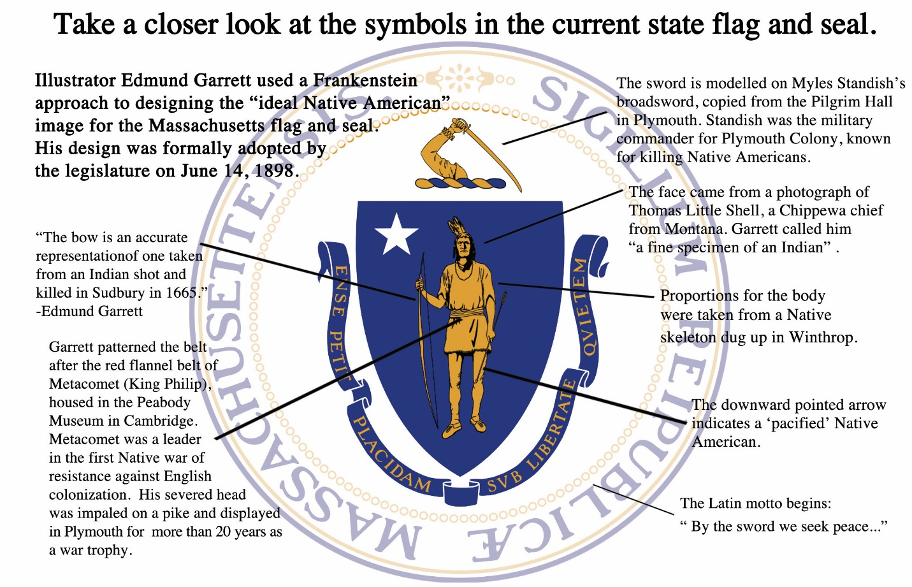

https://changethemassflag.com/?fbclid=IwAR2JEXSFXu_LdqXzAYoCcVnEaHf_PnV_I8vICRmmA6tiawTEY91S3IcjvXo

