Dandelions

bright yellow pops
in fields and yards
not weeds
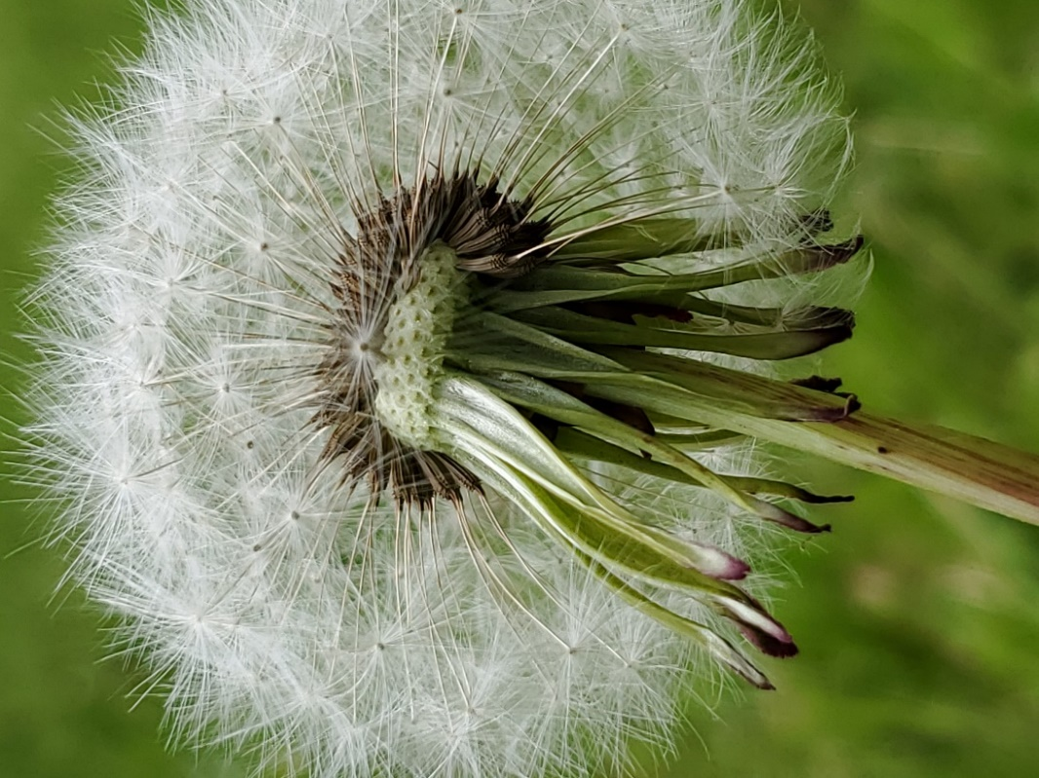
but sustenance
for bees
medicine for humans
teaching us.

let bees taste
their first nectar
ensuring survival
take the greens
brew your tea
detoxify your body

study the way each jagged petal
fits into the next
then watch as they change
to reveal hundreds
each seed attached to a wisp so fine
to be able to float on the air
Wishes

observe each more closely
get a lesson in geometry
a nearly white circle
forms from brown radii
a slight touch sends them out
offers new and different angles

stop spending hours trying
to rid yourself of them
learn your lessons

Joyce Rain Anderson

