Before There Was Light
By: Christi Belcourt

https://www.humansandnature.org/before-there-was-light?fbclid=IwAR14b_dTV900nQF8EX4noBcsZiPllToFVxsArppW2CfklYQgGKWuTdmqZbc
2,406 Words

Before there was light, when black was the only sacred colour, there was sound. A slow, steady beat of a soft rattle. Sh sh sh sh sh sh. Out of black was born this universe, and out of this universe was born our Mother, and out of our Mother was born all the grandmothers to be; each grandmother as the head of their family, watching out for their babies. Grandmother spider, grandmother tick, grandmother mouse, grandmother oak. And so on, and so on.
All work is tied together by invisible threads. What whispers of wisdom does grandmother spider impart to her grandbabies while they are carried on their mother’s back? Oh, there are many secrets here. The soil holds many stories, which won’t ever be spoken of in a human tongue to anyone.
All the prayers of all the mothers since the beginning of time
while they carried babies within them exist now in the beds of
rivers. And when the sturgeon and salmon come to spawn, they
find the clean places where those prayers lie, and they lay
their eggs into them. Each prayer, a story of hope, carried into
the next generation.
What is the language of the land? Does the land speak or does it merely hear? How can we know what stories the land can share unless we speak the language? How can we know what stories the land holds, unless we know how to listen?
• • •
Listening, speaking, and understanding are all keys to any good relationship, whether that be with another person, or with spirits, or with plants, or with the land or waters. Relationships are built with time and trust. You can’t rush them. And they aren’t one-sided. Cultivating a relationship with the land means you get to know it and that the land gets to know you. Your feet know where to land when you know the land you walk.
Without a relationship with the land and the waters, and, importantly, to the spirits that live in those places, we cannot know the stories that are held there.
My own relationship with land didn’t really begin until my partner and I moved out of the city of Ottawa to raise our daughter on the land as best we could. We moved to the North Shore of Lake Huron in Anishinaabeg territory, to live with my partner’s parents on their land, within their traditional territory.
While we were settling in, I would go out into the bush, climbing the rocks that are part of the LaCloche Mountain range, most of the time by myself. In the beginning, I thought it was to “study” the plants that would become the subject of my paintings. But as I sat on the ground, taking in the way the golden light was reflecting on all the spider webs that clung from plant to plant, I looked down at the plant relations that I had come to know, and I saw all these insects on them, all different kinds, all moving and working to keep the whole world alive. I closed my eyes, and I could hear a symphony of bees and other flying insects in a low, steady hum, which was in perfect harmony with the sound of the breeze on the leaves and the crows in the distance. And I remembered years ago, Elder Wilfred Peltier, my friend and mentor, telling us young people stories about where he came from and his experiences, and he would always emphasize this point to us that “all is really only one.”
In this moment with the insects, I saw the interconnectedness of all living things he was talking about. I remembered him and other Elders saying “the plants can speak.” When I was in my late teens I heard their words, and I laughed and doubted them. But here, in the field teaming with life that I found myself in, I understood. So I pulled out a little pinch of tobacco from the pouch I always carried with me, and I offered it to the plant nearest to me. I told the plant that I was new to all of this and I had heard they could speak. I told the plant I wasn’t going to pick it, but that I just wanted to hear it and perhaps understand what it’s medicine could be good for in helping a human being. At first, I felt really weird doing this, like maybe I was going crazy. But I knew that I trusted those Elders’ words. And it was such a commonly held belief amongst different Indigenous nations, I thought there must be something to it that I didn’t understand—yet.
I reached out, I held one of the branches and some leaves, and I sat with my head down and quieted my mind. I tried to turn off all my own thoughts, my own internal dialogue that never seems to shut up. I just held my mind blank, batting away the thoughts that kept invading the empty space I was trying to create. And finally, after a while, I held the space just long enough that I heard a thought. I can’t say I heard a “voice,” because it really wasn’t a voice at all. It was a thought. Or I should say, a bombardment of thoughts that were not my own. It was information that came in quick succession about how the plant could be used and other things which I’m not comfortable writing down—as some things are simply too sacred to write down. All of the information that came to me from the plants was later verified, either through my own research or by asking Elders that knew the plants. Some of the information that came I didn’t have any verification for until many years later. Teachings take time to unfold, sometimes a lifetime. I haven’t told anyone of the specific things the plants told me that day, but I have found everything they have said to be true. And I know that plants can speak because the things they said were so impossible for me to know; I know without a doubt that I wasn’t making it up or couldn’t have known these things on my own.
And so it went for years while I lived on that mountain and we raised our daughter there. I spent much of my time in the area around our house, on those rock mountains, getting to know the plants there, and trying my best to listen. It got to the point where I would think about them in the winter, under the deep snow, and want to go see them in the spring to make sure they made it through the colder months. Sometimes I would have a dream or wake up and would hear them. They wanted me to come and visit.
It’s not just the plants that speak. Elders will tell you it’s also the rocks. The rivers. The mountains. The trees. The animals. The fire. The clouds and so on. I can’t hear all of these, but I believe that is only because I haven’t taken the time to cultivate a relationship with them. But others can. And importantly, anyone can. It’s not a secret. Or a gift. It’s life. It’s simple and pure. It’s untainted. Undamaged. Whole and wholesome, like walking on a path in the bush and breathing in the smell of earth and pine needles that have fallen on the ground. “Listen with your heart,” Elders will say.
There is no corruption in the bush.
• • •
We moved to the mountain in the year 2000 on the North Shore and on Manitoulin Island, in what is now known as Ontario. For those who are unfamiliar with the area, there are many Anishinaabe First Nations here. But all of this territory is Anishinaabeg land. It was stolen through a series of thefts that followed in succession, one after the other, first by the British, then later, Canada.
Indigenous place names are still in use here. Although some have been lost to time, the Anishinaabe language remains strong and the names are still spoken by the people.
Original names given to places by Indigenous people were sometimes given because of a significant event that happened there—events never recorded in any Canadian history book, and so remain unknown to Canadians on the whole, but are still known and spoken about by the people who call that land home. Or sometimes the original place names tell of the particular way the water moves, or the types of plants that grow there. Or they tell a story of a sacred or mysterious event that occurred. Or it’s named for the spirit who dwells there. Or, sometimes, the meaning is lost to this generation. But what original place names always do is tell the story of the very deep and long connection the people have to the lands and waters.
On the lakes, shorelines are filled with stories of summering places, of interactions with water spirits, of burial sites and fasting places, and more. The stories are rich with not only the history of place, but also they reveal an unbroken thread of land use. They reveal the unbroken relationship people have to their lands and waters.

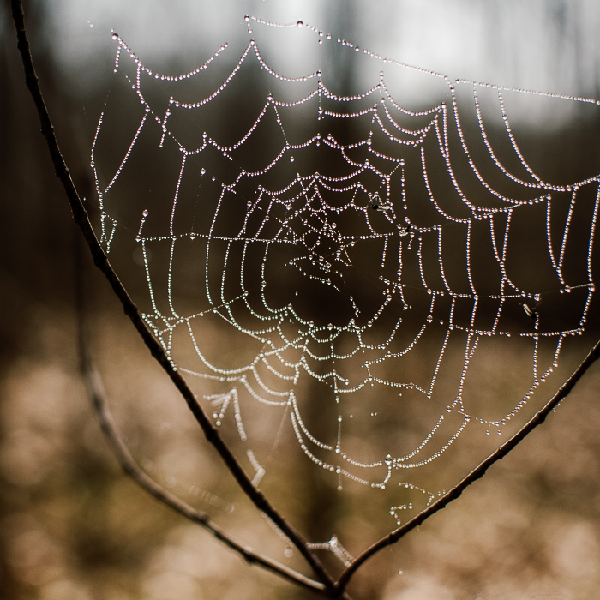
"What whispers of wisdom does grandmother spider impart to her grandbabies while they are carried on their mother’s back?" –Christi Belcourt, Photo Credit: Alyssa Bardy, Chicory Wild Creative

I was raised in Ontario but my ancestry is from the Métis community of Manitou Sakahikan (Lac Ste Anne) in what later became Alberta. The community of Cree-speaking Metis were mostly Catholic. Things are changing now. Fortunately, the Catholic Church no longer has the hold it once held on the people of Manitou Sakahikan.
Lac Ste Anne is the site of a yearly pilgrimage where each July, thousands of Catholics, mostly First Nations and Métis people, come from all over the Prairies and Northwest Territories. The lake is renowned for its healing waters. I’ve never been to pilgrimage, but I’ve heard the stories of reunions with family and friends, fiddle music, partying, laughter, and all the things you know happen when thousands of Indigenous people get together. I’m not Catholic, or Christian, but I want to go someday because it just sounds like a lot of fun. Maybe I’ll even snag. Jokes.
Manitou Sakahikan in Cree means “spirit lake.” Like so many Indigenous place names for water, it contains the word Manitou (Spirit) as part of its name. There are a few small but important written accounts of a Serpent living in the lake, and this could be the reason behind the lake’s original name.
The word “spirit” was often misunderstood by Catholic church representatives, as was Indigenous spirituality and the spiritual significance of land and water to Indigenous People. Today, many places in Canada carry the names of “devil” and “hell” as marks of the continuation of colonization, and these names reveal the way in which colonizers saw sacred lands. I don’t know what the circumstances were around the renaming of Manitou Sakahikan in 1844 to Lac Ste. Anne, but the story goes that upon his arrival to the area, a priest by the name of Fr. Thibault “blessed” the lake and renamed it to Lac Ste. Anne. I hope one day people stop using the name Lac Ste. Anne and return to using its original place name.
Many stories that are told by Elders talk about spirits that are in the waters. There are depictions of them painted on rocks all across this continent and beyond that are thousands of years old. Painted, some say, by little people, or painted by people who had fasted, or painted by spirits themselves. We will never know.
When you go out with Elders onto the land or water, they will often say something like, “this is the place where the little people live, so we will leave something here for them.” And they might add that we aren’t to speak too loudly in those places. We leave a little offering of food or something shiny they would like, or maybe a little useful tool or piece of metal. We don’t linger. We respect that this is their home and not ours and we keep moving.
The concept that human beings don’t have a right to be in certain places is something Canada hasn’t yet learned.
The stories of land are stories of relationships with the land and the spirits that live there; relationships built over time, over centuries, over millennia.
Maria Campbell, my Elder, Auntie, and teacher, has often told me that the land also tells us how to speak about it. She says, “all Indigenous languages are shaped by the lands and waters we live on.” So the story of land is also the story of language.
• • •
The love we have for the land is generations deep. And with that love also comes worry because of climate change and because of the violence we see being inflicted on Mother Earth.
My Elders and teachers have always told me to keep offering my tobacco and to keep making those offerings to the waters and the land; to trust in what the Grandmother of us all is setting into motion; to remember the earth is powerful; to never forget to sing our songs and to make our prayers; to keep giving and keep making those petitions to the spirit world for help. There are a great many things we will never understand in this Great Mystery. But what we can do is bring children to the land to let them form their own relationships with the spirits that are within everything. We can retell the stories we do know about the places we come from, even if it feels like we don’t know very much. We can encourage them to know that this world is filled with magic and mystery. And perhaps, in the end, that is the greatest gift we can give back to this world.
All the prayers of all the mothers since the beginning of time while they
carried babies within them exist now deep within the rich soil. And when
the rains come, drenching the earth, the trees drink them up and breathe
them back out to the world for us.
Do not carry fear in your hearts for the world to come. For fear is the
killer of new ideas and fresh thoughts. Rest easy my relatives, and
remember, all the prayers of all the mothers, since the beginning of time,
while they carried babies within their wombs, exist now embedded deep
within the soil. And when the rains come, drenching the earth, the trees
drink them up and breath them back out into the world,
for us.

Published on 20 June 2021
NOTES (show)
Special thanks to Samantha Butwell for her work on this series.

IMAGE CREDIT:
PHOTOGRAPH BY ALYSSA BARDY.

CHRISTI BELCOURT
Artist and Author
Christi Belcourt (Michif / Lac Ste. Anne, AB) is a visual artist, designer, community organizer, environmentalist, social justice advocate, and avid land-based arts and language learner.

What stories does the land hold?

QUESTION BACKGROUND:
Across the world, Indigenous people share something in common: our connection to land and our Ancestral territories.
We all carry a relationship to land; to the place that we call home, and the places that carry us.
This collection of Indigenous voices shows the stories of the land that we carry with us and that guide us through our lives. These stories connect us to land, to each other, and to all of our relations.

